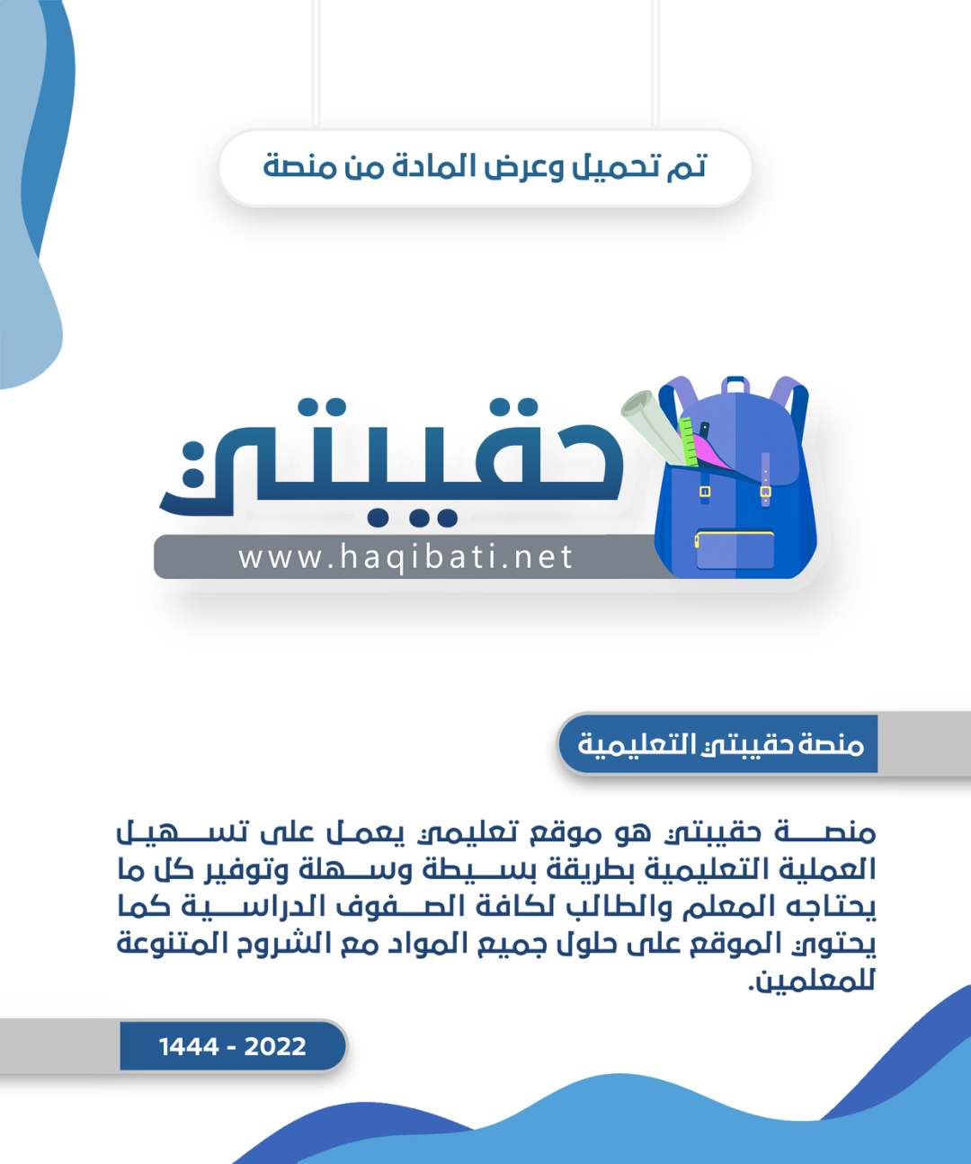



English Language

Grade 2nd secondary

period Exam

Kingdom of Saudi Arabia

Ministry of Education

………..Education Directorate

………………… secondary School

Student's Name : class:

**Reading comprehension ✦**

……\ 5 marks

1-Read the following passage and answer the questions below:

Since the 1990s technology has advanced rapidly . The birth of the internet has changed our life completely . **It** helped some families work at home and sell their products in social network sites . People now seem to spend most of their working days reading and sending emails to complete their daily tasks. What about the future? How will we work in 100 years’ time? People may be able to choose when and where they want to work.

|  |  |  |
| --- | --- | --- |
| 1- What does the word rapidly mean ? | | |
| c- hardly | b- slowly | a- quickly |
| 2- What does the word it refer to ? | | |
| c- cheese | b- tourism | a- internet |
| 3- Since the ………….. technology has advanced rapidly. | | |
| c- 2000s | b- 1990s | a- 1890s |
| 4- People now seem to spend most of their working days reading and sending emails to…........... | | |
| c- develop their skills. | b- complete their daily tasks. | a-play video games. |
| 5- What might happen in the future ? | | |
| c-people choose when and where to work. | b- people will work at night only. | a- people do not work at all. |

**Grammar**  ✦

**A. Choose the correct answer.**

1- Did you( write- wrote – writing ) the H.W?

2-Ali is (tallest – tall – taller ) than Ahmad.

3- The car needs to be (wash – washing – washed ).

4- I have the room (clean – cleaned – cleans ).

5-(Was – Were – Is ) they reading the book?

6- She had been( live - lived -living ) there since she was a child.

7- Sami used to( play- plays – playing ) football. But not any more.

8- The door was ( closed – closing – close ) by me.

……\ 4 marks

[](https://t.me/Asmaworld)

……\ 4 marks

**B. Do as shown between brackets.**

**1-( Correct)**

a- After she had **moves** out, I found her notes…………..

b-The computer needed to be **fix** …………………………

**2.( Unscramble the questions. )**

a-use \ Do \ the \you \ ever \ a fax machine \ ?

……………………………………………………………………………………….…?

**3-( change into passive )**

a- Omar broke the window.

……………………………………………………………………………………….

✦  **Vocabulary**

……\ 2 marks

**A-Complete the missing words ( grim**  - **adventure - insured - obsessed )**

1-That watch is valuable. you should have it ……………………... .in case it's ever stolen.

2-Faisal loves to try new things . He is an ………………..………boy.

3-Omar is …………….……... of technology and media.

4- The news about the plane crash was ……………. There were no survivors

**B- Find the odd words.**

1- Thief robber burglar plane

2- cyber virtual taxi networking

**C- Write the correct word under each picture**

……\ 1 mark

……\ 4 marks

**paramedics - Jewelry - detective - asthma**





…………………………

…………………………

…………………………

…………………………

Your teacher:

The end of the questions

Good luck

Your teacher ………………………

المملكة العربية السعودية

وزارة التعليم

الإدارة العامة للتعليم بمحافظة الأحساء

مدرسة الإمام جعفر الصدق الثانوية

10



|  |  |  |  |  |  |  |  |  |  |  |  |
| --- | --- | --- | --- | --- | --- | --- | --- | --- | --- | --- | --- |
|  | | |  | | |  | | | | العام الدراسي | 1444هـ |
|  | | | | الفصل الدراسي | الأول |
|  | | | | الدور | الوحدة 1-2 |
|  | | | المصحح | | | Q-A | Q-B | Q-C | Q-D | الصف | الثاني الثانوي |
| اسم الطالب |  | | المصحح | عمار العيد |  |  |  |  | المادة | **Mega Goal 2** |
| الشعبة |  | | **4** | **2** | **2** | **2** | زمن الاختبار | 50 دقيقة |

**1 each= 4**

**A) Choose the correct answer:**

**1- A lot of money ( was - were - is - are ) taken from the cash register..**

**2- Did she(found – find – finds - finding)lots of resources for her essay online?**

**3- The door ( have - has - are - were ) been opened.**

**4- The TV needs to be ( fixed – fix – fixing – fixes).**

**B) Do as shown between brackets:**

**1 each= 2**

**1- Police found the suspect hiding in a trash can. *( Make Passive )***

**………………………………………………………………………………………………………………………………………………………………………**

**2-(1st) Tania was talking on the phone. (2nd) She heard an intruder in the house. *(Combine)***

**………………………………………………………………………………when……….………………………………………………………………………………………**

**0.5 each= 2**

**C) Match the word with its meaning:**

|  |  |  |  |
| --- | --- | --- | --- |
| **-** | **Word** | **-** | **Meaning** |
| **1** | **Easy mark** |  | **not on purpose** |
| **2** | **By accident** |  | **likely victim(s)** |
| **3** | **Nabbed** |  | **Stolen.** |
| **4** | **Come on** |  | **Please be serious.** |

**D) Put each word from the box in the correct sentence:**

**1 each= 2**

**assume - insured - grim**

**1- That watch is valuable. You should have it ___________________ in case it’s ever stolen.**

**2- The news about the plane crash was ____________________. There were no survivors.**

المملكة العربية السعودية

وزارة التعليم

الإدارة العامة للتعليم بمحافظة الأحساء

مدرسة الإمام جعفر الصدق الثانوية



|  |  |  |  |  |  |  |  |  |  |  |  |
| --- | --- | --- | --- | --- | --- | --- | --- | --- | --- | --- | --- |
|  | | |  | | |  | | | | العام الدراسي | 1445هـ |
|  | | | | الفصل الدراسي | الأول |
|  | | | | الدور | الوحدة 1-2 |
|  | | | المصحح | | | Q-A | Q-B | Q-C | Q-D | الصف | الثاني الثانوي |
| اسم الطالب |  | | المصحح | عمار العيد |  |  |  |  | المادة | **Mega Goal 2** |
| الشعبة |  | | **4** | **2** | **2** | **2** | زمن الاختبار | 50 دقيقة |

10

**1 each= 4**

**A) Choose the correct answer:**

**1- A lot of money ( was - were - is - are ) taken from the cash register..**

**2- Did she(found – find – finds - finding)lots of resources for her essay online?**

**3- The door ( have - has - are - were ) been opened.**

**4- The TV needs to be ( fixed – fix – fixing – fixes).**

**B) Do as shown between brackets:**

**1 each= 2**

**1- Police found the suspect hiding in a trash can. *( Make Passive )***

**………………………………………………………………………………………………………………………………………………………………………**

**2-(1st) Tania was talking on the phone. (2nd) She heard an intruder in the house. *(Combine)***

**………………………………………………………………………………when……….………………………………………………………………………………………**

**0.5 each= 2**

**C) Match the word with its meaning:**

|  |  |  |  |
| --- | --- | --- | --- |
| **-** | **Word** | **-** | **Meaning** |
| **1** | **Easy mark** |  | **not on purpose** |
| **2** | **By accident** |  | **likely victim(s)** |
| **3** | **Nabbed** |  | **Stolen.** |
| **4** | **Come on** |  | **Please be serious.** |

**D) Put each word from the box in the correct sentence:**

**1 each= 2**

**assume - insured - grim**

**1- That watch is valuable. You should have it ___________________ in case it’s ever stolen.**

**2- The news about the plane crash was ____________________. There were no survivors.**

|  |
| --- |
|  |
| 15 |



English Language

Midterm Exam

\3\1444

King of Saudi Arabia

Ministry of Education

2rd Sacandary Grade

|  |  |  |
| --- | --- | --- |
| **Class\** |  | **Student's name** |

**Section A: Read and answer the following questions:_**

|  |
| --- |
|  |
| 2 |

This is Salwa. She lives in a house. It is a big house. There are 4 bedrooms upstairs. There is a living room downstairs. They have a garage, they keep the car inside **it**. They have a beautiful garden. The garden has flowers and trees. Her family is nice. She has 2 sisters and I brother. His name is Ali. Her mother works in the kitchen and her father works in the garden.

**A) Choose the right answer**

**1**-The living room is [ downstairs - behind – upstairs ]

2-In line two " **it** " refer to [ bed – car – garage]

**B) Put ( √ ) or ( x )**

1-Salwa's father works in the garden. [ ]

[ ] 2-They keep the car in the garage.

|  |
| --- |
|  |
| 4 |

**------------------------------------------------------------------------------------------**

**Section B: _ "Grammar"**

1 -They (don't – doesn't - didn't – haven't) play football yesterday

2-He was ( study – studies – studied – studying ) his lessons

3-I used to ( get up – gets up – getting up – got up ) late when I was a student .

4-Saudi Arabia is ( big – bigger – biggest – bigger ) than Bahrain

5-They stole the car . ( Change into passive )

………………………………………………………………………………………

6-the Internet / Has / working / been / ? ( Rearrange to make a question )

………………………………………………………………………………………

7- Was the password changed ? …………………………………… . ( Give negative short answer)

**8-** He was tired because he (run)……………………………….. . for 2 hours . ( Correct the verb )

|  |
| --- |
|  |
| 4 |

**Section C: 1- Vocabulary" Write the correct word under each picture:**

**1- asthma 2- pickpocket 3- download 4- acronyms 5- newborn**

|  |  |  |  |
| --- | --- | --- | --- |
| Download Free Download Manager | Baixaki | Cartoon Acronym Stock Illustrations – 443 Cartoon Acronym Stock  Illustrations, Vectors & Clipart - Dreamstime | 6 خطوات للتعامل مع الربو.. لدى الصغار | 395 Pickpocketing Illustrations & Clip Art - iStock |
|  |  |  |  |

**2- Match each word with its meaning.**

|  |  |  |
| --- | --- | --- |
| 1. nabbed |  | **a.** refuse |
| 2. decline |  | **b.**  stolen |
| 3. misdemeanor |  | **c.** a minor crime |
| 4. inmate |  | **d.** a prisoner |

**------------------------------------------------------------------------------------------**

|  |
| --- |
|  |
| 5 |

**Section D: _ "listening"**

** Listen to the recording then answer:

1- where does the young girl want to go with her father?

**( to the park – to the movie – to the school** )

2-what does the father suggest they do at the end of the day?

( **go to eat – watch a firework display – go down to the peach** )

3-what does the girl want to do later ?

**( go to the ice cream store – swim at the park – go down to the peach** )

4- The movie will start in 2:45 ( T - F )

5- The girl's older brother will go with them ( T - F )