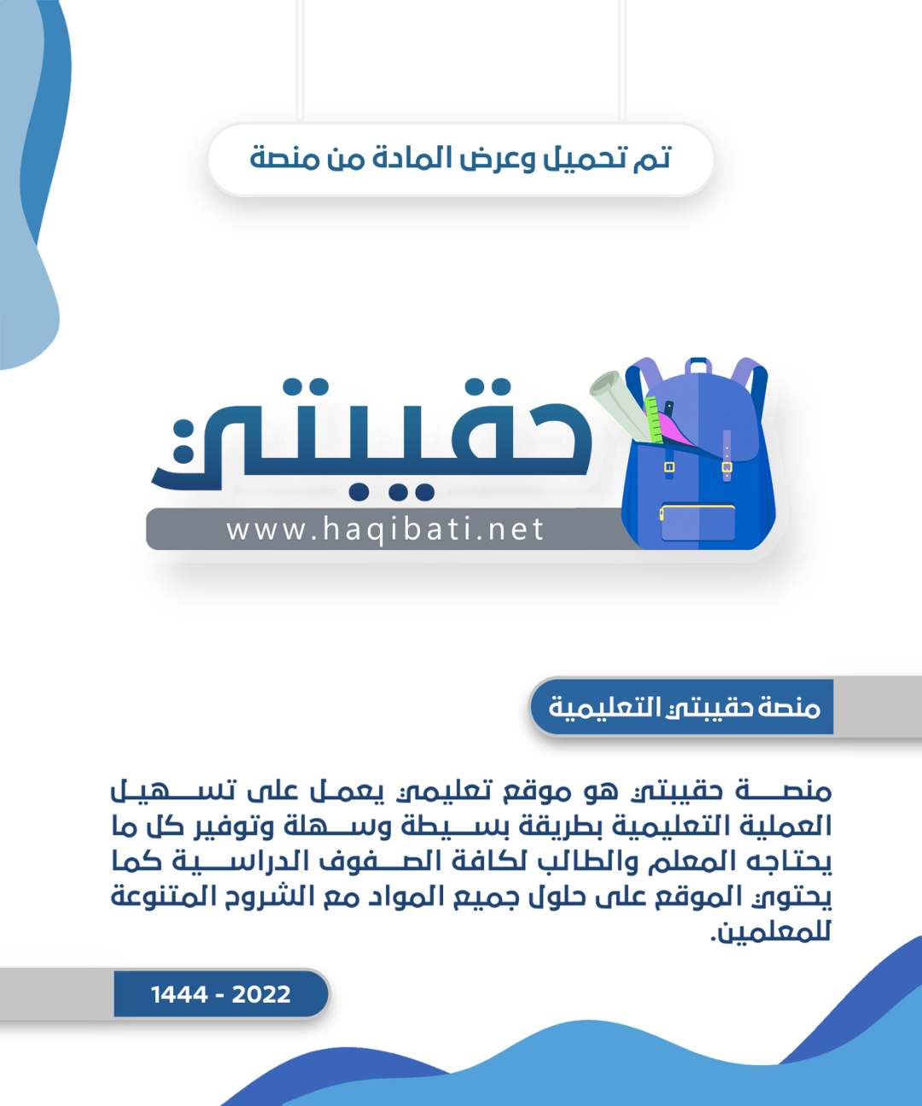



**Kingdom of Saudi Arabia**

**Ministry of Education**

**………… Education Directorate............**

**…………..……………….. Intermediate School**

|  |
| --- |
|  |
| **20** |

**Total**

**Midterm Test units 1 & 2**

|  |
| --- |
| **First Intermediate Grade** |

**Name ………………………………… Class ………………………………**

__________________________________________________________________________________________

/ 4

**Comprehension**

**Read the following then answer the questions:**

My name is Abdullah, I was born in Jeddah. I am from Saudi Arabia and I am 22 years old.

I am a student at the Business Administration College. I have got one brother and one sister.

In my free time, I watch TV and play computer games. And I also play basketball every weekend. I like to have a good time with my friends, but I hate shopping for clothes.

**A- Put (√ ) for true or ( ᵡ ) for false :**

|  |  |
| --- | --- |
| **( )** | **1.** He has got two sisters. |
| **( )** | **2.** In his free time, he watches TV. |

**B- Choose the right answer:**

|  |  |  |  |  |
| --- | --- | --- | --- | --- |
| **Tabuk** | **Abha** | **Jeddah** | **Riyadh** | **1-**He was born in ______. |
| **driver** | **student** | **teacher** | **doctor** | **2-**Abdullah is a _______. |

_________________________________________________________________

/ 5

**Grammar**

**Choose the right answer:**

|  |
| --- |
| **1-**  You _______ my best friend. **.** |
| A**. is** B**. am** C**. are** D**. do** |
| **2** - I’m a student. _______ name is Aisha |
| A**. his** B**. my** C**. your** D**. she** |
| **3 -**  Our vacation is ____ May. |
| A**. on** B**. in** C**. at** D**. under** |
| **4 -**  ______ old are you? I’m fifteen . |
| A**. Where** B**. How**  C**. When**  D**. which** |
| **5 -**  Sara ____ a nurse . |
| A**. am** B**. are** C**. is** D**. she** |

/ 4

**Vocabulary**

**A- Choose the best answer to fill in the blank:**

|  |  |  |  |
| --- | --- | --- | --- |
| 1. I need a pair of ________ to cut this paper. | | | |
| D. **pen** | C. **pencil** | B. **scissors** | A. **book** |
| 2. Good night, Fatima. __________ , Mona | | | |
| D. **Good afternoon** | C. **Good night** | B. **Good bye** | A. **Good morning** |
| 3- January is the first _____ of the year. | | | |
| D. **hour** | C. **day** | B. **week** | A. **month** |
| 4- _____ your books. Look at page 12. | | | |
| D. **cut** | C. **open** | B. **write** | A**. help** |

**B- Put the right word under its picture:**

|  |  |  |  |  |
| --- | --- | --- | --- | --- |
| Listening Vector Art, Icons, and Graphics for Free Download | Orange Pencil Clip Art Free Pictures｜Illustoon | Eko - Notebook - Ruled / Plain / Dot-Grid Pages - 120 Pages | The Dolphin Chronotype's Ultimate Guide | Sleepopolis | How To Draw a Parrot (Step by Step Pictures) |
|  |  |  |  |  |

**Parrot , dolphin , pencil , notebook , listen**

/ 5

_______________________________________________________________________________

/ 2

**Orthography**

**Choose the correct letter:**

|  |  |  |  |
| --- | --- | --- | --- |
| **k** | **h** | **l** | 1. The food on planes is terrib_e. |
| **b** | **d** | **t** | 2. Our visit is on Thurs_ay. |

Good luck T.



English Language

Intermediate Grade 1st

period Exam

Kingdom of Saudi Arabia

Ministry of Education

………..Education Directorate

………………… Intermediate School

Student's Name : class:

**Reading comprehension ✦**

……\ 5 marks

1-Read the following passage and answer the questions below:

Ali gets up at five o'clock every morning. He performs morning prayer. For breakfast, he likes to eat eggs and bread. He drinks milk. Ali always goes to school by bus. He reaches school at seven o’clock. Later, he has lunch at half past two with her family. In the afternoon, he starts doing his homework at four o’clock. He goes to bed at ten o’clock.

|  |  |  |
| --- | --- | --- |
| 1- Ali gets up at ………… o'clock every morning. | | |
| c- ten | b- three | a- five |
| 2- For breakfast, he likes to eat …………. and bread | | |
| c- cheese | b- cereal | a- eggs |
| 3- Ali drinks ……………… | | |
| c- juice | b- milk | a- coffee |
| 4-. Ali always goes to school by …………….. | | |
| c-train | b-bus | a-car |
| 5- He goes to bed at ………. o’clock. | | |
| c- ten | b- nine | a- one |

**Grammar**  ✦

……\ 4 marks

**A. Choose the correct answer.**

1- You ( is – are – am ) a doctor.

2-(Where – What – Why ) day is today?

3-( What – How – when ) are you?

4- Omar (is – are – am) a student.

5- Please ( open – opening – opens ) your book.

6- I’m a student. (Her – My – His )name is Alan.

7-This is my friend .She (is – are -am) a teacher.

8- The exam is ( in – on – at )Monday.

[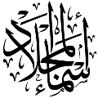](https://t.me/Asmaworld)

**B. Do as shown between brackets.**

**1-( Correct)**

a-What is **you** name? ………………

b- Our vacation is **on** the winter. ………..

**2-Write the negative.**

a-Close the door…………………………………………………………………………….

**3-Write the following dates.**

a-2/15 ………………………………………………………………………………………..

……\ 4 marks

✦  **Vocabulary**

**A-choose the correct answer.**

1-We( read – cut - swim) books.

2- Open your books. Look at ( page – pencil – read ) twelve.

**B- Write the correct word under each picture**

……\ 5 marks

**cat pencil scissors dolphin**

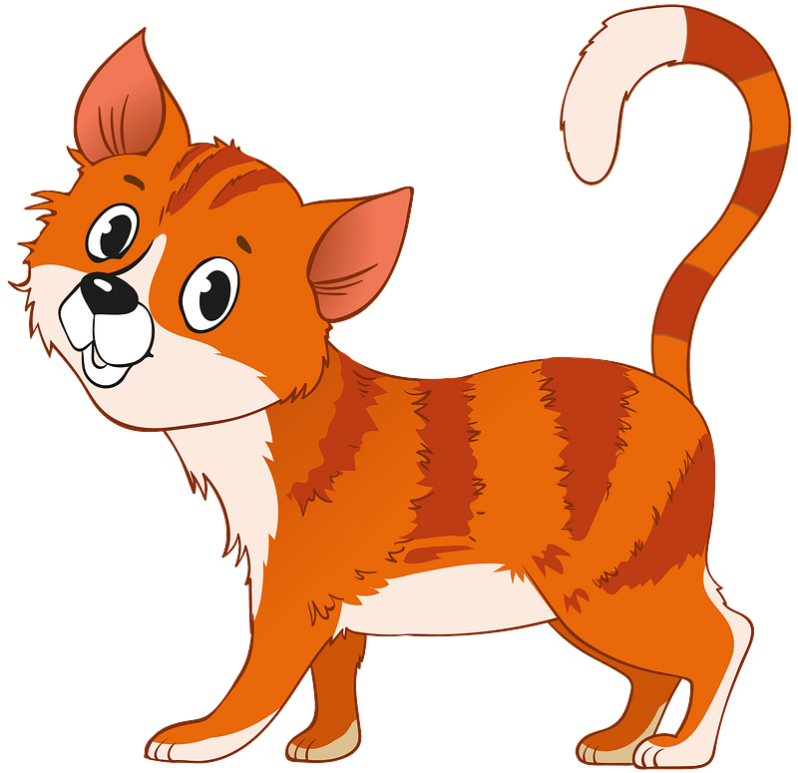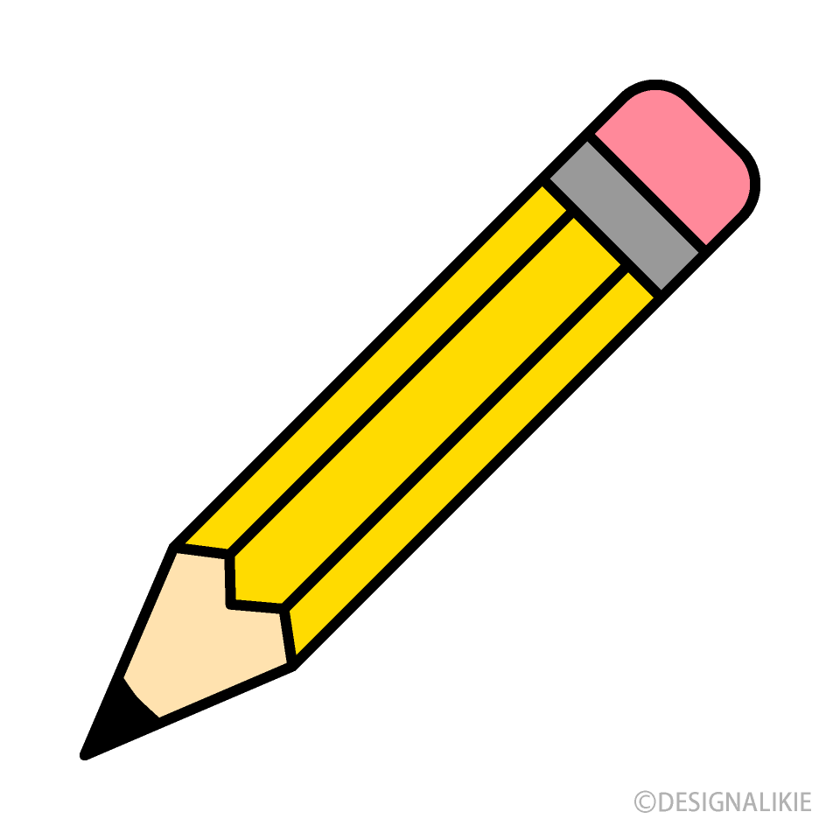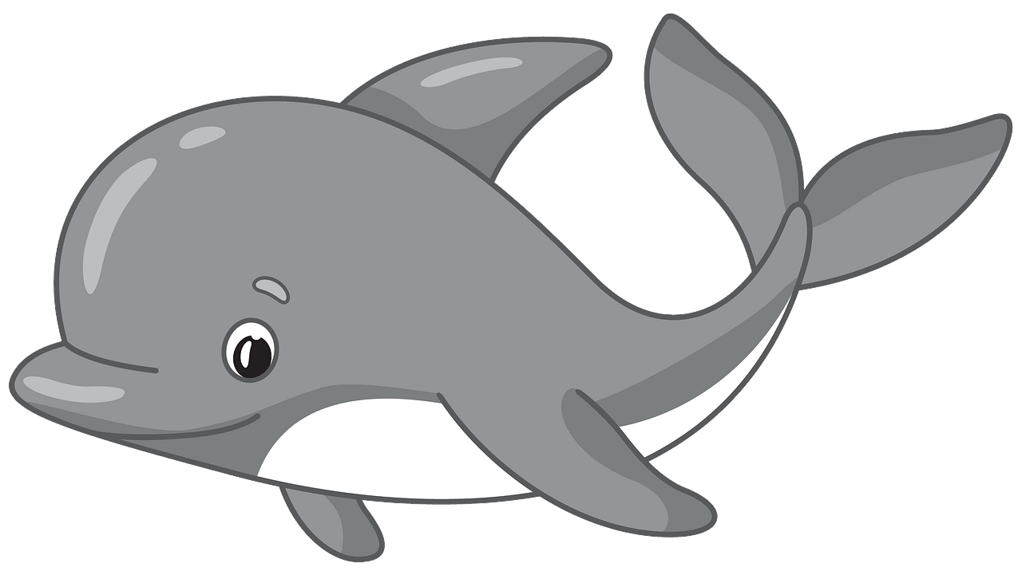

…………………………

…………………………

…………………………

…………………………

**✦ Orthography**

**Choose the corre**

……\ 2 marks

**A. Choose the missing letter.**

1- We’re going sailing on Mo….day. ( n – u – q ).

2- Ni….e to meet you. I'm Fahad. ( p – c – z )

**B. Write the missing letter.**

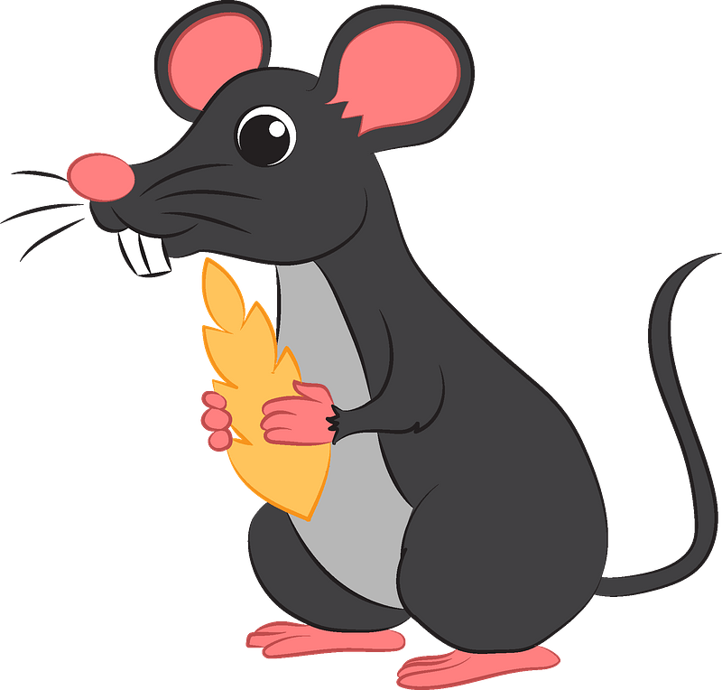

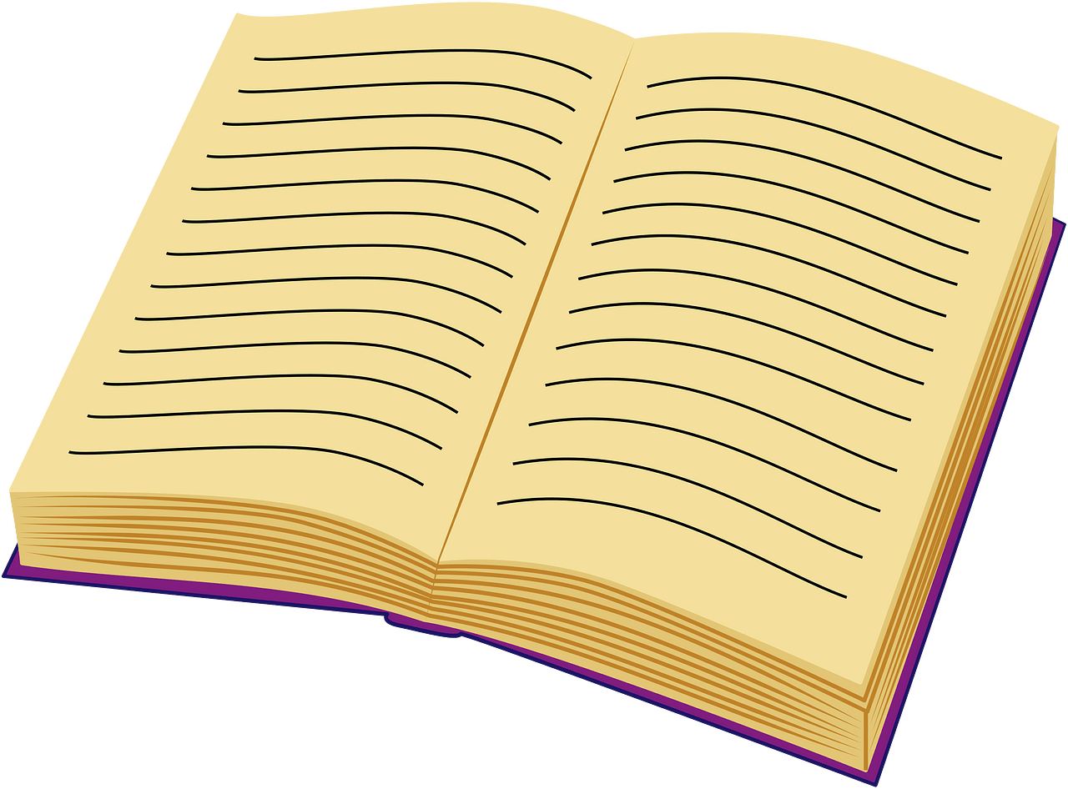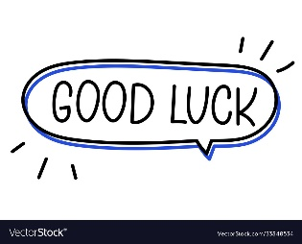

Your teacher:

2- ….ouse ( h – m – p )

1-Boo…… ( k – j – a )

The end of the questions

Good luck

Your teacher ………………………