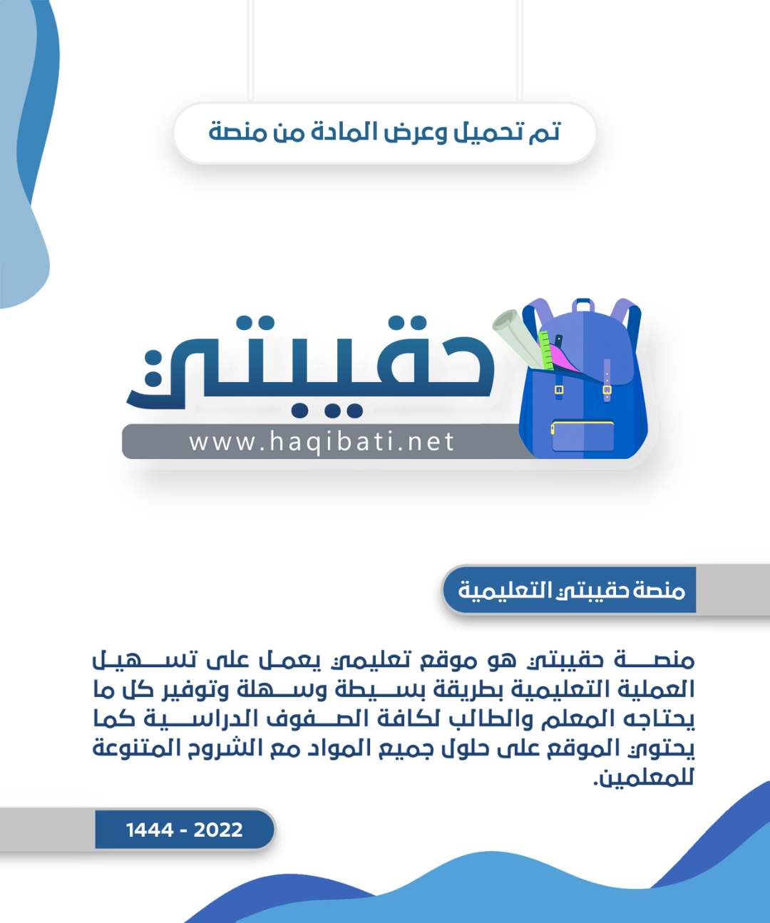



**Kingdom of Saudi Arabia**

**Ministry of Education**

**………… Education Directorate............**

**…………..……………….. Intermediate School**

|  |
| --- |
|  |
| **20** |

**Total**

**Midterm Test units 1 & 2**

|  |
| --- |
| **Third Intermediate Grade** |

**Name ………………………………… Class ………………………………**

__________________________________________________________________________________________

**Comprehension**

/ 4

**Read the following then answer the questions:**

I am Sarah and I am 17 years old. I am from Riyadh It is a beautiful city and most of my relatives live here that is why I love it here. I live with my family and I have an older sister, my sister is a very good cooker and she teaches me sometime. My mother is a doctor and she would like me to be a doctor too. My father works at a technology company. I am a good student and always get a good grade on my exams. I would like to be a doctor**.**

**A- Put (√ ) for true or ( ᵡ ) for false :**

|  |  |
| --- | --- |
| **( )** | **1.** Sara is from Riyadh . |
| **( )** | **2.**  She has a younger sister . |

**B- Choose the right answer:**

|  |  |  |  |  |
| --- | --- | --- | --- | --- |
| **nurse** | **cooker** | **teacher** | **mom** | 1-Her older sister is very good ______. |
| **water** | **electricity** | **technology** | **telecom** | 2- Her father works at a _______ company. |

___________________________________________________________________

/ 5

**Grammar**

**Choose the right answer:**

|  |
| --- |
| **1-**  She _______ coffee now and then. |
| A**. drink** B**. drinks** C**. drinking** D**. drank** |
| **2** - ____ of them are teachers. |
| A**. Both** B**. Can**  C**. Neither**  D**. Do** |
| **3 -**  Did you live in Riyadh? Yes, I ______ . |
| A**. do** B**. does** C**. am** D**. did** |
| **4 -**   His parents _____ married in Tabuk. |
| A**. am** B**. was**  C**. were**  D**. are** |
| **5 -**  When I was a child, I ____ ___ play with my toys all day. |
| A**. use to** B**. am to** C**. using to** D**. used to** |

/ 4

**Vocabulary**

**A- Choose the best answer to fill in the blank:**

|  |  |  |  |
| --- | --- | --- | --- |
| 1. A ________ diet contains plenty of fresh produce. | | | |
| D. **small** | C. **fast** | B. **unhealthy** | A. **healthy** |
| .2. For teenagers, the ________ is a tool for learning and a means of communication | | | |
| D. **pen** | C. **computer** | B. **bag** | A. **book** |
| 3- She never eats meat, She is____________ . | | | |
| D. **shopping** | C. **devoted** | B. **slim** | A. **Vegetarian** |
| 4- I first rode a ____ when I was four. | | | |
| D. **train** | C. **plane** | B. **bike** | A**. bus** |

**B- Put the right word under its picture:**

|  |  |  |  |  |
| --- | --- | --- | --- | --- |
| 10,000+ Free Sale Shopping & Shopping Images - Pixabay | The General Consensus | The Dangers and the Benefits of Cell Phones | Twins peak with more born than ever before - BBC News | Premium Vector | Japanese Ramen noodles Bowl Cartoon Illustration for  mascot logo or sticker | Cartoon Camel Isolated On White Background Stock Illustration - Download  Image Now - Camel, Cartoon, Humor - iStock |
|  |  |  |  |  |

**camel , noodles , cell phone , shopping , twins**

/ 5

_______________________________________________________________________________

/ 2

**Orthography**

**Choose the correct letter:**

|  |  |  |  |
| --- | --- | --- | --- |
| **r** | **c** | **d** | 1. He flew aboard the spa_e shuttle Discovery. |
| **v** | **o** | **u** | 2. He likes to wear fashionable cl_thes. |

Good luck T.



English Language

Intermediate Grade 3rd

period Exam

Kingdom of Saudi Arabia

Ministry of Education

………..Education Directorate

………………… Intermediate School

Student's Name : class:

**Reading comprehension ✦**

……\ 5 marks

1-Read the following passage and answer the questions below:

Salem is a Saudi engineer. He studied at a university in Paris. One summer day, when he was on his way to work, he saw some poor people who lived in the open air. Suddenly, he had an idea. He thought of the large land behind his house to build as a home for them. Because he did not have enough money, he started to collect it from the rich people in the city. Everyone was kind and helpful. As an engineer, he began building the houses, and many young people came to help.

|  |  |  |
| --- | --- | --- |
| 1- The Best title for this passage could be:- | | |
| c- Going to London. | b- long vacation. | a- A Home for the Poor |
| 2- He studied at a university in …………... | | |
| c- Mexico | b- Makkah | a- Paris |
| 3- What was Salem’s idea? | | |
| c-to build school for poor people. | b-to build a home for poor people. | a- to teach poor people English language. |
| 4- He did not have enough ………………… | | |
| c- money | b- books | a-cars |
| 5- Everyone was ……………….. and helpful. | | |
| c- sad | b- lazy | a- kind |

**Grammar**  ✦

……\ 4 marks

**A. Choose the correct answer.**

1-I always (do - does – doing ) my homework in the afternoon.

2-Did you (live – lived – living) in Jeddah?

3-When she was at school, she (see – saw – sees) her friend.

4- Sarah (eat- eats – ate ) chocolate morning, noon, and night.

5-How ( many – old -much) time do you spend in the shower?

6-(Neither – All - both ) of them is a teacher.

7-I asked my teacher a question (last – ago – yesterday).

8-Where did they ( work- worked- working) ?

[](https://t.me/Asmaworld)

**B. Do as shown between brackets.**

**1-( Correct)**

a- I rarely **sleeping** late on the weekend……………

b-I didn’t use to **playing** video games. ………………….

**2-Reorder.**

a-you \ How often \ surf \ do \on the internet \ ?

…………………………………………………………………………………………….

b- Omar \ stay \ at \ home \ didn't

………………………………………………………………………………………………

……\ 4 marks

✦  **Vocabulary**

**A-choose the correct answer.**

1- Metropolis means : a big ( city – street – country ).

2-(Donate – Donor – Clinic ) to give something or money to a person that needs help.

3- Ali is online all the time, even in the park! He is(an exercise freak- an Internet addict)

4- Jake never eats meat. He’s ( an Internet addict- a vegetarian).

**B- Write the correct word under each picture**

……\ 5 marks

**shuttle - infant))**



…………………………

…………………………

**✦ Orthography**

**Choose the corre**

……\ 2 marks

**A. Choose the missing letter.**

1- He works out at the gy…*.*. ( m - s – q )

3-Noura never drinks coffee, but she loves her…al tea.( w - o – b )

3- The ..ustodian of the Two Holy Mosques, King Salman bin Abdulaziz was born in Riyadh.( C – J - R)

2-You did an out…..tandingjob on the project. ( s – a – w )

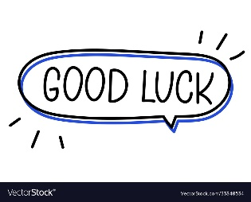

Your teacher:

The end of the questions

Good luck

Your teacher ………………………