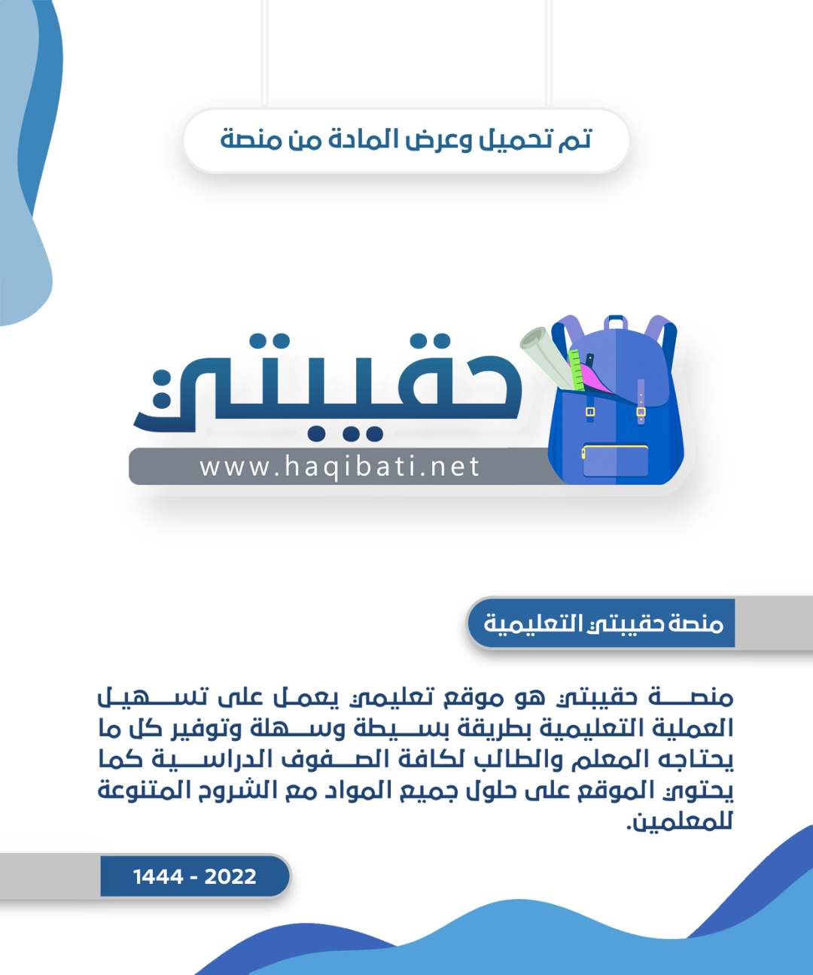



**Kingdom of Saudi Arabia**

**Ministry of Education**

**………… Education Directorate............**

**…………..……………….. Intermediate School**

|  |
| --- |
|  |
| **20** |

**Total**

**Midterm Test units 1 & 2**

|  |
| --- |
| **Second Intermediate Grade** |

**Name ………………………………… Class ………………………………**

__________________________________________________________________________________________

/ 4

**Comprehension**

**Read the following then answer the questions:**

Last weekend, I went to a new shopping mall that opened last month. The shopping mall is so huge and has five gates. Inside the mall, there are many stores and a place for people to pray. Also, the mall has a food area with more than 5 different restaurants**.**

**A- Put (√ ) for true or ( ᵡ ) for false :**

|  |  |
| --- | --- |
| **( )** | **1.** The shopping mall opened last week. |
| **( )** | **2.** The mall has five gates. |

**B- Choose the right answer:**

|  |  |  |  |  |
| --- | --- | --- | --- | --- |
| **beautiful** | **crowded** | **huge** | **small** | **1-**The mall is so ______. |
| **sleep** | **pray** | **play** | **study** | **2-**Inside the mall there is a place for people to _____. |

_________________________________________________________________

/ 5

**Grammar**

**Choose the right answer:**

|  |
| --- |
| **1-**  We ___________ here for the festival. |
| A**. is** B**. am** C**. are** D**. do** |
| **2** - ______ are you doing? Fine, thanks. |
| A**. Where** B**. How**  C**. When**  D**. which** |
| **3 -**   What are you ______ now? |
| A**. doing** B**. do** C**. does** D**. did** |
| **4 -**   I _______ martial arts films. |
| A**. am liking** B**. likes**  C**. like**  D**. liking** |
| Among Vs Between - Between Preposition - Free Transparent PNG Clipart  Images Download **5 -**  The apple is _______the boxes . |
| A**. under** B**. on** C**. in** D**. between** |

/ 4

**Vocabulary**

**A- Choose the best answer to fill in the blank:**

|  |  |  |  |
| --- | --- | --- | --- |
| 1. _________ are good places for meeting people. | | | |
| D. **Playground** | C. **Room** | B. **Schools** | A. **Hotels** |
| .2. Good night. ___________ tomorrow | | | |
| D. **Good afternoon** | C. **See you** | B. **Good bye** | A. **Good morning** |
| 3- Are you here for the conference? No, I’m here on ________ with my family. | | | |
| D. **playing** | C. **study** | B. **vacation** | A. **hotel** |
| 4- He is _____ ______ in the library. | | | |
| D. **eating a sandwich** | C. **watching a film** | B. **reading a book** | A**. playing a game** |

**B- Put the right word under its picture:**

|  |  |  |  |  |
| --- | --- | --- | --- | --- |
| What to consider before you get a new credit card | Fiberglass Step Ladder - 8' H-1195 - Uline |  | Premium Vector | Realistic white webcam | Pizza Vectors & Illustrations for Free Download |
|  |  |  |  |  |

**pizza , ladder , webcam , credit card , karate**

/ 5

_______________________________________________________________________________

/ 2

**Orthography**

**Choose the correct letter:**

|  |  |  |  |
| --- | --- | --- | --- |
| **k** | **h** | **d** | 1. I’d like to intro_uce you to Joe. |
| **b** | **m** | **t** | 2. The soup s_ells good . |

Good luck T.



English Language

Intermediate Grade 2nd

period Exam

Kingdom of Saudi Arabia

Ministry of Education

………..Education Directorate

………………… Intermediate School

Student's Name : class:

**Reading comprehension ✦**

……\ 5 marks

1-Read the following passage and answer the questions below:

Sami is the editor of The Daily news. All the reporters and photographers at the newspaper like Sami a lot. He’s a great boss and they enjoy working with him. He lives in Jeddah . He works very hard and gets home after eight in the evening. He’s usually very tired . His wife is a part-time chef so she cooks lovely food for them. Sami doesn’t have much free time but, when he does he loves watching TV and surfing the Net. His dream is to take karate lessons and become active in the future.

|  |  |  |
| --- | --- | --- |
| 1- Sami is the ……….. of The Daily news. | | |
| c- doctor | b- teacher | a- editor |
| 2- He’s a ……………. boss. | | |
| c- old | b- bad | a- great |
| 3- Sami lives in …………….. . | | |
| c- Jeddah | b- Abha | a- Riyadh |
| 4- His wife is a part-time ……………. | | |
| c- chef | b-nurse | a-engineer |
| 5- His dream is to take ………. lessons | | |
| c- French | b- karate | a- cook |

**Grammar**  ✦

**A. Choose the correct answer.**

1- (open – opening – opened ) the book please.

2-Riyadh(is – are – am )in Saudi Arabia.

3- I ( isn't – aren't – am not ) doctor.

4- Are you ( sleep – sleeping – sleeps )?

5-Who ( is – are – am ) your teacher?

6- Sara is ( make – makes – making ) a cake.

7- Don't ( eat – eats – eating ) junk food.

8-( How – what – where ) old are you?

……\ 4 marks

[](https://t.me/Asmaworld)

**B. Do as shown between brackets.**

**1-( Correct)**

a- Dubai **aren't** in Egypt. …………….

b- **Closing** the window please.. ………………

2**-(Give a short answer)**

a- is he a doctor ?

- No,………………………………………………………………

3-**(make a Yes or No question)**

a-They are working now.

…………………………………………………………..……….?

……\ 4 marks

✦  **Vocabulary**

……\ 5 marks

**A-choose the correct answer.**

1- ( hostel – supermarket – bank ) is a place where  young people can stay cheaply.

2-(script -soup - sofa ) is the words of a movie, play, or speech.

**B- Write the correct word under each picture**

**webcam elevator credit card volcano**

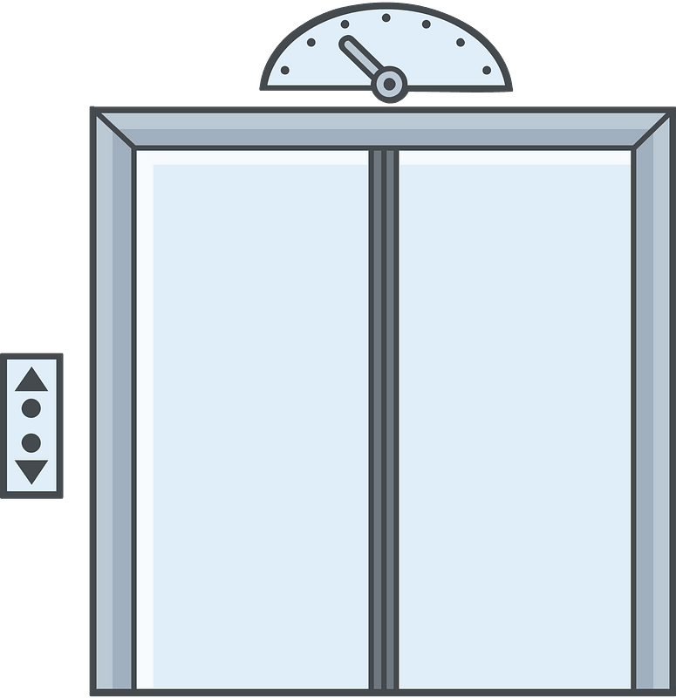

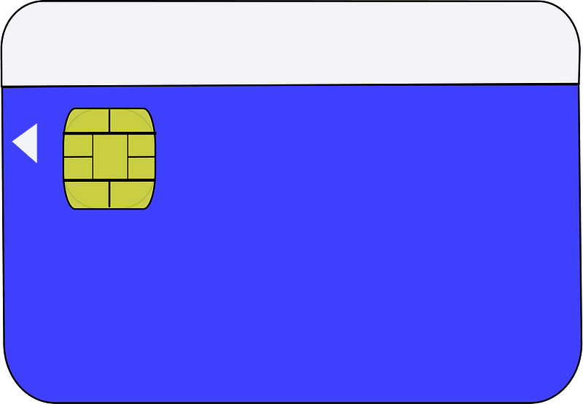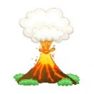

…………………………

…………………………

…………………………

…………………………

**A. Choose the missing letter.**

1- During his summer ……acation, he visited Dubai. ( v - a - d )

2- I had just returned from the Cannes Film Fe….tival. ( q - s - w )

**✦ Orthography**

**Choose the corre**

……\ 2 marks

**B. Write the missing letter.**



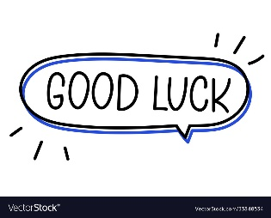

1-Ca…..era ( u – m – z )

Your teacher:

2-Fi….h ( s - g - r )

The end of the questions

Good luck

Your teacher ………………………

Name :…………………………………………………………………… Class:…….……….

**Super Goal 2** - **Test** unit 1 & 2

**Reading**

2 Marks

* **Read the text and answer the questions. Write T or F at the end of each question/statement.**

I like to go to the sports center. I go there every weekend. At the sports center, you can do many things. For example, you can play golf or tennis. There is a pool, so you can also swim or relax by the pool. There is a beach next to the sports center. You can swim, water-ski, or windsurf in the ocean. You can also sail on windy days. There aren’t any fish near the beach, so you can’t snorkel. When I go to the sports center, I like to play volleyball on the beach. I also like to jog on the beach. I can’t swim well, so I don’t like to water-ski or windsurf.

1. At the sports center, you can do many things.( )
2. You can swim in the pool or in the ocean. ( )
3. People can windsurf in the pool. ( )
4. You can sail on windy days in the ocean. ( )

**Grammar**

5 Marks

* **Choose the best answer to fill in the blank in each question.**

1. Who _____ that girl?

**a**. am **b**. is  **c**. are  **d.** i

1. **John:** _____ your friend? - **Adnan:** He is in the restaurant.

**a**. How’s **b**. What’s  **c**. When’s  **d.** Where’s

1. It _____ a beautiful day today**.**

**a**. is **b**. are  **c**. not  **d.** am

1. _____ in that new TV film?

**a**. He acting  **b**. He is acting **c**. Is acting **d.** Is he acting

1. 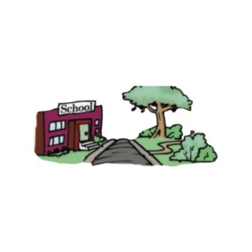What is he eating ? - he's ________ an apple .

صورة تحتوي على فن, ليل

تم إنشاء الوصف تلقائياً**a**. eat **b**. is eat **c**. eating  **d.** ate

1.5 Marks

* **Use ( across from – next to – between )**

1. صورة تحتوي على رسوم متحركة, نافذة أو شباك, بناء, منزل

   تم إنشاء الوصف تلقائياًThe park is ____________________ the school .
2. The bank is ______________ the post office and the restaurant .
3. The pharmacy is ______________ the bookstore .

* **Write the imperative sentence.**

1.5 Marks

1. Will you clean up this mess? ________________________________________
2. Why aren’t you eating your vegetables? _______________________________
3. You can’t take photographs. _________________________________________

**Vocabulary**

* **Choose the best answer to fill in the blank in each question.**

5 Marks

1. Thank you !

**a**. You’re welcome. **b**. He’s from Muscat.  **c**. That’s all right. **d.** Hi

1. What is your country ?

**a**. Fine thank you  **b**. I'm 13 years old **c**. Nice to meet you **d.** I'm from Saudi Arabia

1. Many young people traveling around the world are ________ .

**a**. old people **b**. backpackers **c**. teachers  **d.** business men

1. What is Ali doing ? - He’s _______ soup .

**a**. making  **b**. breaking **c**. writing **d.** talking

1. ________ sometimes use webcams in the classroom.

**a**. Students **b**. Teachers **c**. Farmers  **d.** business men

* **Write the correct word under the picture.**

3 Marks

coffee shop – Webcam – Turn Right

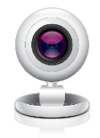

…………………………………………….

…………………………………………….

…………………………………………….

* **Choose the correct letter.**

2 Marks

* See you tomorr…..w. ( o – y – r )
* I don't he….r anything. ( t – a – r )



English Language

Intermediate Grade 2nd

1st period Exam

Kingdom of Saudi Arabia

Ministry of Education

………………… School

Student's Name : class:

|  |
| --- |
|  |
| 5  5 |

**1-Read the following e-mail then answer the questions below:**

Dear Salem,

I would like to tell you about my last winter vacation. I travelled to Morocco with my family. Morocco is a wonderful country in North Africa. It is famous for its high mountains. My family booked a hotel in a small village in Al-Atlas Mountains. We stayed there for a week. The views were wonderful. We watched the snow falling. After that, we went skiing in the mountains. On the next day, we went to the market to buy some presents for our friends. We bought some colorful wool rugs. The people were so **friendly** there. I advise you to visit Morocco soon.

Yours sincerely,

Rashid

|  |  |  |
| --- | --- | --- |
| 1- The best title for this email is: | | |
| c- The weather in Jordan | b- The weather in Oman | a- The weather in Morocco |
| 2- I travelled to Morocco with my ………………….. | | |
| c-cousins | b- family | a-friends |
| 3- Morocco is a wonderful country in …………. | | |
| c- North Africa | b- South Africa | a- East Africa |
| 4- We stayed in Morocco for …………. | | |
| c- a year | b- a month | a- a week |
| 5- The meaning of the word "friendly" in the last line is: | | |
| c- sad | b-hungry | a- welcoming |

**2-Choose the correct answer**

|  |
| --- |
|  |
| 5  5 |

1- I ( isn't – aren't – am n't ) doctor.

2- Sara is ( make – makes – making ) a cake.

3- Who ( is – are – am ) your teacher?

4-(open – opening – opened ) the book please.

5- Aisha and Fadwa ( is -are – am ) at the mall.

6-( How – what – where ) old are you?

7- The pizza ( smell – smells - smelling ) good.

8- Riyadh(is – are – am )in Saudi Arabia

9- I (liking – likes - like )martial arts films.

10- Don't ( eat – eats – eating ) junk food.

**3. Do as shown between brackets.**

|  |
| --- |
|  |
| 5  5 |

**A-( Correct )**

1**- when** is your name? …………………….……

2-I **wanting** a new cell phone. …………………

**B-(Give a short answer)**

a- is he a doctor ?

No,………………………………………………………...…..

**C-(make a Yes or No question)**

1-They are working now.

………………………………………………………………....…..?

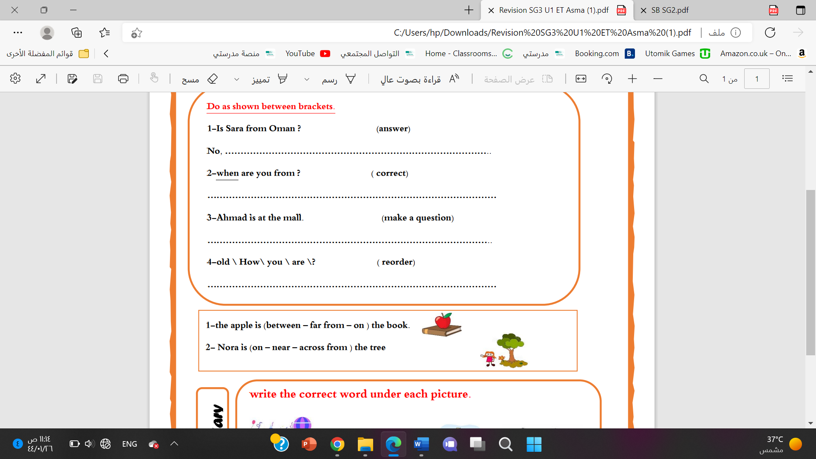a**-**Mahmoud isn’t in the kitchen.

…………………………………………………..………….………?

**D-(Choose)**

a- Nora is (on – near – across from ) the tree

b-The thieves are getting (in front of – away ) in a fast car.

**4-choose the missing letter**

1-During his summer ……acation, he visited Dubai. ( v - a - d )

|  |
| --- |
|  |
| 5 |

2-I had just returned from the Cannes Film Fe….tival. ( q - s - w )

**5- write the correct word under each picture.**

Webcam elevator volcano castle

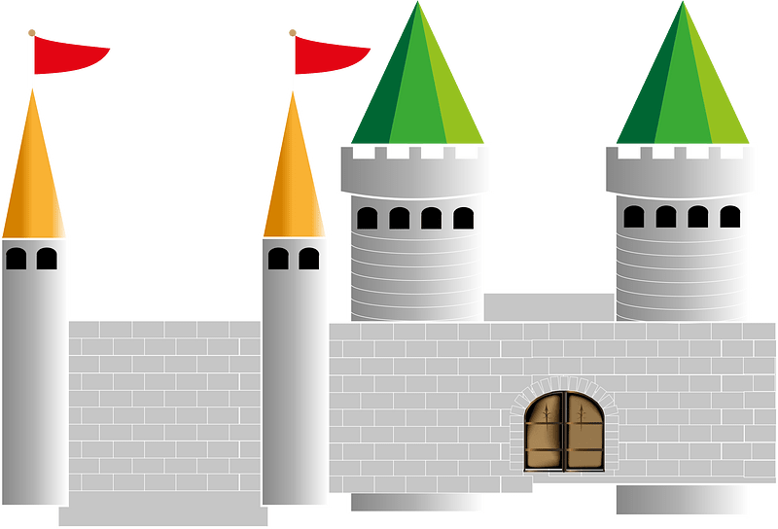

……………….

……………….

……………….

……………….

Best of luck

Your teacher:

Your teacher: