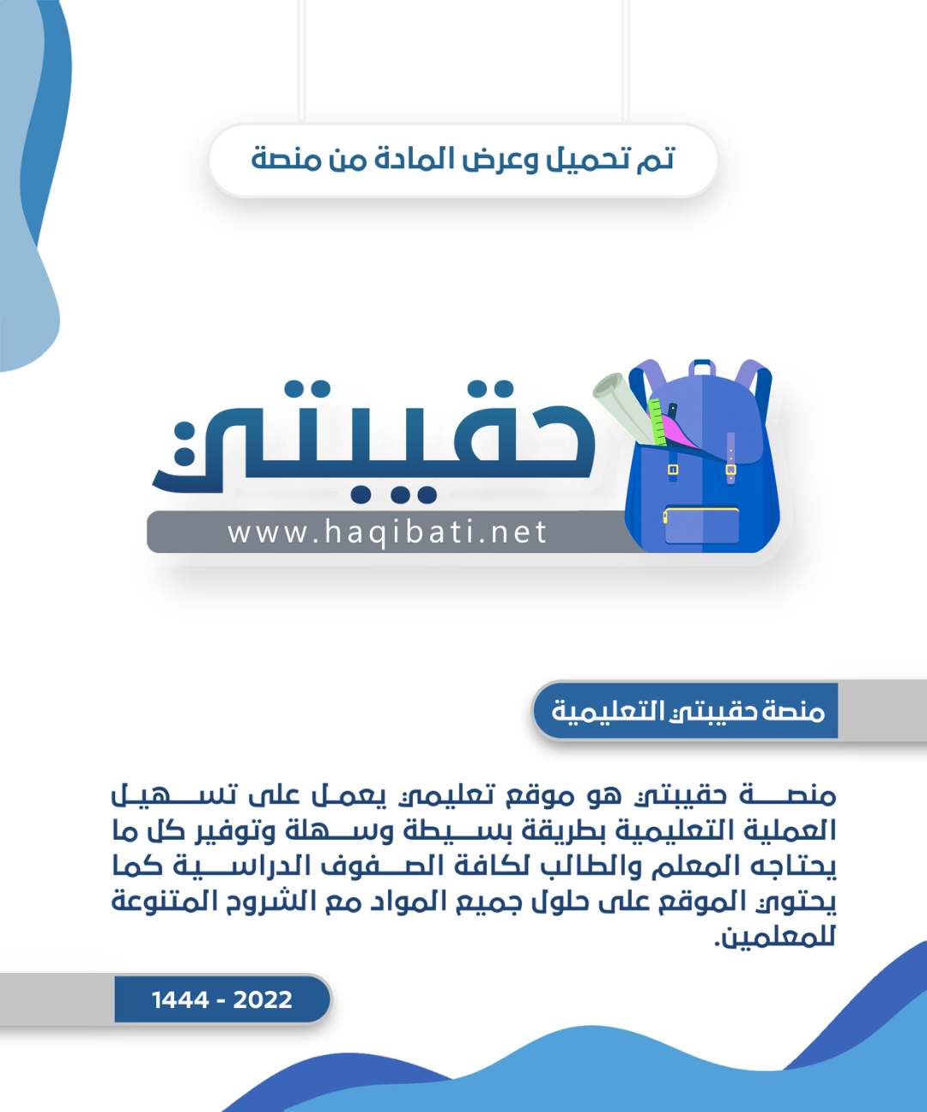



Kingdom of Saudi Arabia

Ministry of Education

……..Education Directorate

………………… School

English Language

elementary Grade …..

period Exam

…………….\20

Student's Name : class:

……\ 4 marks

General questions

[](https://t.me/Asmaworld)

**A.Answer the questions**

|  |  |  |  |
| --- | --- | --- | --- |
| I never forget to feed it. |  | What are you afraid of? | 1 |
| It's mine. |  | What school subject is more difficult at school? | 2 |
| I think math is more difficult. |  | Whose dress was it?? | 3 |
| I'm afraid of spiders. |  | How often do you feed the fish? | 4 |

Controlled Writing

……\ 1 marks

**A-reorder.**

1-computer \ that \ Whose\ is \ ?

………………………………………………………………………………………………………

……\ 4 marks

Reading short sentence

|  |  |  |
| --- | --- | --- |
| Little boy with guitar. Boy playing guitar. Child playing musical  instrument 20629557 Vector Art at Vecteezy | **1- He is playing on the guitar ( )** | |
| 1,531 Child Feed Dog Stock Vectors and Vector Art | Shutterstock | **2- My little brother is kind . He always feeds dogs. ( )** |

**A-Put (** ✔ **) or (**  X  **)**

**B. Choose the correct answer**

|  |  |  |  |
| --- | --- | --- | --- |
| Math | naughty | School | 1-My little brother is very ………….. |
| helpful | chatty | lazy | 2- Noura likes to talk a lot. She is very………… |

……\ 4 marks

Grammar

**A-Choose the correct answer.**

1-I’m( do – did – doing) my homework.

2-The chocolate cake ( was – were – am )delicious.

3-Omar usually( go – goes – going ) fishing on the weekend.

4-How ( old – much – often) does your sister go cycling?

Vocabulary

……\ 5 marks

**A.write the correct word under each picture**

**( strong - drums - bus - cat - grandpa)**

**)**

|  |  |  |  |  |
| --- | --- | --- | --- | --- |
| Strong Man And Weak Man Strong Image Firm Vector, Strong, Image, Firm PNG  and Vector with Transparent Background for Free Download | Drums |  | Cute kitten cartoon clipart AI Generated 27241786 PNGGrandpa | PNG All | School bus |
|  |  |  |  |  |

Orthography

……\ 2 marks

**A. Fill in the missing letters**

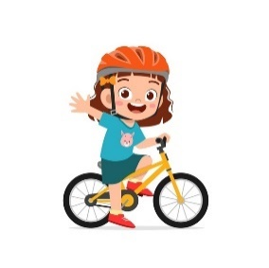

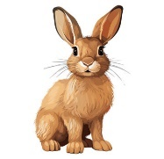

**1-Ca…..era**

**( m – j - y )**

**4- ….allon**

**( k – b - s )**

**3- …ycling**

**( l - c - x)**

**2- rab…it**

**( b – j - s )**

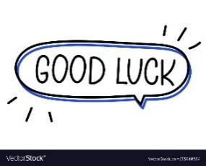

Your teacher:

Your teacher …..:…………………………….

  **Midterm Exam– Top** **Goal1**

**مدرسة:**

|  |  |  |  |  |  |
| --- | --- | --- | --- | --- | --- |
| **الاسم ثلاثي:** |  | **الفصل** | **/** | **الدرجة** | **20 /** |

__________________________________________________________________________________________

**Choose the correct answer:**

|  |
| --- |
| 1– What school subject is more difficult at school?    A**. I think math.** B**. I am surprised**. |
| 2 –What is your favorite place to visit?  A**. Diriyah is my favorite place .** B**. I usually visit my uncle** . |

____________________________________________________________________________________________________

**Choose 🗸 or 🗴:**

|  |  |  |
| --- | --- | --- |
| She is afraid. | He is fishing in a boat**.** | She is playing a soccer. |
| 383,634 Afraid Images, Stock Photos, 3D objects, & Vectors | Shutterstock | Boat Cartoon Fishing Stock Illustrations – 8,414 Boat Cartoon Fishing Stock  Illustrations, Vectors & Clipart - Dreamstime | ‪Premium Vector | Cartoon little girl playing tennis‬‏ |
| **🗸 🗴** | **🗴 🗸** | **🗸 🗴** |

___________________________________________________________________________________________

|  |  |  |  |
| --- | --- | --- | --- |
| 1- a terrible – It – game – is ( Rearrange) ……………………………………………………………………………………… | | | |
| **grandparents** | **parents** | **uncle** | 2 - My mom and dad are my ______. (choose ) |

**Do as shown between brackets :**

**Choose the correct word:**

|  |  |  |  |
| --- | --- | --- | --- |
| **are** | **do** | **does** | 1- How often ____ you see your cousin? |
| **were** | **was** | **is** | 2- We ____ happy . |
| **mine** | **your** | **my** | 3- Whose dress was it? It was _____ . |

**Choose the correct word:**

|  |  |  |  |  |  |
| --- | --- | --- | --- | --- | --- |
| Premium Vector | Cartoon cute boy weightlifting | Cartoon Fishing Images - Free Download on Freepik | Cartoon funny little boy running Royalty Free Vector Image | Cartoon Drums Images – Browse 43,462 Stock Photos, Vectors, and Video |  Adobe Stock | Vector Cartoon Danger Icon in Comic Style. Attention Caution Sign  Illustration Pictogram Stock Illustration - Illustration of sign, caution:  133003613 | Bus Cartoon Vector Images (over 20,000) |
| Strong | Cycling | Running | Drum | Stop | Bus |
| weak | Fishing | Reading | Guitar | Dangerous | Poster |

**Choose the correct letter to fill in the blank:**

|  |  |  |  |
| --- | --- | --- | --- |
| People Celebrate Achievement Victory Friends Birthday Stock Vector (Royalty  Free) 2055918341 | Shutterstock | Cartoon Camera Images – Browse 156,520 Stock Photos, Vectors, and Video |  Adobe Stock | Grandfather Cartoon Images – Browse 121,428 Stock Photos, Vectors, and  Video | Adobe Stock | Cute Kitten Cartoon Illustration, Cute Clipart, Cartoon Clipart, Kitten  Clipart PNG Transparent Image and Clipart for Free Download |
| Cele_ration | Ca_era | grand_a | kitte_ |
| **b** | **n** | **p** | **n** |
| **d** | **m** | **m** | **b** |

Good luck T.

Controlled writing

