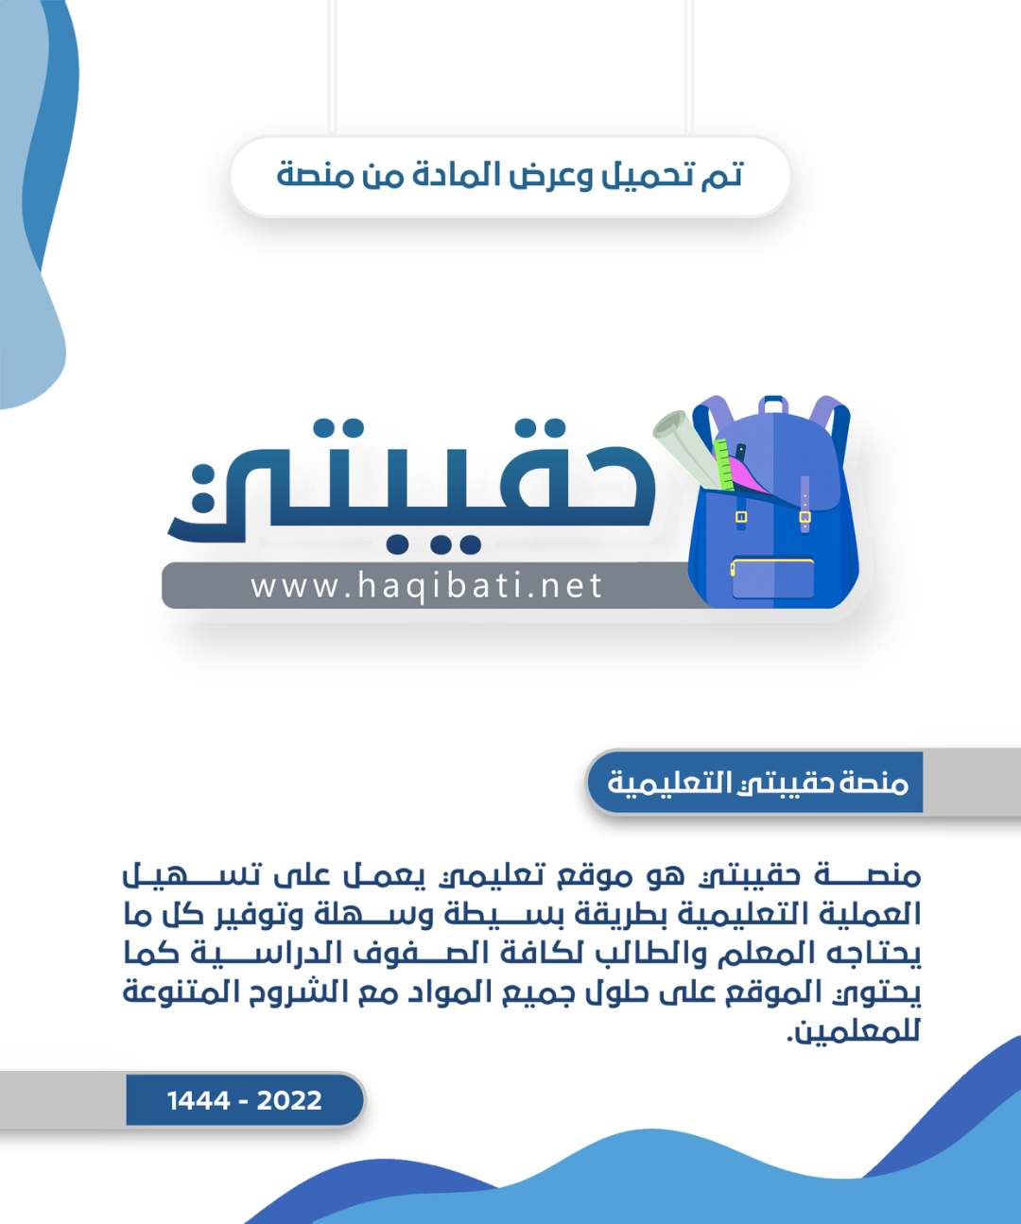



Kingdom of Saudi Arabia

Ministry of Education

___________ Gen. Dept. of Education

___________ Secondary School

English Language Final Listening Exam

Grade: ____

Term: 1st Term – 1444

Time: 25 minutes

|  |  |  |
| --- | --- | --- |
| Markers | Total Mark in Letters | |
| **Graded by:** | ___________________________  ___________________________ |  |
| **Revised by:** | 5 |

**اختبار استماع مادة (اللغة الإنجليزية - الفصل الدراسي الأول - الدور الأول) للصف** ___________  **ثانوي - للعام الدراسي 1444هـ - نظام المسارات**

**اسـم الطالب : ____________________________________________________________ رقم الجلوس : ___________ اللجنة : ___________**

**رَبِّ اشْرَحْ لِي صَدْرِي وَيَسِّرْ لِي أَمْرِي**

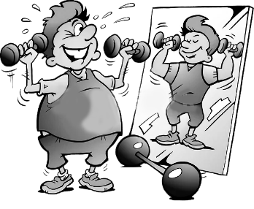Listen to the conversation between Waseem and his friend, Mustafa, talking about fitness and health

and answer the following questions

**3**

1. **Choose the correct answer:** (½ mark each)

|  |  |  |  |  |  |  |  |
| --- | --- | --- | --- | --- | --- | --- | --- |
| **1)** | Waseem joins the gym to ___________ | | | | | | |
| a- | get fit | b- | lose weight | c- | build muscles | d- | hang out | |
| **2)** | Mustafa joins the gym to ___________ | | | | | | |
| a- | get fit | b- | lose weight | c- | build muscles | d- | hang out | |
| **3)** | The trainer told Mustafa to do ___________ minutes on the running machine. | | | | | | |
| a- | 14 | b- | 20 | c- | 40 | d- | 44 | |
| **4)** | The trainer told Mustafa to do ___________ minutes on the weights | | | | | | |
| a- | 14 | b- | 20 | c- | 40 | d- | 44 | |
| **5)** | Waseem can have a personal ___________ when he joins the gym if he likes. | | | | | | |
| a- | food menu | b- | bicycle | c- | email | d- | trainer | |
| **6)** | Mustafa will ___________ Waseem about the cycle classes. | | | | | | |
| a- | call | b- | send a snap to | c- | text or email | d- | send voice message to | |

1. **Put ( T ) for true or ( F ) for false sentences :** (½ mark each)

**2**

1. [_____] Mustafa thinks the gym isn't really good.
2. [_____] A free health check is given when you join the gym.
3. [_____] Cycling is one of the best ways to build muscles.
4. [_____] Mustafa will check the website about having cycle classes.

_____________________________________________________________________



Kingdom of Saudi Arabia

Ministry of Education

___________ Gen. Dept. of Education

___________ Secondary School

English Language Final Listening Exam

Grade: ____

Term: 1st Term – 1444

Time: 25 minutes

|  |  |  |
| --- | --- | --- |
| Markers | Total Mark in Letters | |
| **Graded by:** | ___________________________  ___________________________ |  |
| **Revised by:** | 5 |

**اختبار استماع مادة (اللغة الإنجليزية - الفصل الدراسي الأول - الدور الأول) للصف** ___________  **ثانوي - للعام الدراسي 1444هـ - نظام المسارات**

**اسـم الطالب : ........................................................................................................ رقم الجلوس : ................. اللجنة : ..............**

**رَبِّ اشْرَحْ لِي صَدْرِي وَيَسِّرْ لِي أَمْرِي**

Listen to the conversation between Waseem and his friend, Mustafa, talking about fitness and health

and answer the following questions

**3**

1. **Choose the correct answer:** (½ mark each)

|  |  |  |  |  |  |  |  |
| --- | --- | --- | --- | --- | --- | --- | --- |
| **1)** | Waseem joins the gym to ___________ | | | | | | |
| a- | **get fit** | b- | lose weight | c- | build muscles | d- | hang out | |
| **2)** | Mustafa joins the gym to ___________ | | | | | | |
| a- | get fit | b- | **lose weight** | c- | build muscles | d- | hang out | |
| **3)** | The trainer told Mustafa to do ___________ minutes on the running machine. | | | | | | |
| a- | 14 | b- | **20** | c- | 40 | d- | 44 | |
| **4)** | The trainer told Mustafa to do ___________ minutes on the weights | | | | | | |
| a- | 14 | b- | 20 | c- | **40** | d- | 44 | |
| **5)** | Waseem can have a personal ___________ when he joins the gym if he likes. | | | | | | |
| a- | food menu | b- | bicycle | c- | email | d- | **trainer** | |
| **6)** | Mustafa will ___________Waseem about the cycle classes. | | | | | | |
| a- | call | b- | send a snap to | c- | **text or email** | d- | send voice message to | |

1. **Put ( T ) for true or ( F ) for false sentences :** (½ mark each)

**2**

1. [__**F**__] Mustafa thinks the gym isn't really good.
2. [__**T**__] A free health check is given when you join the gym.
3. [__**F**__] Cycling is one of the best ways to build muscles.
4. [__**T**__] Mustafa will check the website about having cycle classes.

_____________________________________________________________________



Kingdom of Saudi Arabia

Ministry of Education

___________ Gen. Dept. of Education

___________ Secondary School

English Language Final Listening Exam

Grade: ____

Term: 1st Term – 1444

Time: 25 minutes

**اختبار استماع مادة (اللغة الإنجليزية - الفصل الدراسي الأول - الدور الأول) للصف** ___________  **ثانوي - للعام الدراسي 1444هـ - نظام المسارات**

Audio Script

**Waseem and Mustafa - Fitness and Health**

**Waseem**: Hi Mustafa. How are you?

**Mustafa**: Hi Waseem. Yes, I’m fine apart from I hurt all over!

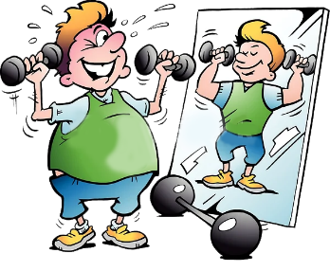**Waseem**: Why? What happened?

**Mustafa**: I joined the gym.

**Waseem**: But you aren’t supposed to hurt yourself when you join a gym.

**Mustafa**: I know, but the personal trainer told me to do twenty minutes on the running machine and then we did forty minutes on the weights. It felt fine while I was doing it but now, I can hardly move.

**Waseem**: Why did you join the gym?

**Mustafa**: Well, I’ve put on a lot of weight and I wanted to lose it.

**Waseem**: And … what’s the gym like?

**Mustafa**: Oh – it’s really good. They give you a full health check free when you join, and you can have a personal trainer if you like.

**Waseem**: What are the classes like? I want to join a cycle class because I want to get fit. I’ve heard cycling is one of the best ways to strengthen your heart and burn calories. And I’m so unit – I have to do something.

**Mustafa**: Why don’t you join?

**Waseem**: But do they have any cycle classes?

**Mustafa**: Mmm … I think so. I’ll check the website and get back to you. Maybe we could go together?

**Waseem**: Yes, that’s a good idea.

**Mustafa**: OK, I’ll text you or email you tomorrow with the information.

**Waseem**: Fine.

**Mustafa**: Bye!

**Waseem**: Bye!

|  |  |  |
| --- | --- | --- |
| **اسم الطالب/ه : .........................................** |  | **المملكة العربية السعودية** |
| **رقم الجلوس : .....................................** | **وزارة التعليم** |
| **الزمن : ..............................** | **إدارة تعليم .................** |
| **الصف : .....................** | **مكتب تعليم ....................** |
| **المادة : لغة انجليزية** | **مدرسة .....................** |
| **الدرجة رقما : ..................** | **التوقيع : .............................** | **اسم المصحح/ة : ............................** |
| **الدرجة كتابة : ..................** | **التوقيع : .............................** | **اسم المراجع/ة : .............................** |
| **الاختبار الشفهي للفصل الدراسي الأول للعام الدراسي 1444 هـ - المرحلة الثانوية** | | |

**Listen and circle the correct answer**

**[](https://drive.google.com/file/d/15LZqruhnuYHUFLCnS83rUBiODTS2k6si/view?usp=sharing)**

1. **For the main course , Andi ordered :**
2. A cheese burger
3. A double cheese burger
4. A burger with chips
5. **For dessert , Andi chooses :**
6. Ice cream
7. Chocolate cake
8. Banana cake
9. **To drink , Andi chooses :**
10. Apple juice
11. Fizzy water
12. Still water
13. **The table number is :**
14. 9
15. 5
16. 3
17. **Andi's meal costs :**
18. $8.15
19. $8.37
20. $8.50
21. **Check the statements as ( T ) Or ( F ) :**
22. Andi ordered two burgers . ( )
23. Andi had some coffee . ( )
24. He ordered one cake . ( )
25. Andi pays in cash . ( )
26. The change is 2 pounds . ( )

**End of Questions**

**Answers**

1. **For the main course , Andi ordered :**
2. A cheese burger
3. A double cheese burger
4. A burger with chips
5. **For dessert , Andi chooses :**
6. Ice cream
7. Chocolate cake
8. Banana cake
9. **To drink , Andi chooses :**
10. Apple juice
11. Fizzy water
12. Still water
13. **The table number is :**
14. 9
15. 5
16. 3
17. **Andi's meal costs :**
18. $8.15
19. $8.37
20. $8.50
21. **Check the statements as ( T ) Or ( F ) :**
22. Andi ordered two burgers . ( F )
23. Andi had some coffee . ( F )
24. He ordered one cake . ( T )
25. Andi pays in cash . ( T )
26. The change is 2 pounds . ( F )

**Script**

**Café worker:** Next, please! What would you like?

Andi: Can I have a burger, please?  
Café worker: A cheese burger or double cheese burger?  
Andi: Double cheese burger, please.  
Café worker: Anything else?  
Andi: Yeah, I'd like some banana cake.  
Café worker: Would you like a drink?  
Andi: Yes, can I have an apple juice, please?  
Café worker: OK, so that’s one double cheese burger, one banana cake and an apple juice. What’s your table number?  
Andi: Table 3. How much is that?  
Café worker: That’s £8.37, please.  
Andi: Here you are.  
Café worker: Thank you ... that’s £10.00 ... and £1.63 change. Next, please ...