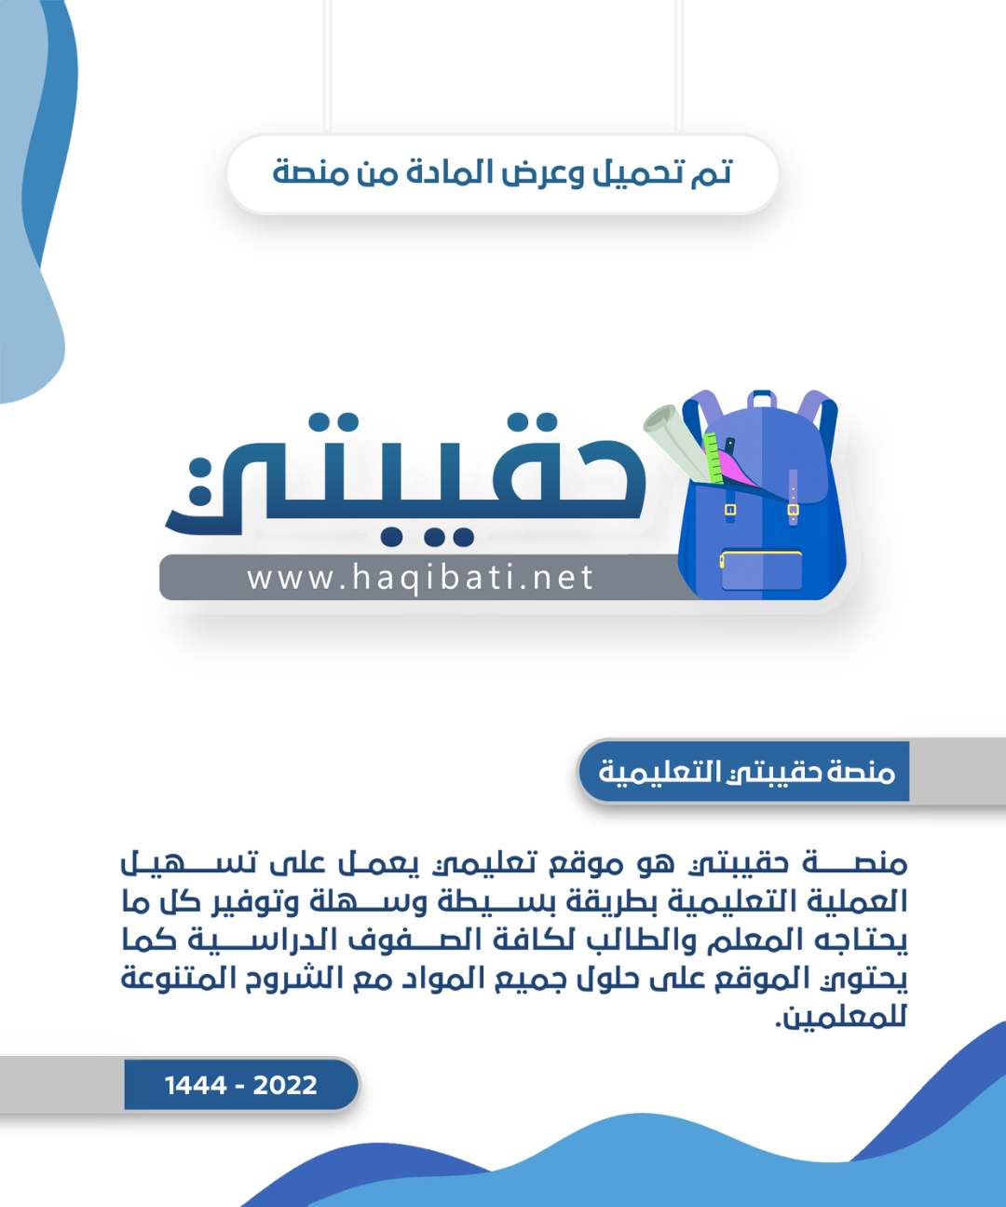

**First Term Kingdom of Saudi Arabia**

**First Intermediate grade Ministry of Education**

**English Language Time : 90 minutes**

**اسم الطالب: ............................................................................. رقم الجلوس:.......................................**

|  |  |  |  |  |  |  |  |
| --- | --- | --- | --- | --- | --- | --- | --- |
|  | **الدرجة** | **المصحح** | **التوقيع** | **المراجع** | **التوقيع** | **الدرجة النهائية** | |
| **السؤال الأول** |  |  |  |  |  | **رقماً** | **كتابة** |
| **السؤال الثاني** |  |  |  |  |  |  |  |
| **السؤال الثالث** |  |  |  |  |  |
| **السؤال الرابع** |  |  |  |  |  | **المدقق** | **التوقيع** |
| **السؤال الخامس** |  |  |  |  |  | **(لجنة التدقيق)** |  |
| **امتحان listening** |  |  |  |  |  |  |  |
| **المجموع** |  |  |  |  |  |  |  |

**I - { Composition }**

1. **Write a short paragraph of six sentences on: (yourself):**

**6**

|  |
| --- |
| **Name**: Ali |
| **Age**:13 |
| **Nationality**: Saudi |
| **Favorite hobby**: Reading |
| **Favorite sport**: football |
| **Favorite subject**: English |

……………………………………………………………………….

…………………………………………………………………………………………………………………………………………………………………………………………………………………….……………………………………………………………………………………………………………………………………………………………………........................................................................................................................................................................................................................................................................………………………………………………………………………………………………......................................................................................................................................................................................................................................................................................................................................................................................................................................................................................................................................................................................................................................................

**Page 2**

**II- { Reading Comprehension }**

**6**

**Kingdom of Saudi Arabia**



**Ministry of Education**

**Third Year intermediate Exam** **1444 AH**  **Time : 2 hours**

**مدرسة الضاحية الأهلية المتوسطة بنين (الفصل الدراسي الأول ثالث متوسط )** **Eastern Region (English Language**) **اسـم** **الطالب** / ………………………………………… **رقم الجلوس**/............. **Dahia private schools**

**اختبار الفصـــل الدراســي الأول للعــام الـدراســي 1444هـــ (ثالث متوسـط )**

1. **Read the following passage, then answer the questions below:**

Sami is a great doctor. He lives in Riyadh . He works in King Faisal Hospital. He has a beautiful wife and 5 wonderful children. His house is big. It is white. There is a garden in the house. His children like football. They play football in the garden. The house is opposite a bog mosque . He and many people pray in the mosque. He goes to the hospital by car.

**A) Answer The following questions:**

1- What does Sami live?

…………………………………………………………………………………………………

2- What color is his house?

…………………………………………………………………………………………………

**B)- Choose the correct answer:**

1-Sami has ………..… children (**five – six - seven**)

2- Sami’s house is ………a big mosque (**next to –near - opposite**)

**C- Put (T) or (F):**

1- Sami goes to the hospital by bike . ( )

2.Doctors work in hospital. ( )

**III {Grammar}**

**7**

**(A)Choose the correct answer between brackets :**

1. ……………Sultan Ahmed a teacher?
2. **Is b- Are c- Were d- Can**
3. I am student. …………………….name's Samir.
4. **My b- Your c- His d- Her**
5. This is ……………. washing machine.
6. **a b- an c- that d- those**
7. Her final test is ………………. May 15th.
8. **on b- in c- at d- of**

**(B) Do as shown between brackets:** -

1 –He is a student.  **(Negative)**

……………………………………………………….

2 – They are at school.  **(Make a question)**

**……………………………………………………………..**

3- Sunday, Monday,……………. , Wednesday **(Complete)**

**Page 3**

**IV – { Vocabulary }**

**7**

**(A) Fill in each space with a word from the following list:-**

[sunday – Nice–first]

1. …………..….to meet you, Asma.
2. Today is Saturday. Tomorrow is………………..
3. January is the ……………..month of the year.

**(B) Circle the correct answer:-**

1-There are ………………….days in the weeks

**a-three b- four c- seven d- five**

2-I am from Saudi Arabia. I'm ……………

**a- British b- Mexican c- Saudi d- Egyptian**

3-My final test is ………September.

**a- in b- on c- at d- to**

4-…………….day is today? It's Sunday

**a-What b- Where c- When d- Why**

**V- {Orthography}**

**4**

**Match Column (A) with its meaning in Column (B):-**

|  |  |
| --- | --- |
| **( A )** | **( B )** |
| 1- crayon | ( …….. ) write |
| 2- pencil | ( ……. ) erase |
| 3- eraser | ( ……. ) color |
| 4- scissors | ( ……. ) clean |
|  | ( ……. ) cut |

انتهت الأسئلة *

**معد الأسئلة أ /**

**التوقيع :**

\***Good luck\***

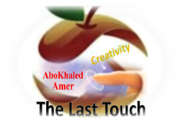

##### 

##### **وزارة التعليم**

**الإدارة العامة للتعليم بمنطقة -------**

**مجمع مدارس --------------------- ( بنين )**

**اختبارات نهاية الفصل الدراسي الأول 1445هـ**

|  |  |  |
| --- | --- | --- |
| **المادة:**  **لغة انجليزية** | **الصف: الأول المتوسط رقم الجلوس : ( )** | **الزمن:**  **ساعتان** |
| **اسم الطالب: ................................................................................................................................................** |

|  |  |  |  |  |  |  |  |
| --- | --- | --- | --- | --- | --- | --- | --- |
| **Total**  **written** | **5 spelling** | **4 Vocabulary** | **3 Grammar** | **2 Comprehension** | | **1 Composition** | **Q. NO.** |
|  |  |  |  |  | |  | **Mark Given** |
| **30** | **4** | **7** | **7** | **6** | | **6** | **Mark** |
|  | | | **Reviser** | |  | | **Corrector** |
|  | |

[**https://t.me/abokhaledamer**](https://t.me/abokhaledamer)

**0557325813**

**Composition**

**6**

**1- Write a paragraph about “Yourself"**

**\* Who are you? * How old are you? * Where are you from? * What's your nationality?**

**\* What subjects do you like? * What sports do you play? * What do you want to be?**

…………………………………………

………………………………………………………………………………………………………………………………………………………………………………………………………………………………………………………………………………………………………………………………………………………………………………………………………………………………………………………………………………………………………………………………………………………………………………………………………………………………………………………………………………………………………………………………

**2) Comprehension**

**6**

**2- Read the following passage then answer the questions:**

**Nada is a student. She is 13 years old. She is from Najran. She is very active girl. She loves museums. Last Monday, she visited Al OKHDOOD MUSEUM. She saw old things.**

**A- Put ( ) or ( x ):**

**1. Nada is a teacher. ( )**

**2. She is from Najran. ( )**

**B- Choose the correct answer:**

**1. She visited the museum on (**Saturday – Monday – Friday**).**

**2. She saw (**new – old – bad**) things old.**

**C- Answer the following questions:**

**1. Is she active girl?**

.....................................................................

**2. What did she visit?**

...................................................................

**3) Grammar**

**A: Choose the correct answer:**

**7**

**1. I (**am – is – are**) very happy.**

**2. This is my brother. (**Her – His – My**) name is Ali.**

**3. English classes are (**in – on – at**) Mondays and Wednesdays.**

**4. (**Who – How – What**) old are you?**

**5. This (**am – is – are**) my pencil.**

**6. (**Isn’t – Doesn’t – Don’t**) buy that painting.**

**7. Mr. Omar is here (**in – on – at**) business.**

**8. (**When – What – Where**) are you from?**

**9. I (**have – has – is**) a sister.**

**10. Do you have (**a – any – some**) brothers and sisters?**

**B: Do as shown between brackets:**

**1. She is Nora. (**Make Negative**)**

……………………………………………………………………………………………………………………………………

**2. What day is today? (**Answer the question**)**

……………………………………………………………………………………………………………………………………

**3. That is --------- calculator. (**Put indefinite article a / an**)**

……………………………………………………………………………………………………………………………………

**4. She is from Saudi Arabia. (**Make Yes/No Question**)**

……………………………………………………………………………………………………………………………………

**4) vocabulary:**

**7**

**A- Write the correct number under its picture:**

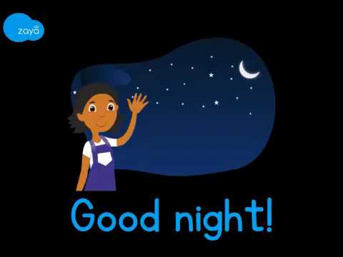**1. camera 2. parrot 3. family 4. scissors 5. reindeer 6. headphones 7. night**

****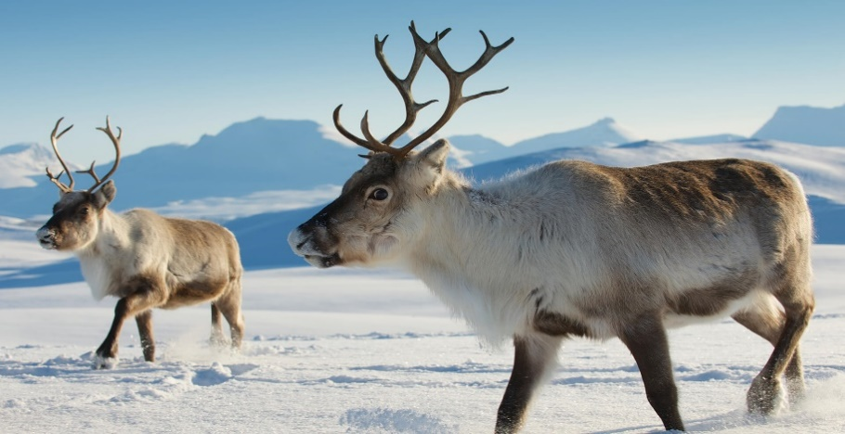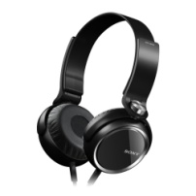

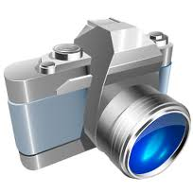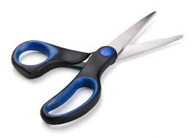

**( ) ( ) ( ) ( ) ( ) ( ) ( )**

**B- Match the Real Talk:**

**1. I’ve got a. Not very much**

**2. Not really b. I have**

**3. Guess what? c. A reply to “Thank you.”**

**4. You’re welcome d. tell a surprise**

**C- Circle the correct spelling:**

**1. skelton - skeltan – skeleton**

**2. family – familiy - famliy**

**3. vacotion – vacation – vecation**

**5) Orthography**:

**4**

**A- Fill in the missing letters:**

**1. m__rning**

**b – r – o – u**

**2. num__ers**

**3. muse__m**

**4. wo__ld**

**B- Circle the odd one out:**

**1. morning afternoon evening school**

**2. father mother Jeddah sister**

**3. doctor Brazil Egypt Canada**

**4. Sunday Mom Monday Tuesday**



**End of Questions**

[**https://t.me/abokhaledamer**](https://t.me/abokhaledamer)

**0557325813**

**Best of Luck**

المملكة العربية السعودية الصف: الأول متوسط

وزارة التعليم الفصل الدراسي: الأول

الإدارة العامة للتعليم بمحافظة الليث العام الدراسي 1445 هـ

مدرسة متوسطة وثانوية حفار الزمن: ساعة ونصف

**الاختبار النهائي لمادة اللغة الإنجليزية – الصف الأول متوسط – الفصل الدراسي الأول (الدور الأول) لعام 1445 هـ**

**عزيزتي الطالبة:**

* **استعيني بالله ثم اجيبي عن الأسئلة**
* **فضلا تأكدي من كتابة اسمك الرباعي ورقم الجلوس**
* **الإجابة باللون الأزرق فقط**

|  |  |  |  |
| --- | --- | --- | --- |
| **اسم الطالبة رباعيا** |  | | |
| **رقم الجلوس:** | | **الصف: الأول متوسط** | **المادة: اللغة الإنجليزية** |
| **اليوم:** | **التاريخ: / / 1445 هـ** | | |

|  |  |  |  |  |  |
| --- | --- | --- | --- | --- | --- |
| **المدققة وتوقيعها** | **المراجعة وتوقيعها** | **المصححة وتوقيعها** | **الدرجة كتابة** | **الدرجة رقما** | **السؤال** |
|  |  |  |  |  | **Guided**  **Composition** |
|  |  |  |  |  | **Reading Comprehension** |
|  |  |  |  |  | **Grammar** |
|  |  |  |  |  | **Vocabulary** |
|  |  |  |  |  | **Orthography** |
|  |  |  |  | **30** | **المجموع** |

Kingdom of Saudi Arabia 1st Intermediate Grade

Ministry of Education Time: An hour and a half

Hifar Intermediate and Secondary School Number of papers: 3

Final Exam – First Term - 1445 AH

1. **Guided Composition:**

**6**

“I am who I am!”. Use the following word bank to write a paragraph about

your ***yourself.***

**Word bank:** (years old – from – Saudi – student – like – live – favourite)

________________________

__________________________________________________________________________________________________________________________________________________________________________________________________________________________________________________________________________________________________________________________________________________________________________________________________________________________________________________________________________________________________________________________________________________________________________________________

**6**

1. **Reading Comprehension:**

***Read the passage and answer the questions below:***

My name is Jana. I have a friend. My friend lives in London. Her name is Jessica Roberts. She is seventeen years old. She likes to read. She is a good reader. She is smart so she is good at math. It is her best subject. I like to eat lunch with her. **We** eat lunch on Monday, Tuesday, and Wednesday. I like her a lot.

1. **Answer the following question:**
2. **Where does Jessica live?**

………………………………………………

1. **Choose the correct answer:**
2. This text is about:

|  |  |  |  |
| --- | --- | --- | --- |
| 1. Jana’s pet | 1. Jana’s school | 1. Jana’s friend | 1. Jana’s family |

1. Jessica Roberts is ………………… years old.

|  |  |  |  |
| --- | --- | --- | --- |
| 1. 7 | 1. 17 | 1. 70 | 1. 71 |

1. Jessica’s hobby is …………………

|  |  |  |  |
| --- | --- | --- | --- |
| 1. reading | 1. drawing | 1. swimming | 1. cooking |

1. **Smart** means:

|  |  |  |  |
| --- | --- | --- | --- |
| 1. happy | 1. sad | 1. sleepy | 1. intelligent |

1. **We** in line **3** refers to:

|  |  |  |  |
| --- | --- | --- | --- |
| 1. Jana&Jessica | 1. Jana | 1. Jessica | 1. math teacher |

1. **Check ( T ) or ( F ):**
2. Jessica likes math. ( )
3. Jana and Jessica have lunch together on weekends. ( )
4. Jana’s friend last name is Roberts. ( )
5. Jana’s friend is a girl. ( )
6. Jana and Jessica have lunch together two times a week. ( )

**7**

1. **Grammar:**
2. **Choose the correct answer:**
3. Mr. Omar ……… a teacher.

|  |  |  |  |
| --- | --- | --- | --- |
| 1. Am | 1. is | 1. are | 1. can |

1. I am Lora. This is ……… mother.

|  |  |  |  |
| --- | --- | --- | --- |
| 1. Your | 1. his | 1. our | 1. my |

1. …………. is your name?

|  |  |  |  |
| --- | --- | --- | --- |
| 1. Why | 1. How | 1. What | 1. Where |

1. I have an appointment with the dentist ……… Monday.

|  |  |  |  |
| --- | --- | --- | --- |
| 1. in | 1. on | 1. at | 1. from |

1. …………. are my keys.

|  |  |  |  |
| --- | --- | --- | --- |
| 1. This | 1. Them | 1. These | 1. That |

1. ………… sun rises in the east and sets in the west.

|  |  |  |  |
| --- | --- | --- | --- |
| 1. A | 1. An | 1. The | 1. Ø |

1. Mr. Ali is here ………. business.

|  |  |  |  |
| --- | --- | --- | --- |
| 1. in | 1. on | 1. from | 1. at |

1. **A:** Are they Chinese?

**B:** No, …………….

|  |  |  |  |
| --- | --- | --- | --- |
| 1. not they are | 1. are they | 1. they are not | 1. they no are |

1. Hanan ……… a big house.

|  |  |  |  |
| --- | --- | --- | --- |
| 1. has | 1. have | 1. am | 1. are |

1. This is ………… book.

|  |  |  |  |
| --- | --- | --- | --- |
| 1. Amal | 1. Amal’s | 1. Amals | 1. Amals’ |

1. **Do as shown between brackets:**
2. This is my sister. **His** name is Nada. **(Correct the mistake)**

…………………………………….

1. **(Use a or an)**

* …….. egg
* …….. car

1. Can you open the window? **(Agree)**

……………………………………

1. **Vocabulary**:

**7**

1. **Write the words under the pictures:**

**scissors – turtle – married – radio – tourist**

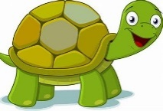

___________ ___________ ___________ ___________

1. **Classify the words:**

**parrot – pencil – skeleton – niece**

|  |  |  |  |
| --- | --- | --- | --- |
| **Family** | **School Supplies** | **Animals** | **Museum Items** |
|  |  |  |  |

1. **Choose the correct answer to fill in the blank in each question:**
2. **‘enormous’** means:

|  |  |  |  |
| --- | --- | --- | --- |
| 1. very small | 1. very big | 1. new | 1. single |

1. A …………. is the son or daughter of an uncle or aunt.

|  |  |  |  |
| --- | --- | --- | --- |
| 1. nephew | 1. brother | 1. wife | 1. cousin |

1. August is the ………… month of the year.

|  |  |  |  |
| --- | --- | --- | --- |
| 1. first | 1. eighth | 1. second | 1. fourth |

1. We ……….. with crayons.

|  |  |  |  |
| --- | --- | --- | --- |
| 1. color | 1. cut | 1. cook | 1. read |

1. **Circle the odd word:**
2. morning – afternoon – husband – night
3. Bye – Hello – See you later – Take care

1. **Orthography:**

**4**

1. **Choose the correctly spelled word:**
2. sester – sister – sistar – sestar
3. headphones – headfones – hedfones – hedphones
4. langewge – langoege – language – langwge
5. Novambar – November – Nofambar – Noovamber
6. **Complete the missing letters:**
7. They went to Euprope on **va__ation**.
8. The child lost his **t__y.**
9. I want to be a science **teach__r.**
10. I usually eat at home with my **fami__y.**

**END OF QUESTIONS**

**BEST OF LUCK**

**Ms. Tahani AlGhamdi**