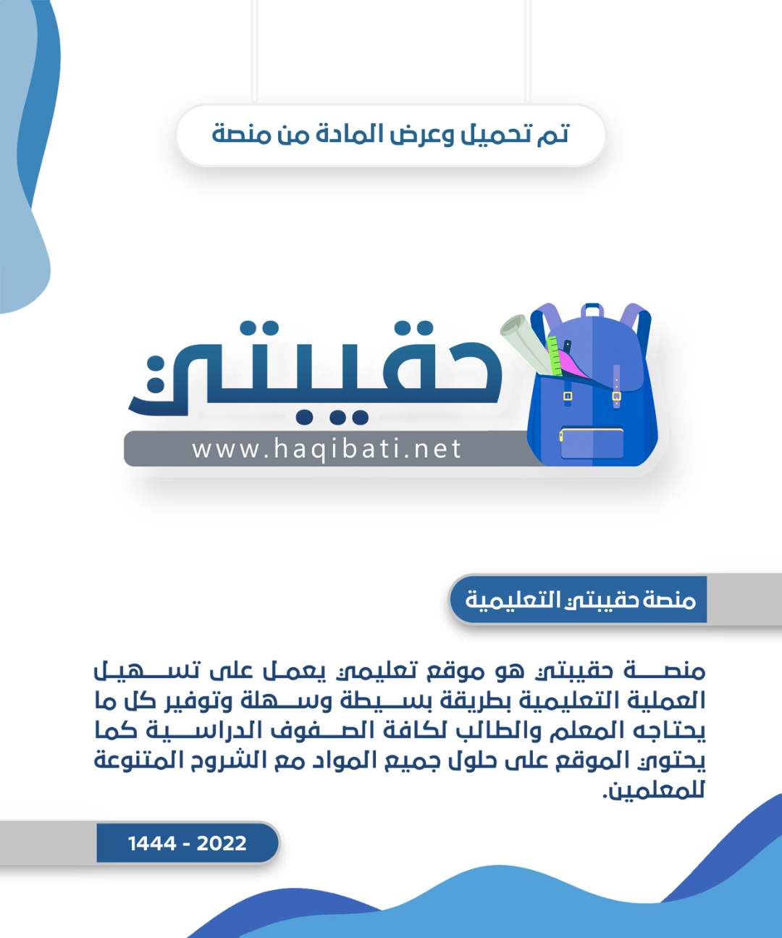







**الاختبار النهائي لمادة اللغة الانجليزية الفصل الدراسي الاول الدور الاول للعام الدراسي 1445هـ**

**اسم الطالبة:........................................................... الصف :الثالث متوسط ( )**

**رقم الجلوس :....................................................**

**اليوم :....................................... التاريخ : \ \ 1445هـ عدد الصفحات : 3**

**"اللهم لا سهل إلا ما جعلته سهلا و انت تجعل الحزن إذا شئت سهلا"**

|  |  |  |  |  |  |  |  |  |  |  |
| --- | --- | --- | --- | --- | --- | --- | --- | --- | --- | --- |
| **signature** | **Checked by** | **signature** | **The reviser** | **signature** | **The corrector** | **Student’s Mark Written** | **Student`s Mark Number** | **Question** | | **Number** |
| **Mark** | **Question** |
|  |  |  |  |  |  |  |  | **6** | **Guided composition** | **Q1** |
|  |  |  |  |  |  |  |  | **6** | **Reading Comprehension** | **Q2** |
|  |  |  |  |  |  |  |  | **7** | **Grammar** | **Q3** |
|  |  |  |  |  |  |  |  | **7** | **Vocabulary** | **Q4** |
|  |  |  |  |  |  |  |  | **4** | **Orthography** | **Q5** |
|  |  |  |  |  |  |  |  | **30** | **Total** | |
|  |  |  |  |  |  |  |  | **10** | **Listening and speaking** | |
|  |  |  |  |  |  |  |  | **40** | **Total** | |

**Q1:Guided Composition:**

**6**

Write a paragraph about **( your lifestyle )** you can use these guide words

( name – wake up – brush – on time – help – watch – sleep )

……………………………………………………………………..

……………………………………………………………………………………………………………………………………………………………………………………….……………………………………………………………………………………………………………………………………………………………………………………………………………………………………………………………………………………………………………………………………………………………………………………………………………………………………………………………………………………………………………………………………………………………………………………………………………………………………………………………………………………………………………………………………………………………………………………………………………………………………………………………………………………………………………………………………………………………………………………………………………………………………………………………………………………………………………………………………………………………………………………………………………………………………………………………………………………………………………………………………………………………………………………………………………………………………………………………...

**Q2:Reading Comprehension:**

**6**

**Read the following passage then answer the question below:-**

Ahmed has got a small shop .Everyday he goes to the shop at six o’clock in the morning .There are eggs, milk, fruit and cheese at the Shop. Every Sunday he closes his shop and goes to e farm to buy new things for his shop .People come to Ahmed’s shop to buy there things because he has clean and new things. they like Ahmed. He is a good Shopkeeper .Ahmed comes back home at eleven o’clock at night .He has Dinner and goes to bed.

**A: Tick ( ) or (X):**

1-People don’t like Ahmed. ( )

2-Faud goes to bed very late. ( )

3-Oranges and apples are fruit. ( )

**B: Choose the correct answer:**

1- Ahmed ------------------ his shop every Sunday.

a) opens b) closes c) goes

2- I have fish for --------------------- tonight.

a) breakfast b)lunch c) dinner

3- we can keep tame animal on the ----------------------

a)shop b) form c)bed

**1**

***Q3:Grammar:***

***A:Choose the correct answer:***

**7**

1-I always ( do – does – doing ) my homework in the afternoon.

2-(Neither – all – both ) of them is a teacher.

3- Ali is ( write – wrote – writing ) the lesson.

4-There is ( some – any – a ) juice.

***B- Do as shown between brackets:***

1-He is going to Paris to **studying** French. **( correct )**

………………………………………………………………………………………………………

2-Omar will go to school tomorrow. **( make a negative )**

……………………………………………………………………………………………………

3-you \ need \ do \ eggs \ ? **(use How many )**

…………………………………………………………………………………………………….

***Q4:Vocabulary:***

***A:Find the ode words:***

**7**

1-Salmon – crab – taxi

2-Car – carrot – onion

3-Beef – spoon - chicken

4-mango – orange – pen

***B:Write the correct word under each picture:***

Salad – shrimp – suitcase – passport – infant – cheese – cheesecake

|  |  |  |  |  |  |
| --- | --- | --- | --- | --- | --- |
|  |  |  |  |  |  |
|  |  |  |  |  |  |

**2**

***Q5:Orthography***

***A:Choose the missing letter:***

**4**

1-toma__oes ( t – r – q ) 3-pi__ot ( r – m – l )

2-a__ocado ( r – v – x ) 4-gy__ ( m – t – k )

***B-Write the missing letter:***

r - t - g - u - m

|  |  |  |  |
| --- | --- | --- | --- |
|  |  |  |  |
| Yogu__t | S__eak | Bagga__e | so__p |

**3**

**Tr.Najah Aljuhani**

**Good luck**

المملكة العربية السعودية الصف: الثالث متوسط

وزارة التعليم الفصل الدراسي: الأول

الإدارة العامة للتعليم بمحافظة الليث العام الدراسي 1445 هـ

مدرسة متوسطة وثانوية حفار الزمن: ساعة ونصف

**الاختبار النهائي لمادة اللغة الإنجليزية – الصف الثالث متوسط – الفصل الدراسي الأول (الدور الأول) لعام 1445 هـ**

**عزيزتي الطالبة:**

* **استعيني بالله ثم اجيبي عن الأسئلة**
* **فضلا تأكدي من كتابة اسمك الرباعي ورقم الجلوس**
* **الإجابة باللون الأزرق فقط**

|  |  |  |  |
| --- | --- | --- | --- |
| **اسم الطالبة رباعيا** |  | | |
| **رقم الجلوس:** | | **الصف: الثالث متوسط** | **المادة: اللغة الإنجليزية** |
| **اليوم:** | **التاريخ: / / 1445 هـ** | | |

|  |  |  |  |  |  |
| --- | --- | --- | --- | --- | --- |
| **المدققة وتوقيعها** | **المراجعة وتوقيعها** | **المصححة وتوقيعها** | **الدرجة كتابة** | **الدرجة رقما** | **السؤال** |
|  |  |  |  |  | **Guided**  **Composition** |
|  |  |  |  |  | **Reading Comprehension** |
|  |  |  |  |  | **Grammar** |
|  |  |  |  |  | **Vocabulary** |
|  |  |  |  |  | **Orthography** |
|  |  |  |  | **30** | **المجموع** |

Kingdom of Saudi Arabia 3rd Intermediate Grade

Ministry of Education Time: An hour and a half

Hifar Intermediate and Secondary School Number of papers: 3

Final Exam – First Term - 1445 AH

1. **Guided Composition:**

**6**

You plan to go on a trip during the coming vacation. Use the following word bank

to write a paragraph about your ***trip.***

**Word bank:** (leave – stay – restaurant – plane – museums – travel – excited)

________________________

__________________________________________________________________________________________________________________________________________________________________________________________________________________________________________________________________________________________________________________________________________________________________________________________________________________________________________________________________________________________________________________________________________________________________________________________

**6**

1. **Reading Comprehension:**

***Read the passage and answer the questions below:***

Nelly is a nurse. She is tall and thin. She works at the hospital. She looks after sick people. She gets up at six o’clock in the morning. She takes a shower and puts on her clothes. Then, she eats breakfast at half past six. At seven o’clock, she drives her car to the hospital. Nelly starts work at eight o’clock. She cleans the rooms in the hospital. Then, **she** helps the doctors. At twelve o’clock, she has lunch. She goes home at five o’clock. At home, she takes a shower and cooks dinner. She has dinner at half past six in the evening. Then, she watches TV at ten o’clock. She goes to bed.

1. **Answer the following question:**
2. **When does Nilly watch TV?**

………………………………………………

1. **Check ( T ) or ( F ):**
2. This text is about Nelly’s daily routine. ( )
3. Nelly takes a shower once a day. ( )
4. Nelly works for three hours. ( )
5. Nelly wears her clothes before breakfast. ( )
6. Nelly likes to read novels before sleeping. ( )
7. **Choose the correct answer:**
8. Nelly goes to her work ………

|  |  |  |  |
| --- | --- | --- | --- |
| 1. by bus | 1. on foot | 1. by car | 1. by bike |

1. Nelly has breakfast at ……….

|  |  |  |  |
| --- | --- | --- | --- |
| 1. 6:45 | 1. 6:30 | 1. 6:15 | 1. 6:00 |

1. Nelly has dinner ………….

|  |  |  |  |
| --- | --- | --- | --- |
| 1. at home | 1. at work | 1. in the mall | 1. at restaurant |

1. **look after** means:

|  |  |  |  |
| --- | --- | --- | --- |
| 1. see | 1. take care | 1. watch | 1. go |

1. **She** in line **5** refers to:

|  |  |  |  |
| --- | --- | --- | --- |
| 1. doctor | 1. rooms | 1. Nelly | 1. sick people |

1. **Grammar:**

**7**

1. **Choose the correct answer:**
2. Maram usually …….. a haircut every two months.

|  |  |  |  |
| --- | --- | --- | --- |
| 1. get | 1. gets | 1. got | 1. getting |

1. Rana and Huda are friends. ……….. of them is a teacher.

|  |  |  |  |
| --- | --- | --- | --- |
| 1. Both | 1. All | 1. Neither | 1. None |

1. Jana ……. tennis yesterday.

|  |  |  |  |
| --- | --- | --- | --- |
| 1. play | 1. plays | 1. played | 1. playing |

1. I am going on vacation ……. August.

|  |  |  |  |
| --- | --- | --- | --- |
| 1. in | 1. on | 1. at | 1. from |

1. Maybe I …………. early in the morning.

|  |  |  |  |
| --- | --- | --- | --- |
| 1. leave | 1. leaves | 1. will leave | 1. leaving |

1. Muslims walk ………... the Kabah.

|  |  |  |  |
| --- | --- | --- | --- |
| 1. across | 1. around | 1. through | 1. up |

1. Hana is staying up late ……. her homework.

|  |  |  |  |
| --- | --- | --- | --- |
| 1. do | 1. does | 1. did | 1. to do |

1. I am studying English ……. I love languages.

|  |  |  |  |
| --- | --- | --- | --- |
| 1. so | 1. because | 1. to | 1. first |

1. He cut …… yesterday.

|  |  |  |  |
| --- | --- | --- | --- |
| 1. myself | 1. herself | 1. himself | 1. yourself |

1. There are …….. monkeys at the zoo.

|  |  |  |  |
| --- | --- | --- | --- |
| 1. a little | 1. a few | 1. much | 1. any |

1. **Do as shown between brackets:**
2. Is there **something** I can help you with? **(Correct the mistake)**

…………………………………….

1. Deema visited her uncle last weekend. **(Make a Yes/No question)**

…………………………………….

1. Yara washes the dishes after dinner. **(Use ‘often’)**

…………………………………

1. **Vocabulary**:

**7**

1. **Write the words under the pictures:**

**condiment – vaccination – infant – vegetarian**

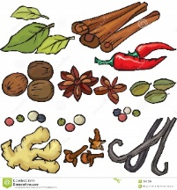

___________ ___________ ___________ ___________

1. **Classify the words:**

**watermelon – shrimp – parsley - cheese**

|  |  |  |  |
| --- | --- | --- | --- |
| **Vegetables** | **Fruit** | **Dairy Products** | **Seafood** |
|  |  |  |  |

1. **Choose the correct answer to fill in the blank in each question:**
2. **‘unique’** means:

|  |  |  |  |
| --- | --- | --- | --- |
| 1. learn | 1. special | 1. tradition | 1. busy |

1. I want to study ……….. in Canada.

|  |  |  |  |
| --- | --- | --- | --- |
| 1. encourage | 1. proud | 1. abroad | 1. pizza |

1. I …….. my mailbox every five days.

|  |  |  |  |
| --- | --- | --- | --- |
| 1. check | 1. leave | 1. flight |  |

1. Khaled regularly chats online. He is an ……………..

|  |  |  |  |
| --- | --- | --- | --- |
| 1. chef | 1. teacher | 1. employee | 1. internet addict |

1. **Circle the odd word:**
2. grill – rice – fry – steam
3. ticket – passport – stranger – boarding pass

1. **Orthography:**

**4**

1. **Choose the correctly spelled word:**
2. ingrediant – ingredient – engredient – ingrebient
3. leedership – leadarship – leadershib – leadership
4. challenging – chalenging – shallenging – challenjing
5. ibentify – iddentify – identify – identefy
6. **Complete the missing letters:**
7. She tried her best to **sol__e** the problem.
8. You did an **outsta__ding** job on the project.
9. The city has a warm **clim__te**.
10. Sara needs some **lett__ce** and tomatoes to make a salad.

**END OF QUESTIONS**

**BEST OF LUCK**

**Ms. Tahani AlGhamdi**



##### 

##### **وزارة التعليم**

**الإدارة العامة للتعليم بمنطقة ----------**

**مجمع مدارس ------------------- ( بنين )**

**اختبارات نهاية الفصل الدراسي الأول 1445هـ**

|  |  |  |
| --- | --- | --- |
| **المادة:**  **لغة انجليزية** | **الصف: الثالث المتوسط رقم الجلوس : ( )**  [**https://t.me/abokhaledamer**](https://t.me/abokhaledamer)  **0557325813** | **الزمن:**  **ساعتان** |
| **اسم الطالب: ................................................................................................................................................** |

|  |  |  |  |  |  |  |  |
| --- | --- | --- | --- | --- | --- | --- | --- |
| **Total**  **written** | **5 spelling** | **4 Vocabulary** | **3 Grammar** | **2 Comprehension** | | **1 Composition** | **Q. NO.** |
|  |  |  |  |  | |  | **Mark Given** |
| **30** | **4** | **7** | **7** | **6** | | **6** | **Mark** |
|  | | | **Reviser** | |  | | **Corrector** |
|  | |

1) **Composition**

**1- Write a paragraph about “Your Life Story"**

**You may answer these questions:**

**Where and when were you born? Where were you raised and educated?**

**Who do you live with? What do you like to be?**

…………………………………………

………………………………………………………………………………………………………………………………………………………………………………………………………………………………………………………………………………………………………………………………………………………………………………………………………………………………………………………………………………………………………………………………………………………………………………………………………………………………………………………………………………………………………………………………

**6**

**2) Comprehension**

**2- Read the following passage then answer the questions:**

Mohamed and his family were in London last week. It was very expensive. They stayed in a hotel for three days. Then they took an apartment. Mohamed stayed there until Friday. He flew back home last night. His father is still there. His mother is with his father. Next week, Mohamed is going somewhere else.

**A- Put ( ) or ( x ):**

**1. Mohamed and his family were in Paris. ( )**

**2. Staying in London was cheap. ( )**

**3. Mohamed flew back home last night. ( )**

**4. Next month, Mohamed is going somewhere else. ( )**

**5. The apartment was cheaper than the hotel. ( )**

**B- Choose the correct answer:**

**1. He stayed there until (**Friday – Saturday – Sunday**).**

**2. Mohamed and his family were in London last (**year – week – day).

**3. They took an (**hotel – apartment – house**).**

**4. Next (**week – holiday – day**), Mohammad is going somewhere else.**

**C- Answer the following questions:**

**1. Where were Mohamed and his family last week?**

----------------------------------------------------------------.

**2. How long did they stay in a hotel?**

----------------------------------------------------------------.

**3. Who stayed in London?**

----------------------------------------------------------------.

**3) Grammar**

**7**

**A: Choose the correct answer:**

**1. I rarely (**drink – drinks – drinking**) coffee.**

**2. How (**old – many – often**) do you use your cell phone?**

**3. I (**am – were – was**) born in Najran.**

**4. When I was little, I (**uses to – use to – used to**) play with toys.**

**5. My friends are (**waited – waiting – wait**) for me at the airport**

**6. Maybe I (**was – am going to – will**) stay with friends.**

**7. How (**many – much – often**) bananas do you eat?**

**8. I don’t have (**something – nothing – anything**) for lunch.**

**B: Do as shown between brackets:**

**1. How (many) milk do you drink? (Correct)**

**------------------------------------------------------------------------------------------**

**2. I eat a little seafood. (Change into Negative)**

**------------------------------------------------------------------------------------------**

**3. What – doing – you – are – tonight? (Rearrange)**

**------------------------------------------------------------------------------------------**

**4. He is going to travel this year. (Make Yes/No Question)**

**------------------------------------------------------------------------------------------**

**5. His parents were (marry) in Tabuk. (Correct the verb)**

**------------------------------------------------------------------------------------------**

**6. Ibrahim constantly talks on the phone. (rarely)**

**------------------------------------------------------------------------------------------**

**4) vocabulary:**

**7**

**A- Write the correct number under its pictures:**

**1.cell phone 2.avocado 3.suitcase 4.vegetarian 5.plane 6. blood**

****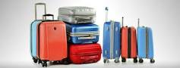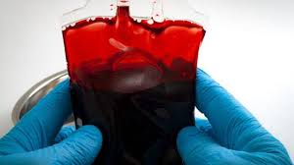****

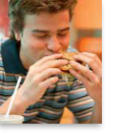

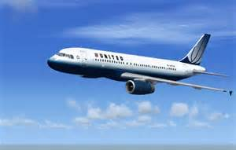

**……………. ……………. ……..……. ………..…… …………… …………..**

**B- Match the answers:**

|  |  |  |
| --- | --- | --- |
| **a. in some ways / slightly** | **1. turn (someone) off** | ------ |
| **b. does not interest at all** | **2. kind of** | ------ |
| **c. a big city** | **3. big break.** | ------ |
| **d. important opportunity** | **4. I can’t wait.** | ------ |
| **e. I am very eager for something.** | **5. metropolis** | ------ |

**C- Circle the correct spelling:**

**1. infent - infont – infant**

**2. abroad – abrood - aproad**

**3. fligt – flight – filght**

**5) Orthography**:

**4**

**A- Fill in the missing letters:**

**1. add__ct**

**z – o – i – r**

**2. bl__od**

**3. airpo__t**

**4. appeti__er**

**B- Choose the odd one out:**

**1. milk coffee school juice**

**2. nurse doctor meat dentist**

**3. always sleep usually sometimes**

**4. funny What When Where**

[**https://t.me/abokhaledamer**](https://t.me/abokhaledamer)

**0557325813**

**End of Questions**

**Best of Luck**