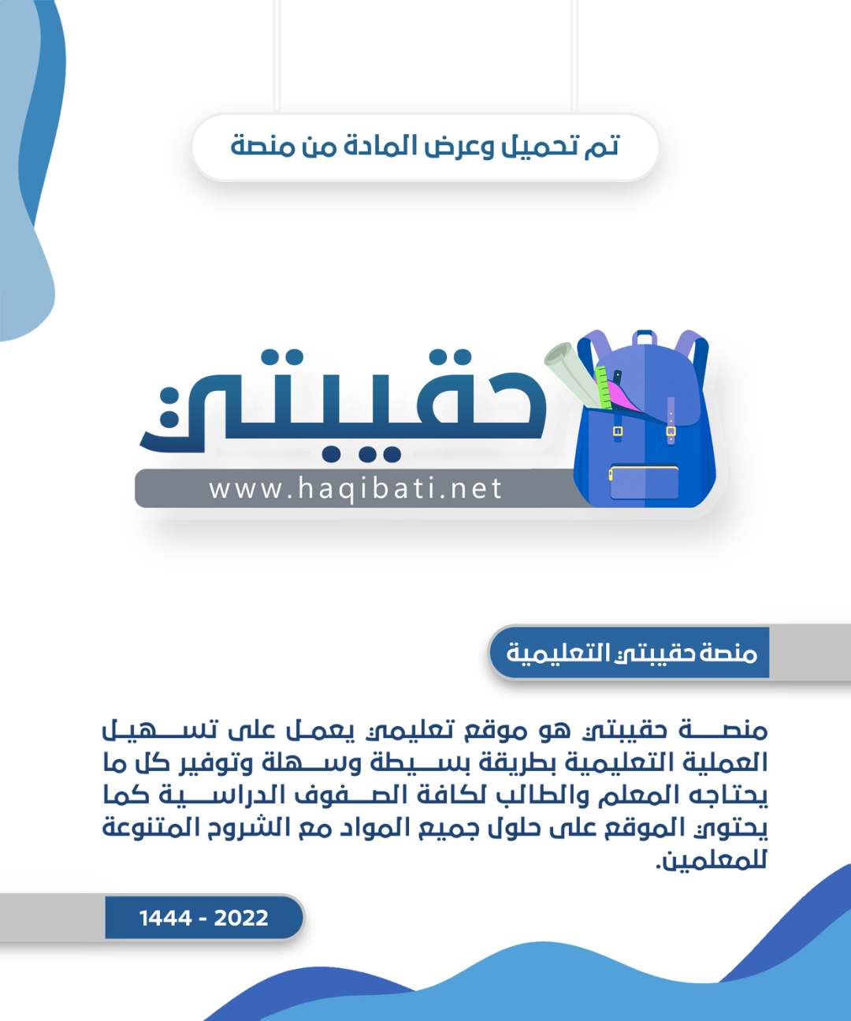



English Language Final Exam

Term: 1 – 1444 Session: 1

Time: 2:30 hrs

Grade: 2 - Mega Goal 2.1

Kingdom of Saudi Arabia

Ministry of Education

__________ Gen. Dept. of Education

__________ Secondary School

|  |  |  |  |
| --- | --- | --- | --- |
| Graded by: | ________________________________________  ________________________________________ |  | Mark out of  30 |
| Revised by: |

**اختبار مادة (اللغة الإنجليزية 2.1- الفصل الدراسي الأول - الدور الأول) للصف الثاني ثانوي - للعام الدراسي 1444هـ - نظام المسارات**

**اسـم الطالب : ___________________________________________________________ رقم الجلوس : ________ اللجنة : ________**

**اللَّهمَّ لا سَهلَ إلَّا ما جَعَلتَه سَهلًا، وأنتَ تَجعَلُ الحَزْنَ إذا شِئتَ سَهلً**

1. **Reading Comprehension**  (1 mark each)

**6**

**Read the following text, and then answer the questions below:**

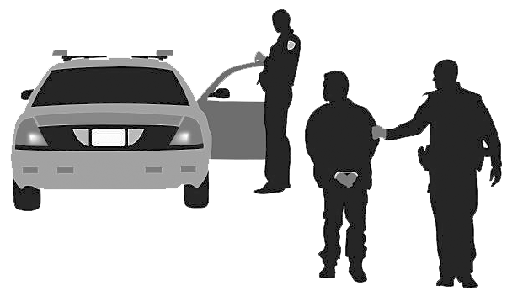 A man had driven to the local grocery store, parked his car, and gone into the store to do some shopping. When he came out of the store, carrying his bags, he saw that his car was missing from the parking lot. He called the police and reported that his car had been stolen. He told the police that he had left his cell phone in the car. The police thought hard about how to use the cell phone to find the stolen car. Finally, one of the police officers had a brilliant idea.

A police officer called the man’s cell phone, and the thief answered the phone. The officer explained that he had seen an advertisement in the newspaper about the car for sale and that he was interested in buying the car. The officer asked a few information questions about the car and arranged a meeting for him to take a look at the car later that day.

A few hours later, the thief drove the car to the meeting place, expecting to be paid for the car that ***he*** had just stolen. He was arrested on the spot and the car was returned to its owner. What a silly criminal!

1. **Where did the man park his car?** ______________________________________
2. **Who called the thief?** ______________________________________
3. **Choose the correct answer**

* The underlined pronoun " ***he***" refers to the _________.

a) car's owner b) thief c) police officer d) reporter

1. **Put ( T ) for true or ( F ) for false sentences :**
2. The car was missing from the owner's house. [______]
3. A day later, the thief went to the arranged meeting place. [______]
4. Calling the thief was an officer's idea. [______]

Page: 1 out of 4

**P.T.O**

1. **Vocabulary** (½ mark each)

**6**

1. **Fill the blanks with the correct words**

**cozy** - **hijack**(**ed**) - **version** - **loner** - **remote**

1. Faisal is a/an ___________________. He likes to spend time by himself.
2. A man stole jewelry then ___________________ a car.
3. Luckily, the hotel provides ___________________ sleeping bags for the guests.
4. I like the software ___________________ of my cell phone.
5. **Match each phrase/expression with its meaning**

|  |  |  |
| --- | --- | --- |
| **Phrase / Expression** |  | **Meaning** |
| 1. get a kick out of |  | 1. disappointment |
| 1. drag |  | 1. overnight |
| 1. easy mark |  | 1. wait |
| 1. hold on |  | 1. enjoy |
|  |  | 1. likely victim |

1. **Write the correct word and its picture**

**igloo** - **contestant** - **networking** - **asthma** - **inmate**

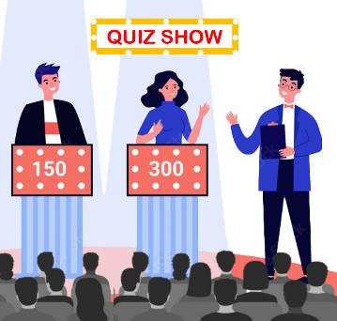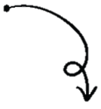

|  |  |  |  |
| --- | --- | --- | --- |
|  |  |  |  |
| ____________ | ____________ | ____________ | ____________ |

Page: 2 out of 4

**P.T.O**

1. **Grammar** (½ mark each)

**6**

1. **Circle the correct answers**

|  |  |  |  |  |  |  |  |
| --- | --- | --- | --- | --- | --- | --- | --- |
| **1)** | He _____________ use his phone every day. | | | | | | |
| a- | don't | b- | doesn't | c- | hasn't | d- | haven't |
| **2)** | The Tv needs to be _____________ | | | | | | |
| a- | fix | b- | fixes | c- | fixed | d- | fixing |
| **3)** | The robber _____________ by the police two days ago. | | | | | | |
| a- | arrest | b- | arrested | c- | was arrested | d- | is arrested |
| **4)** | We _____________ when the robbery took place. | | | | | | |
| a- | were play | b- | were playing | c- | was playing | d- | are playing |
| **5)** | The food _____________ for me. | | | | | | |
| a- | was tasty too | b- | was too tasty | c- | too was tasty | d- | too tasty was |
| **6)** | She _____________ new shoes. | | | | | | |
| a- | going to buy | b- | are going to buy | c- | are going buying | d- | is going to buy |
| **7)** | Sara: _____________ are you doing tonight? **⦁** Nora: I'm **studying** for final exams. | | | | | | |
| a- | What | b- | Where | c- | Who | d- | Why |
| **8)** | He passed _____________. | | | | | | |
| a- | me the salad | b- | the salad me | c- | for me the salad | d- | to me the salad |

1. **Unscramble the** *Comparative Sentence*

* the tallest / Jamal / in his class / student / is

________________________________________________________________

1. **Make it** *Negative*

* We used to go to the gym in the past.

*We* _____________________________ *to the gym in the past*.

1. **Complete with a correct** *Relative Pronoun*

* The popcorn ______________________ I ate made me thirsty.

1. **Circle the** *Indirect Object*

* Jinan translated a text for Amal.

Page: 3 out of 4

**P.T.O**

1. **Composition**
2. **GUIDED COMPOSITION** (6 Marks)

**6**

* **Of no less than (70) words, write about your Favorite Tv Show.**
* Your writing should answer the followings

1. *What is your favorite Tv show?*
2. *What kind of Tv show is it?*
3. *Why do you like it?*
4. *What channel does the TV show air on?*
5. *Give a brief description about it.*

_____________________________________________________________________

_____________________________________________________________________

_____________________________________________________________________

_____________________________________________________________________

_____________________________________________________________________

_____________________________________________________________________

_____________________________________________________________________

_____________________________________________________________________

_____________________________________________________________________

1. **FREE COMPOSITION** (6 Marks)

**6**

* **Choose ONE topic and write a paragraph about it of no less than (50) words.**

1. **Unusual Hotel** you lived in, heard or read
2. Describe Your **Personality**

_____________________________________________________________________

_____________________________________________________________________

_____________________________________________________________________

_____________________________________________________________________

_____________________________________________________________________

_____________________________________________________________________

_____________________________________________________________________

_____________________________________________________________________

Finished & Good Luck

Regards - ___________________

Page: 4 out of 4

Done by: Essa Al Hussaini



English Language Final Exam

Term: 1 – 1444 Session: 1

Time: 2:30 hrs

Grade: 2 - Mega Goal 2.1

Kingdom of Saudi Arabia

Ministry of Education

Riyadh Gen. Dept. of Education

---- Secondary School

|  |  |  |  |  |  |  |  |  |
| --- | --- | --- | --- | --- | --- | --- | --- | --- |
| **اختبار مادة (اللغة الإنجليزية 2.1- الفصل الدراسي الأول - الدور الأول)**  **للصف الثاني ثانوي - للعام الدراسي 1444هـ - نظام المسارات** | | | Composition | | 12 | |  | |
| تصحيح ألي | | 18 | |  | |
| الدرجة كتابة | ……………………………… | Total | | 30 | |  | |
| Corrected by: | ……………………………… | Reviewed by: | | ……………………………… | | | |

**اسـم الطالبة : ______________________________________________________ رقم الجلوس : ________ الفصل : ________**

**اللَّهمَّ لا سَهلَ إلَّا ما جَعَلتَه سَهلًا، وأنتَ تَجعَلُ الحَزْنَ إذا شِئتَ سهلا**

1. Composition

**12**

# ***① Write a paragraph about (Socializing Online or Face to Face ):***

# **Guide words: behavior / technology / combine / expressions / communication /**

# **effort / remote / effective / social skills / dear**

# *Socializing Online or Face to Face*

……………………………………………………………………………………………………………………………………………………………………………………………………

……………………………………………………………………………………………………………………………………………………………………………………………………

……………………………………………………………………………………………………………………………………………………………………………………………………

……………………………………………………………………………………………………………………………………………………………………………………………………

……………………………………………………………………………………………………………………………………………………………………………………………………

……………………………………………………………………………………………………………………………………………………………………………………………………

…………………………………………………………………………………………………………………………………………………………………………………………………………………………………………………………………………………………………………………………………………………………………………………………………………………………………………………………………………………………………………………………………………………………………………………………………………………………………………………………………………………………………………………………………………………………………………………………………………………………………………………………………………………………………………………………………………………………………………………………………………………………

…………………………………………………………………………………………………………………………………………………………………………………………………………………………………………………………………………………………………………………………………………………………………………………………………………

② Write a paragraph about ( **A place in Saudi Arabia** ):

……………………………………………………………………………………………………………………………………………………………………………………………………

……………………………………………………………………………………………………………………………………………………………………………………………………

……………………………………………………………………………………………………………………………………………………………………………………………………

……………………………………………………………………………………………………………………………………………………………………………………………………

……………………………………………………………………………………………………………………………………………………………………………………………………

……………………………………………………………………………………………………………………………………………………………………………………………………

………………………………………………………………………………………………………………………………………………………………………………………………………………………………………………………………………………………………………………………………………………………………………………………………………………………………………………………………………………………………………………………………………………………………………………………………………………

**Page: 1 out of 4**

**P.T.O**

**6**

1. **Reading Comprehension**

Read the following text, and then answer the questions below: ( ½ a mark each)

You have got something that is more complicated than the most powerful computer in the world. With this thing, you can experience the sight and smell of a flower, the memory of holiday, the pain when you hit your thumb with a hammer, the sound of your favourite singer, your thoughts and ideas. All these are possible because of a kilo of cells in your skull: the brain. Your brain controls everything you do. It receives information from your senses about conditions inside and outside your body. Your brain analyses this information with amazing speed and sends out messages that control your body. For example, when you put your hand in very hot water, you think “Oh! That hurts!” and you pull your hand from the water. This is what happens in your brain. Your hand sends a message to your brain: "Very hot!" and your brain immediately sends a message to your hand: “Take your hand out.” Your brain also stores memories of things that happened to you in the past and this makes remembering easy. Finally, your brain controls your lungs, heartbeat, body temperature and the actions of your stomach. The brain cells create and send more messages than all the phones in the entire world. An average person uses only about 10% of the brain’s capacity.

* Choose the correct completion ( Multiple-choice 1- 8 ) ½ a mark for each

|  |  |  |  |  |  |  |  |
| --- | --- | --- | --- | --- | --- | --- | --- |
|  | Your brain stores memories of things that happened to you in the -------- . | | | | | | |
| **A** | past | **B** | present | **C** | future | **D** | tomorrow |
|  | The brain is found in the -------- . | | | | | | |
| **A** | memory | **B** | thumb | **C** | skull | **D** | idea |
|  | According to the text, the brain is made up of -------- . | | | | | | |
| **A** | senses | **B** | cells | **C** | messages | **D** | thoughts |
|  | The brain is more -------- than the most powerful computer in the world. | | | | | | |
| **A** | easy | **B** | simple | **C** | heavy | **D** | complicated |
|  | Your hand sends a ------- to your brain: "Very hot!" | | | | | | |
| **A** | email | **B** | computer | **C** | book | **D** | messages |
|  | Your brain analyses this information with -------- . | | | | | | |
| **A** | spoon | B | speed | **C** | sight | **D** | stomach |
|  | With ------- , you can experience the sight and smell of a flower. | | | | | | |
| **A** | brain | **B** | Lungs | **C** | stomach | **D** | foot |
|  | An average person uses only about ------- of the brain’s capacity. | | | | | | |
| **A** | 10 % | **B** | 1% | **C** | 20 % | **D** | 30 % |

* Put T for true or F for false : ( 1- 4 ) ½ a mark for each

1. [------ ] The brain controls everything you do.
2. [------ ] Your heart controls your lungs, brain, temperature and stomach.
3. [------ ] The brain cells create and send more messages than all phones in the world.
4. [------ ] It receives information from your senses about conditions inside your body only.

**Page: 2 out of 4**

**P.T.O**

**6**

1. **Grammar**

* Circle the correct answers: (½ a mark each)

|  |  |  |  |
| --- | --- | --- | --- |
| 1. They ----------- play football yesterday. | | | |
| 1. don't | 1. doesn't | 1. haven't | 1. didn't |
| 1. Gold is ------------ expensive than silver. | | | |
| 1. more | 1. most | 1. less | 1. least |
| 1. The TV needs to be ------------. | | | |
| 1. fix | 1. fixes | 1. fixed | 1. Fixing |
| 1. The car was ------------ yesterday. | | | |
| 1. break | 1. broken | 1. broke | 1. breaking |
| 1. I was ------------ TV when the phone rang. | | | |
| 1. watch | 1. watch | 1. watched | 1. watching |
| 1. These books will ------------ at the weekend. | | | |
| 1. publish | 1. published | 1. be published | 1. been published |
| 1. I am going to ------------- to London. | | | |
| 1. travel | 1. traveled | 1. travels | 1. traveling |
| 1. Hurry ! They ------------- be here soon! | | | |
| 1. going to | 1. will | 1. is going to | 1. won't |
| 1. ------------- is he going to leave? next week | | | |
| 1. Who | 1. Where | 1. When | 1. How |
| 1. My father bought a new mobile ------------ me. | | | |
| 1. to | 1. on | 1. into | 1. for |
| 1. He needs a computer ------------ works well. | | | |
| 1. who | 1. that | 1. where | 1. whom |
| 1. It might rain so take ------------ umbrella with you. | | | |
| 1. a | 1. an | 1. the | 1. no article |

**Page: 3 out of 4**

**P.T.O**

**6**

1. **Vocabulary**

* **Choose the correct words:** (½ a mark each)

|  |  |  |  |
| --- | --- | --- | --- |
| 1. We had no plans to do it. It was a ---------------------- thing. | | | |
| 1. adventure | 1. straightforward | 1. spontaneous | 1. loner |
| 1. The department store has a beautiful vacation ---------------------- in their window. | | | |
| 1. display | 1. insured | 1. suspect | 1. pavement |
| 1. We need to ---------------------- to get to that undersea house. | | | |
| 1. fertile | 1. dive | 1. tropical | 1. humid |
| 1. To plan something secretly is to ----------------------. | | | |
| 1. puzzling | 1. version | 1. broadcast | 1. plot |

* Match each word with its meaning:

|  |  |  |
| --- | --- | --- |
| 1. warm & comforting |  | 1. get it |
| 1. send out |  | 1. decline |
| 1. understand |  | 1. cozy |
| 1. to refuse |  | 1. transmit |

|  |  |  |
| --- | --- | --- |
| 1. inmate |  | 1. clearly different |
| 1. obsessed |  | 1. terrific! |
| 1. Awesome! |  | 1. very keen on |
| 1. distinct |  | 1. a prisoner |



**Wishing you the best**

Regards : Tr. ----------/ Tr. ---------

Page: 4 out of 4

|  |  |  |  |  |  |
| --- | --- | --- | --- | --- | --- |
| الدرجة | | | | C:\Documents and Settings\user\Desktop\1444823505lnha01401002015ha0016-800x500.jpgC:\Users\Dar Altarbia\Desktop\شعار مدرستي.jpgنتيجة بحث الصور عن شعار رؤية المملكة 2030  =======================================  اسم الطالب ( ------------------------------------)  رقم الجلوس (------------------------------)  المادة (اللغة الانجليزية Mega Goal 2.1 )  زمن الإجابة (ساعتان ونصف)  التاريخ / / 1445 هـ | المملكة العربية السعودية  **وزارة التعليم**  **ثانوية**    **الفصل الدراسي الأول**  **الدور الأول**  **العام الدراسي**    **1445 / 1444**  **الصف الثاني الثانوي** |
| الدرجة | السؤال | | |
|  | 6 | **قطعة** | 1 |
|  | 6 | **القواعد** | 2 |
|  | 6 | **المفردات** | 3 |
|  | 12 | **كتابة** | 4 |
|  | 30 | 30 | **المجموع** |

وطننا بيتنا...فلنحافظ عليه

Q. 1 (Reading )

***A) Read the following passage and answer the following questions:***

**Last night, the police finally caught the well-known hungry burglar in action in the house of TONY Green. The burglar was known in the area for breaking into the houses when the owners were either gone or asleep, and simply eating or taking whatever food he could find. Many victims simply woke up or returned home to find their cupboards and fridges completely empty. That wasn't the case for Tony, however, asleep when heard strange noises coming from the kitchen. He quietly went downstairs and, to his astonishment, saw a chubby man, of about forty, eating his chickens leftovers. He immediately called the police and asked them to come to his house as quickly as possible. The police told him not to panic and said that they would be there in no time. They also told him to stay in his room for safety reasons. I have heard stories of the hungry thief from friends and some neighbors who had been victims of his food raiding, so I was prepared, Tony says. Thankfully, the police arrived before the thief had time to finish my roast chicken. They also found about ten bags of food he was ready to take with him before he left.**

**People like Tim and Miranda Jones were not so lucky. They returned home once to find one of their front windows broken and their kitchen a mess. They said that it looked like a hurricane had passed through their house. There were scraps of food everywhere and pots and pans scattered on the floor. The police asked us if anything else was missing. We checked to see if our money and jewellery were gone. Fortunately everything was in its place. It was just the food he was after. We asked our neighbors if they had heard or seen but nobody had. The police confirmed the identification of the man by matching his fingerprints with some that had been left on food containers from his previous burglaries. After the burglar confessed, the police asked him why he had committed those crimes. He said that he was a homeless man who was simply hungry and preferred eating home cooked meals to stealing from the supermarkets . he also said that he never stole anything apart from food. He was charged with burglary and can face up to two years in prison.**

***B) Put ( T ) for true and ( F ) for false***

1. Tim and Miranda house was untouched. ( )
2. The thief entered the house when Tony was out. ( )
3. The police had arrived before the thief left. ( )
4. It wasn't the first time to the thief to break into houses. ( )
5. Tony was watching TV when the thief broke into his house. ( )
6. The police reached quickly. ( )

follow

Q. 2 ( Grammar )

6

**Choose the correct answer** ( half for each one )

1. We shouldn’t swim in ……………………….……….Red Sea.
2. **the b) an c) a d) some**
3. ……………………………….…..is going to travel with me? Ahmed.
4. **Who b) What c) Where d) Why**
5. Is your coffee hot…………………………………..………..?
6. **too b) enough c) very d) hardly**
7. While I ……………………………….…………….., my brother was watching TV.
8. **studied b) will study c) was studying d) studying**
9. What ………………………………………...the police do? They arrested the criminal.
10. **do b) did c) does d) doing**
11. The murder weapon ………………..……………………………….
12. **had found b) find c) finding d) had been found**
13. Reiko ……………………………………………to look the door before she left the house.
14. **had forgotten b forget c) forgotten d) forgets**
15. We had the house ………………………………………….
16. **painted b) painting c) paint d) paints**
17. The TV needs ……………………………………..………………
18. **to fix b) to be fixed c) to be fixing d) fix**
19. Instant messaging is ………………………………….……………than e-mail.
20. **fast b) fastest c) fast as d) faster**
21. ……………………………………….…you still make your own jewelry? Yes, I do.
22. **Do b) Did c) Are d) Have**
23. We are downloading an antivirus right now. The helping verb is ……………………………………………

1. **we b) are c) downloading d) now**

follow

6

Q. 3 ( Vocabulary )

1. Hang ……………………………………….. means spend time together informally.
2. **on b) off c) out d) at**
3. ……………………………………….…………is related to computer.
4. **Asthma b) Paramedics c) Special d) Cyber**

1. Hold …………………………………………..…… means wait .
2. **on b) up c) for d) down**
3. ………………………………………………. means you take control of a vehicle by force.
4. **Buy b) Take c) Sell d) Hijack**
5. When you refuse something, it means you ………………………….……………………..it.
6. **accept b) decline c) hijack d) say**
7. The news about the plane crash was ………………………….…………….. there were no survivors.
8. **grim b) assume c) good d) pleased**
9. The police are looking for the ………………………….. he has dark hair and was wearing a green shirt.
10. **assume b) suspect c) display d) installed**
11. Crime doesn’t ………………………………………………………..
12. **pay b) buy c) bay d) day**
13. ……………………………………….…… is to keep something safe from injury , harm or destruction.
14. **Pristine b) Preserve c) Lush d) Remote**
15. To plan something secretly is to …………………………………………..………………………
16. **air b) plot c) version d) inspiring**
17. It bugs me. “ bugs” means ……………………………………………..………………..
18. **pleases b) good c) happy d) annoys**
19. ……………………………………………………….is a model used to test a new machine, car, etc.
20. **Patent b) Milestone c) Transmit d) Affluence**

follow

1. 4 ( Writing )

12

1. **Write a paragraph about (T.V). You may use the following words:**

**( amusement – watch – matches – time – films – world cup – national team )**

-------------------------------------------------------------------------------------------------------------------------------------------

-------------------------------------------------------------------------------------------------------------------------------------------

-------------------------------------------------------------------------------------------------------------------------------------------

-------------------------------------------------------------------------------------------------------------------------------------------

-------------------------------------------------------------------------------------------------------------------------------------------

-------------------------------------------------------------------------------------------------------------------------------------------

-------------------------------------------------------------------------------------------------------------------------------------------

-------------------------------------------------------------------------------------------------------------------------------------------

-------------------------------------------------------------------------------------------------------------------------------------------

-------------------------------------------------------------------------------------------------------------------------------------------

-------------------------------------------------------------------------------------------------------------------------------------------

-------------------------------------------------------------------------------------------------------------------------------------------

-------------------------------------------------------------------------------------------------------------------------------------------

-------------------------------------------------------------------------------------------------------------------------------------------

-------------------------------------------------------------------------------------------------------------------------------------------

-------------------------------------------------------------------------------------------------------------------------------

**B) Write about one of the following (Face to face learning ) or ( My favourite city)**

-------------------------------------------------------------------------------------------------------------------------------------------

-------------------------------------------------------------------------------------------------------------------------------------------

-------------------------------------------------------------------------------------------------------------------------------------------

-------------------------------------------------------------------------------------------------------------------------------------------

-------------------------------------------------------------------------------------------------------------------------------------------

-------------------------------------------------------------------------------------------------------------------------------------------

-------------------------------------------------------------------------------------------------------------------------------------------

-------------------------------------------------------------------------------------------------------------------------------------------

-------------------------------------------------------------------------------------------------------------------------------------------

-------------------------------------------------------------------------------------------------------------------------------------------

-------------------------------------------------------------------------------------------------------------------------------------------

-------------------------------------------------------------------------------------------------------------------------------------------

-------------------------------------------------------------------------------------------------------------------------------------------

-------------------------------------------------------------------------------------------------------------------------------------------

-------------------------------------------------------------------------------------------------------------------------------------------

-------------------------------------------------------------------------------------------------------------------------------

Best Wishes

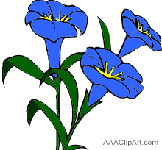

English Department

End of Questions