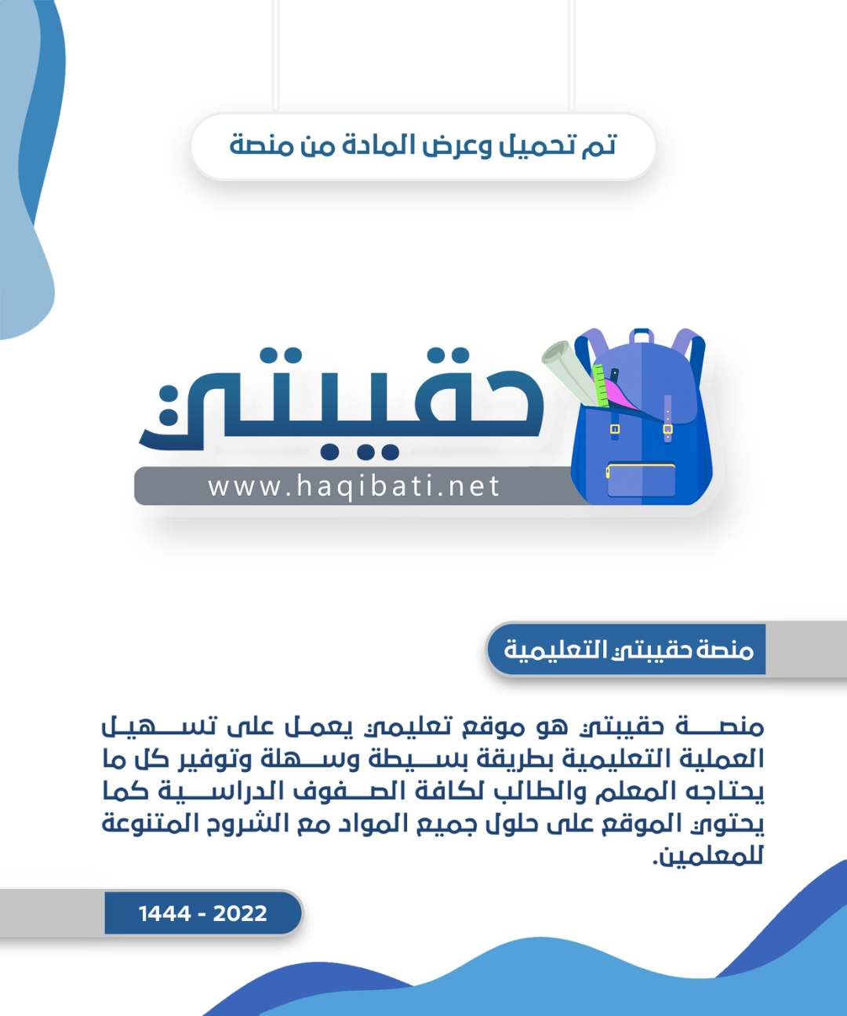

|  |  |  |  |  |  |  |  |
| --- | --- | --- | --- | --- | --- | --- | --- |
| **المملكة العربية السعودية** | |  | | | | **المادة:** | **اللغة الانجليزية (شفوي)** |
| **وزارة التعليم** | | **الصف** | **الأول متوسط** |
| **الادارة العامة للتعليم ب_______** | | **التاريخ:** | **/04/1445 هـــ** |
| **مدرسة__________المتوسطة** | | **الزمن:** | **نصـف ساعة** |
| **اختبار نهاية الفصل الدراسي الاول – الدور الأول للعام الدراسي 1445 هـ** | | | | | | | |
| **الاستماع 5** |  | **التحدث 5** |  | **المجموع 10** |  | | |
| **الاسم ثلاثي** |  | | | **الفصل** | **أول/** | **رقم الكشف** |  |

|  |  |  |
| --- | --- | --- |
| 1. Mustafa, this is my____ Mohammed! Nice to meet you | | C:\Users\96650\Desktop\qq.jpg |
| 🔿 | father |
| 🔿 | friend |
| 🔿 | classmate |

|  |  |  |
| --- | --- | --- |
| 1. When’s your final test? | | C:\Users\96650\Desktop\q22.jpg |
| 🔿 | It’s on April 7th. |
| 🔿 | It’s on November 17th. |
| 🔿 | It’s on September 27th. |

|  |  |  |
| --- | --- | --- |
| 1. What’s that? | | C:\Users\96650\Desktop\q33.jpg |
| 🔿 | I don’t know. |
| 🔿 | I think it’s a radio. |
| 🔿 | I think it’s a bicycle. |

|  |  |  |
| --- | --- | --- |
| 1. Where is Tom from? | | C:\Users\96650\Desktop\q444.jpg |
| 🔿 | He’s from China. |
| 🔿 | He’s from Australia. |
| 🔿 | He’s from New York. |

|  |  |  |
| --- | --- | --- |
| 1. Do you have any brothers and sisters? | | C:\Users\96650\Desktop\q5555.jpg |
| 🔿 | No, I’m an only child. |
| 🔿 | Yes, I have one brother. |
| 🔿 | I don’t have any brothers. |

Audio: <https://youtu.be/rGYNleheXfY>

Forms: <https://forms.office.com/Pages/ShareFormPage.aspx?id=b4OQU5QpqkK9sELnf3f9C84PUFGeBGBFuY4-jPdGsvZUQVM0SUdFT0xCU0pOUTRBVzdVTEtVREhVUi4u&sharetoken=T3dzOiuIUUc1LDGxHa1T>

|  |  |  |  |  |  |  |  |  |  |
| --- | --- | --- | --- | --- | --- | --- | --- | --- | --- |
| **المملكة العربية السعودية** | |  | | | | **المادة:** | | **اللغة الانجليزية (شفوي)** | |
| **وزارة التعليم** | | **الصف** | | **الأول متوسط** | |
| **الادارة العامة للتعليم ب______** | | **التاريخ:** | | **/04/1445 هـــ** | |
| **مدرسة________المتوسطة** | | **الزمن:** | | **نصـف ساعة** | |
| **اختبار نهاية الفصل الدراسي الأول– الدور الأول للعام الدراسي 1445 هــــــ** | | | | | | | | | |
| **الاستماع 5** |  | **التحدث 5** |  | **المجموع 10** |  | | | | |
| **الاسم ثلاثي** |  | | | **الفصل** | **أول /** | | **رقم الكشف** | |  |

**Listen and circle the right answer:**

|  |
| --- |
| 1. What ‘s his nationality?   He’s Spanish - Mexican – Chinese . |

|  |
| --- |
| 1. And what’s this?   It’s a diamond – dinosaur – meteor . |

|  |
| --- |
| 1. Fine, Paul and you?   I’m OK - fine - great . |

|  |
| --- |
| 1. Do you have any brothers and sisters?   No, I don’t – I haven’t – I’m an only child . |

|  |
| --- |
| 1. How old is he?   He’s six weeks – months – years old. |

|  |
| --- |
| 1. Follow me. Please don’t……   eat - drink – touch anything. |

|  |
| --- |
| 1. I’m starving.   The food in planes is great – delicious – terrible . |

|  |
| --- |
| 1. John and Paul are from ………   London – New York – Liverpool . |

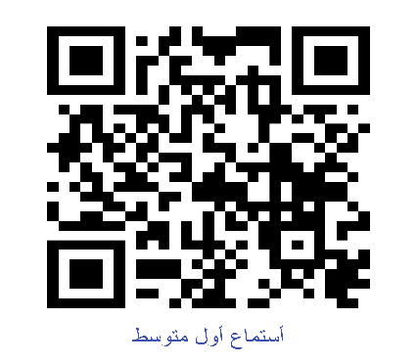** Write or :**

|  |
| --- |
| 1. Her sister’s wedding is on Monday. ( ) 2. The father is from big family too. ( ) |

Audio: <https://youtu.be/0_FKZAMGHRA>

Forms: <https://forms.office.com/Pages/ShareFormPage.aspx?id=b4OQU5QpqkK9sELnf3f9C84PUFGeBGBFuY4-jPdGsvZUM05DVlVKVUVBVDBMRlFLUTlLRVJTOEVPMi4u&sharetoken=T3dzOiuIUUc1LDGxHa1T>