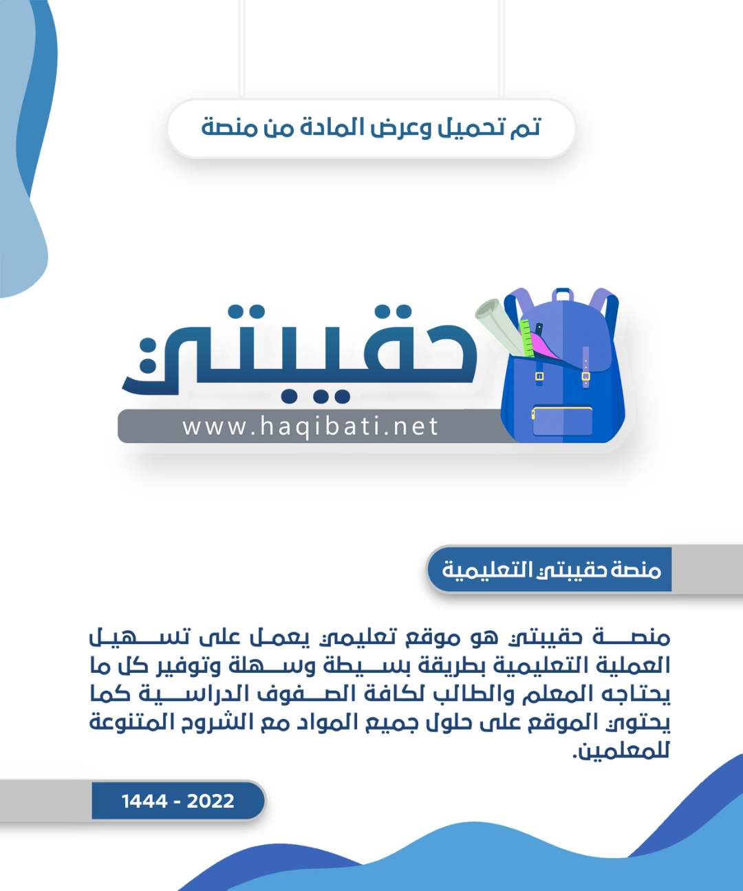



English Language Final Exam

Term: 1 – 1444 Session: 1

Time: 2:30 hrs

Grade: 1 - Mega Goal 1.1

Kingdom of Saudi Arabia

Ministry of Education

__________ Gen. Dept. of Education

__________ Secondary School

|  |  |  |  |
| --- | --- | --- | --- |
| Graded by: | ________________________________________  ________________________________________ |  | Mark out of  30 |
| Revised by: |

**اختبار مادة (اللغة الإنجليزية 1.1- الفصل الدراسي الأول - الدور الأول) للصف الأول ثانوي - للعام الدراسي 1445هـ - نظام المسارات**

**اسـم الطالب : ___________________________________________________________ رقم الجلوس : ________ اللجنة : ________**

**اللَّهمَّ لا سَهلَ إلَّا ما جَعَلتَه سَهلًا، وأنتَ تَجعَلُ الحَزْنَ إذا شِئتَ سَهلًا**

1. **Reading Comprehension**  (1 mark each)

**6**

**Read the following text, and then answer the questions below:**

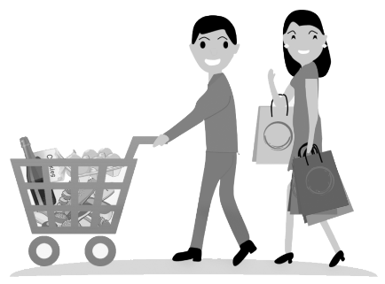Today, hypermarkets are found in almost every city in the world. Panda, AlOthaim, Carrefour and LuLu are one of the famous hyper markets in Saudi Arabia. Euromarche was the first hypermarket opened in Saudi Arabia in 1981. A hypermarket is different from mini markets or other shops.

People prefer shopping in hypermarket because it is convenient, international and one-stop-shopping. Besides, there are special offers that most customers like. In hypermarkets, goods are placed on open shelves. The customers help themselves to choose what they want and put them in the shopping basket, then take them to the check–out counter. There are usually special shelves in hyper markets for inexpensive items just in front of the check – out counter: such as chocolate, sweets, gum and so on.

When customers reach the check – out counter, they can pay cash or with a bank card. Customers feel glad because their shopping is finished. To give comfort to customers, hypermarkets provide parking areas and stay open until very late at night. Nowadays, many of the hypermarkets become huge shopping centers and malls.

1. *(choose)* **The best title for this article is …..**

a) History of Panda c) AlOthaim Mall b) Hypermarkets d) Mini Markets

1. **When was the first hypermarket opened in KSA?** _________________________
2. **Why do people prefer shopping in hyper markets?** (*Write only 1 reason)*

__________________________________________________________________________

1. **Choose the correct answer**

* The _________ help themselves to choose their goods.

a) customers b) malls c) shelves d) check-out counters

1. **Put ( T ) for true or ( F ) for false sentences :**
2. Hypermarkets stay open until very late at night. [______]
3. Nowadays, many of the hyper markets become mini shops. [______]

Page: 1 out of 4

**P.T.O**

1. **Vocabulary** (½ mark each)

**6**

1. **Fill the blanks with the correct words**

quality(iess) - treasure – plastic – motivation – disease

1. I read a story of the discovery of hidden___________________ in the ocean.
2. Please don’t throw away ___________________ bottles. Recycle them.
3. He has a real ___________________ to work. He wants to buy a car.
4. Khaled has different ___________________ . He is organized and reliable.
5. **Match word with its meaning**

|  |  |  |
| --- | --- | --- |
| **Word** |  | **Meaning** |
| 1. to cash in |  | 1. to come together |
| 1. to witness |  | 1. to be strong |
| 1. to establish |  | 1. to set up; to start |
| 1. to gather |  | 1. to make money from |
|  |  | 1. to see an event |

1. **Write the correct word and its picture**

**submarine - robot – bike - economy - cell phone**

|  |  |  |  |
| --- | --- | --- | --- |
|  |  |  |  |
| ____________ | ____________ | ____________ | ____________ |

Page: 2 out of 4

**P.T.O**

1. **Grammar** (½ mark each)

**6**

1. **Circle the correct answers**

|  |  |  |  |  |  |  |  |
| --- | --- | --- | --- | --- | --- | --- | --- |
| **1)** | Hey Jinan. _____________ lessons has she explained? ⦁ Sara: I guess 6. | | | | | | |
| a- | How long | b- | How much | c- | How many | d- | How often |
| **2)** | This is the shirt _____________ I bought yesterday. | | | | | | |
| a- | who | b- | which | c- | where | d- | when |
| **3)** | When _____________ they watch the movie? | | | | | | |
| a- | do | b- | does | c- | is | d- | are |
| **4)** | The food will _____________ by my mother soon. | | | | | | |
| a- | cook | b- | cooked | c- | be cooked | d- | been cooking |
| **5)** | The store won't close soon, _____________ . | | | | | | |
| a- | will it? | b- | it won't? | c- | it will? | d- | won't it? |
| **6)** | Bader: _____________ bag did you buy? ⦁ Ali : the black one | | | | | | |
| a- | who | b- | whose | c- | which | d- | who's |
| **7)** | He is interested _____________ reading novels. | | | | | | |
| a- | at | b- | in | c- | on | d- | of |
| **8)** | This coffee is hot _____________ . I can drink it | | | | | | |
| a- | very | b- | too | c- | enough | d- | many |

1. **Unscramble the sentence**

* new car / expensive / is not as / as the / the used car

________________________________________________________________

1. **Make it** *Negative*

* My grandparents visited us last night.

*My grandparents* _____________________________ *last night*.

1. **Put the word in a correct** *Comparative form*

* Water is ______________________ (*healthy*) than soda. Everybody knows that.

1. **Make** a Question **about the underlined**

* They will go (***to Dubai***) tomorrow morning

______________________ will they go tomorrow morning?

Page: 3 out of 4

**P.T.O**

1. **Composition**
2. **GUIDED COMPOSITION** (6 Marks)

**6**

* **Of no less than (70) words, write about: Teaching the Great Career.**
* The followings words may help you.

*dream – job – students - pass – knowledge – moral – values – educate – study*

_____________________________________________________________________

_____________________________________________________________________

_____________________________________________________________________

_____________________________________________________________________

_____________________________________________________________________

_____________________________________________________________________

_____________________________________________________________________

_____________________________________________________________________

_____________________________________________________________________

1. **FREE COMPOSITION** (6 Marks)

**6**

* **Choose ONE topic and write a paragraph about it of no less than (50) words.**

1. Saudi Vision 2030
2. My Favorite Gadget

_____________________________________________________________________

_____________________________________________________________________

_____________________________________________________________________

_____________________________________________________________________

_____________________________________________________________________

_____________________________________________________________________

_____________________________________________________________________

_____________________________________________________________________

Finished & Good Luck

Regards - ___________________

Page: 4 out of 4

Done by: Essa Al Hussaini

|  |  |  |
| --- | --- | --- |
| **English Language Final Exam** | **شعار وزارة التعليم بدون خلفية بيضاء الجديد مفرغ وشفاف - موقع محتويات** | **Kingdom of Saudi Arabia** |
| **The Second Trimester,1st Session, 1443** | **Ministry of Education** |
| **The 1.2 Secondary Grade** | **General Directorate of Education in Makkah** |
| **Time: 2.30 hours** | **South Education Office** |
| **No. of pages: 3** | **14th Secondary School** |
| **مستعينة بالله أجيبي عن الأسئلة التالية:** | | |

**I- Composition**:

6

**A- Guided Composition:**

**Write an email to advice Nasir that has problem in his new school**

**Guided words**: great school- feeling down- sorry- accepted - new student- short conversation- participate- football team- get better

Dear Nasir

…………………………………………………………………………………………………………………………………………………………………………………………………………………………………………………………………………………………………………………………………………………………………………………………………………………………………………………………………………………………………………………………………………………………………………………………………………………………………………………………………………………………………………………………………………………………………………………………………………………………………………………………………………………………………………………………………………………………………………………………………………………………………………………………………………………………………………………………………………………………………………………………………………………………………………………………………………………………………………………………………………………………………………………………………………………………………………………………………………………………………………………………………………………………………………………………………………………………………………………………………………………………………………………………………………………………………………………………………………………………………………………………………………………………………………………………………………………………………………………………………………………………………………………………………………………………………………………………………………………………………………………………………………………………………………………………………………………………………………………………………………………………………………………………………………………………………………………………………………………………………………………………………………………………………………………………………………………………………………..………………………………………………………………………………………………………………………………………… hope to see you soon

…………….

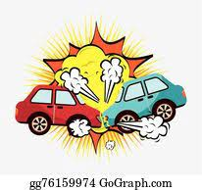+++++++++++++++++++++++++++++++++++++++++++++++++++++++++++++++++++++++++++++++

B- **Free Composition:**

**Write an essay about( accidents )**

………………………………………………………………………………………………………………………………………………………………………………………………………………………………………………………………………………………………………………………………………………………………………………………………………………………………………………………………………………………………………………………………………………………………………………………………………………………………………………………………………………………………………………………………………………………………………………………………………………………………………………………………………………………………………………………………………………………………………………………………………………………………………………………………………………………………………………………………………………………………………………………………………………………………………………………………………………………………………………………………………………………………………………………………………………………………………………………………………………………………………………………………………………………………………………………………………………………………………………………………………………………………………………………………………………………………………………………………………………………………………………………………………………………………………………………………………………………………………………………………………………………………………………………………………………………………………………………………………………………………………………………………………………………………………………………………………………………………………………………………………………………………………………

6

II -Grammar:

6

**A-Choose the correct answers:**

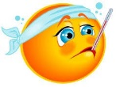1- He bought ( **himself – herself-ourselves** ) a new tablet.

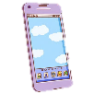2-​I went to the doctor ( **because – so-no** ) I was sick. -

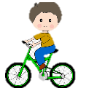3-How  (**many - much** -**any**)  cell phones have you bought ?

4-When I was young, I _(**used to- would-could**) have a lot of energy. I was always outside playing

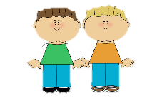or riding my bike.

5-Ali and Ahmad were (**boy-a boy-boys**) who we saw them at the local school

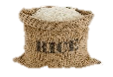6- I bought **( some- any-not**) rice.

**B-Do as shown between brackets:**

1-projector - no - There - is - in the class [**Unscramble to make a sentence**]

----------------------------------------------------------------------------------------------

2- You __________ eat while driving. **[ Give advice**]

3- You ought to ignore speed limits. **[Make it negative**]

-----------------------------------------------------------------------------------------------

**III- Vocabulary:**

6

**A-Match between the words and their pictures:**

1-

1-feeling down 2- **drums** **3- ostrich 4-** telegraph **5-junkfood**

( ) ( ) ( ) ( )

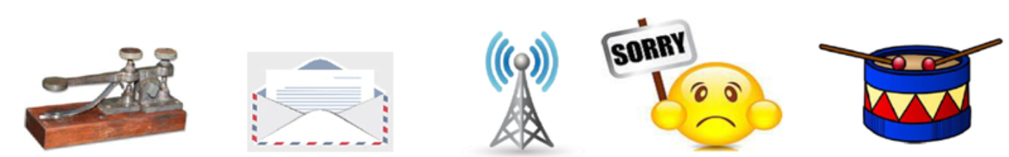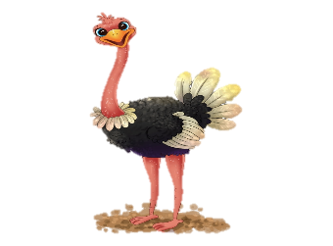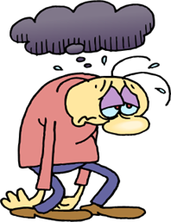



2**- Match the words with the meanings**:

|  |  |
| --- | --- |
| 1-challenge | ( ) being in good health |
| 2- recover | ( ) a period in the history |
| 3-stone age | ( ) get better |
| 4- keep fit | ( ) "fight against |
| 5-Of course |  |

**3- Circle the Odd words** :

a**-** money - prize - tea - news b- ankle – eye – finger – kneepad

**4-Give the antonyms for the words:**

a- healthy #..................................... b**-**gain weight #...............................

**IV-Reading**

6

**Read the following passage and answer the questions below:**

The Eiffel Tower

The *Eiffel Tower* is one of the most famous building in the world. It is a 324m high structure in the center of Paris, France. Over the years, it has become a symbol of the city and the country. When they built it, *The Eiffel Tower* was the tallest building in the world. The tower got its name from its designer, Gustave Eiffel, and it build, from 1887 to 1889. The tower opened to the public on 6 May 1889. Today, it is without doubt one of the most recognizable memorial in Europe, one that can be compared to the Statue of Liberty in New York, and the Big Ben in London.

However, soon after opening, newspapers were full of angry letters from people saying how much they hated the new building. This soon changed, and today it is very popular with millions of tourists who visit it every year. You can even find smaller copies of the structure in many cities around the world.

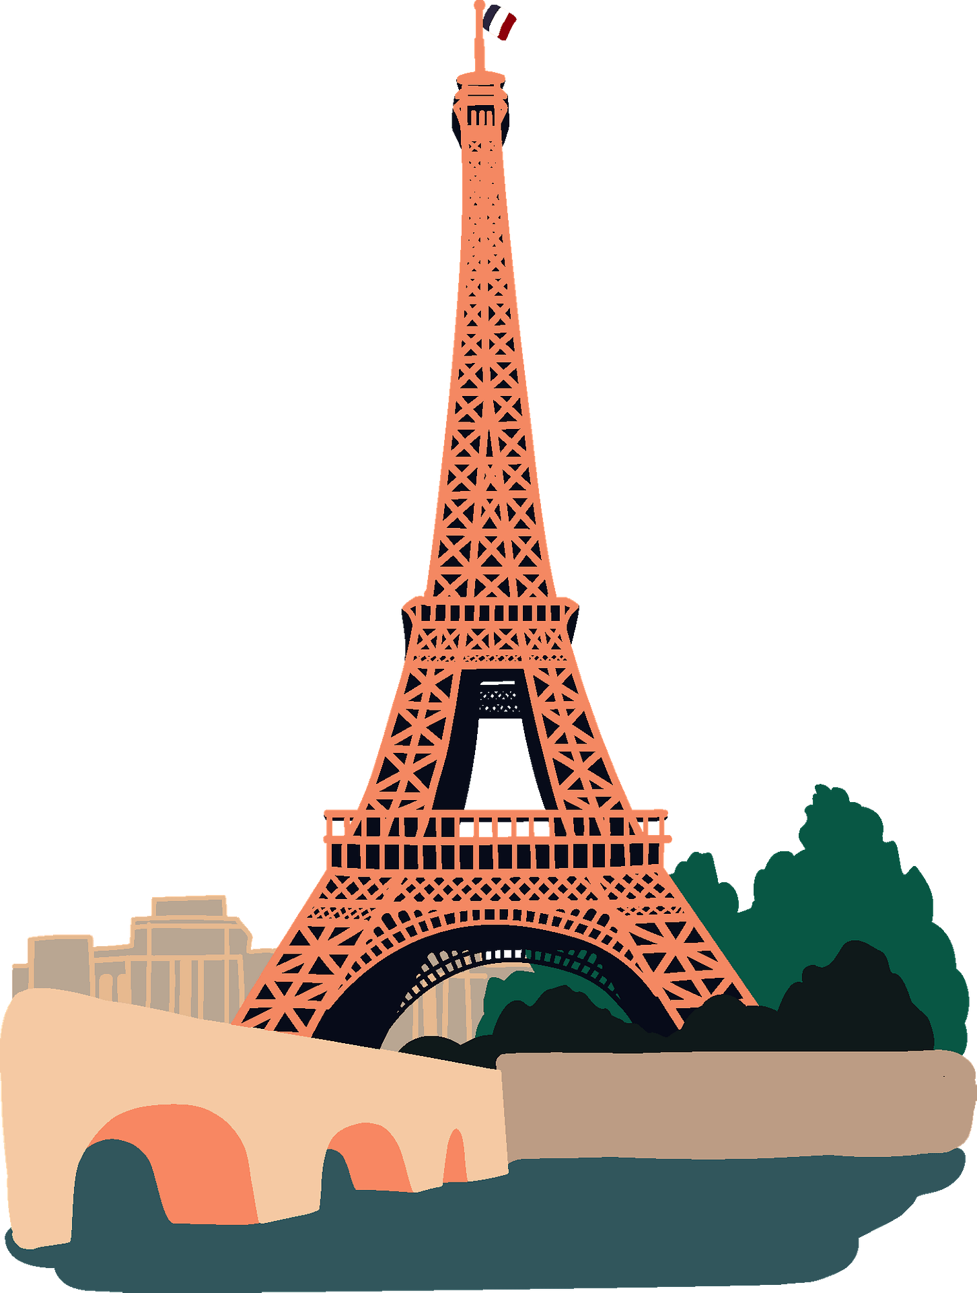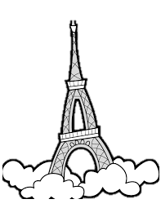

**A-Answer these question:**

1 – What is of the most famous building in the world.?

………………………………………………………………………………………………………………………………………………………………………………

2 - Was it the tallest building in the world?

………………………………………………………………………………………………………………………………………………………………………………

3- Where can you find smaller copies of Eiffel Tower?

……………………………………………………………………………………………………………………………………………………………………………

**B- Write [ T ] for True or [ F ] for False :**

|  |  |
| --- | --- |
| 1. The tower got its name from its designer,. |  |
| 1. At present, it is without doubt one of the most recognizable memorial in Europe. |  |

**C- Choose the right answer :**

1. The tower opened to the public on

**a-**5 May 1889  **b-**6 May 1889  **c-**7 May 1889

2. Eiffel Tower is a ,,,,,,,,,, high

**a-**324m **b-**325m **c-** 326m

**D-Find the antonym** :

a- ****bigger #..................................... b- shorter #......................

|  |  |  |
| --- | --- | --- |
| **English Language Final Exam** | **شعار وزارة التعليم بدون خلفية بيضاء الجديد مفرغ وشفاف - موقع محتويات** | **Kingdom of Saudi Arabia** |
| **The Second Trimester,1st Session, 1443** | **Ministry of Education** |
| **The 1.2 Secondary Grade** | **General Directorate of Education in Makkah** |
| **Time: 2.30 hours** | **South Education Office** |
| **No. of pages: 3** | **14th Secondary School** |
| **مستعينة بالله أجيبي عن الأسئلة التالية:** | | |

**I- Composition**:

**Model Answer**

6

**A- Guided Composition:**

**Write an email to advice Nasir that has problem in his new school**

**Guided words**: great school- feeling down- sorry- accepted - new student- short conversation- participate- football team- get better

Dear Nasir

………………………………………………………………………………………………………………………………………………………………………………………………………………………………………………………………………………………………………………………………………………………………………………………………………………………………………………………………………………………………………………………………………………………………………………………………………………………………………………………………………………………………………………………………………………………………………………………………………………………………………………………………………………………………………………………………………………………………………………………………………………………………………………………………………………………………………………………………………………………………………………………………………………………………any possible answer

……………………………………………………………………………………………………………………………………………………………………………………………………………………………………………………………………………………………………………………………………………………………………………………………………………………………………………………………………………………………………………………………………………………………………………………………………………………………………………………………………………………………………………………………………………………………………………………………………………………………………………………………………………………………………………………………………………………………………………………………………………………………………………………………………………………………………………………………………………………………………………………………………………………………………………………………………………………………..……………………………………………………………………………………………… hope to see you soon

…………….

+++++++++++++++++++++++++++++++++++++++++++++++++++++++++++++++++++++++++++++++

B- **Free Composition:**

**Write an essay about( accidents )**

…………………………………………………………………………………………………………………………………………………………………………………………………………………………………………………………………………………………………………………………………………………………………………………………………… any possible answer ………………………………………………………………………………………………………………………………………………………………………………………………………………………………………………………………………………………………………………………………………………………………………………………………………………………………………………………………………………………………………………………………………………………………………………………………………………………………………………………………………………………………………………………………………………………………………………………………………………………………………………………………………………………………………………………………………………………………………………………………………………………………………………………………………………………………………………………………………………………………………………………………………………………………………………………………………………………………………………………………………………………………………………………………………………………………………………………………………………………………………………………………………………………………………………………………………………………………………………………………………………………………………………………………………………………………………………………………………………………………

6

II -Grammar:

**½** for each

6

**A-Choose the correct answers:**

1- He bought ( **himself – herself-ourselves** ) a new tablet.

2-​I went to the doctor ( **because – so-no** ) I was sick. -

3-How  (**many - much** -**any**)  cell phones have you bought ?

4-When I was young, I _(**used to- would-could**) have a lot of energy. I was always outside playing

or riding my bike.

5-Ali and Ahmad were (**boy-a boy-boys**) who we saw them at the local school

6- I bought **( some- any-not**) rice.

**1** for each

**B-Do as shown between brackets:**

1-projector - no - There - is - in the class [**Unscramble to make a sentence**]

There is no projector in the class.

2- You _should_ eat while driving. **[ Give advice**]

3- You ought to ignore speed limits. **[Make it negative**]

You ought not to ignore speed limits.

**III- Vocabulary:**

**½** for each

6

**A-Match between the words and their pictures:**

1-

1-feeling down 2- **drums** **3- ostrich 4-** telegraph **5-junkfood**

**( 4 ) ( 3 ) ( 2 ) ( 1 )**





2**- Match the words with the meanings**:

|  |  |
| --- | --- |
| 1-challenge | ( 4 ) being in good health |
| 2- recover | ( 3 ) a period in the history |
| 3-stone age | ( 2 ) get better |
| 4- keep fit | ( 1 ) "fight against |
| 5-Of course |  |

**3- Circle the Odd words** :

a**-** money - prize - tea - news b- ankle – eye – finger – kneepad

**4-Give the antonyms for the words:**

a- healthy #.....unhealthy b**-**gain weight #. lose weight.

**IV-Reading**

6

**Read the following passage and answer the questions below:**

The Eiffel Tower

The *Eiffel Tower* is one of the most famous building in the world. It is a 324m high structure in the center of Paris, France. Over the years, it has become a symbol of the city and the country. When they built it, *The Eiffel Tower* was the tallest building in the world. The tower got its name from its designer, Gustave Eiffel, and it build, from 1887 to 1889. The tower opened to the public on 6 May 1889. Today, it is without doubt one of the most recognizable memorial in Europe, one that can be compared to the Statue of Liberty in New York, and the Big Ben in London.

However, soon after opening, newspapers were full of angry letters from people saying how much they hated the new building. This soon changed, and today it is very popular with millions of tourists who visit it every year. You can even find smaller copies of the structure in many cities around the world.



**1** for each

**A-Answer these question:**

1 – What is of the most famous building in the world.?

The *Eiffel Tower*

2 - Was it the tallest building in the world?

Yes, it was.

3- Where can you find smaller copies of Eiffel Tower?

in many cities around the world.

**½** for each

**B- Write [ T ] for True or [ F ] for False :**

|  |  |
| --- | --- |
| 1. The tower got its name from its designer,. T | t |
| 1. At present, it is without doubt one of the most recognizable memorial in Europe.T |  |

**C- Choose the right answer :**

**½** for each

1. The tower opened to the public on

**a-**5 May 1889  **b-**6 May 1889  **c-**7 May 1889

2. Eiffel Tower is a ,,,,,,,,,, high

**a-**324m **b-**325m **c-** 326m

**D-Find the antonym** :

**½** for each

a- ****bigger #....smaller b- shortest #....tallest

|  |  |  |  |  |  |
| --- | --- | --- | --- | --- | --- |
| الدرجة | | | | C:\Documents and Settings\user\Desktop\1444823505lnha01401002015ha0016-800x500.jpgC:\Users\Dar Altarbia\Desktop\شعار مدرستي.jpgنتيجة بحث الصور عن شعار رؤية المملكة 2030  =======================================  اسم الطالب ( ------------------------------------)  رقم الجلوس (------------------------------)  المادة ( اللغة الانجليزية Mega Goal 1.1 )  زمن الإجابة ( ساعتان ونصف)  التاريخ / / 5144 هـ | المملكة العربية السعودية  **وزارة التعليم**  **ثانوية**    **الفصل الدراسي الأول**  **الدور الأول**  **العام الدراسي**    **1444 / 1445**  **الصف الأول الثانوي** |
| الدرجة | السؤال | | |
|  | 6 | **التعبير** | 1 |
|  | 6 | **التعبير** | 2 |
|  | 6 | **القواعد** | 3 |
|  | 6 | **المفردات** | 4 |
|  | 6 | **القطعة** | 5 |
|  | 30 | 30 | **المجموع** |

**Q. 1 ( Writing )**

A) **Write a paragraph – not less than 100 words - about ( Yourself ). Mention the following:( name – age – nationality – city – hobby – family )**

6

**Myself**

-----------------------------------------------------------------------------------------------------------------------------------------------------------

-----------------------------------------------------------------------------------------------------------------------------------------------------------

-----------------------------------------------------------------------------------------------------------------------------------------------------------

-----------------------------------------------------------------------------------------------------------------------------------------------------------

-----------------------------------------------------------------------------------------------------------------------------------------------------------

----------------------------------------------------------------------------------------------------------------------------------------------------

-----------------------------------------------------------------------------------------------------------------------------------------------------------

-----------------------------------------------------------------------------------------------------------------------------------------------------------

-----------------------------------------------------------------------------------------------------------------------------------------------------------

-----------------------------------------------------------------------------------------------------------------------------------------------------------

-----------------------------------------------------------------------------------------------------------------------------------------------------------

-----------------------------------------------------------------------------------------------------------------------------------------------------------

-----------------------------------------------------------------------------------------------------------------------------------------------------------

-----------------------------------------------------------------------------------------------------------------------------------------------------------

----------------------------------------------------------------------------------------------------------------------------------------------------

6

**B) Write a paragraph about one of the following ( MY FAVORITE CITY) or ( MY hobby )**

---------------------------------------------------------------------------------------------------------------------------------------------------------------------------------------------------------------------------------------------------------------------------------------------------------------------------------------------------------------------------------------------------------------------------------------------------------------------------------------------------------------------------------------------------------------------------------------------------------------------------------------------------------------------------------------------------------------------------------------------------------------------------------------------------------------------------------------------------------------------------------------------------------------------------------------------------------------------------------------------------------------------------------------------------------------------------------------------------------------------------------------------------------------------------------------------------------------------------------------------------------------------------------------------------------------------------------------------------------------------------------------------------------

6

1. 2 ( Grammar )

***Choose the correct answer*** ( half for each one )

1. I ………………………………………………..………hard yesterday.
2. **work b) works c) am working d) worked**
3. My friends ……………………………..…..sleeping when I called them.
4. **was b) were c) is d) be**
5. Ahmed ………………………………………………go to school yesterday.
6. **didn’t b) doesn’t c) isn’t d) don’t**
7. It doesn’t rain in summer,………………..……………………?
8. **does it b) it does c) doesn’t it d) it doesn’t**
9. He has been reading a book …………………………………………..two years.
10. **since b) for c) to d) ago**
11. Ahmed is as……………………..………………………… Ali.
12. **old b) older c) oldest d) old as**
13. ……………………………………………….….car is this? It is my car.
14. **Who’s b) Whose c) Where d) How’s**
15. Many countries …………………………………………..launched satellites into space
16. **has b) will c) are d) have**
17. You are from Riyadh, ……………………..………………….you?
18. **are b) aren’t c) is d) does**
19. They ……………………………..………….to Dubai tonight.
20. **flew b) is flying c) has flown d) are flying**
21. By the year 3000, people …………………………..………………..to the age of 120.
22. **will b) will be living c)lived d) living**
23. The Russians …………………………………………the first artificial satellite in 1957.
24. **launched b) will launch c) launch d) are launching**

6

Q. 3 ( Vocab. )

1. To ………………………………………….….means to provide a place for.
2. **affect b) launch c) host d) establish**
3. To …………………………………….……..means to send into the space.
4. **affect b) launch c) take d) give**
5. We go to school ……………………………………………………….Sunday.
6. **in b) on c) at d) for**
7. Saudi Arabia has a ……………………………………………………..for the future 2030.
8. **vision b) video c) audio d) problem**
9. The tiny classic car is back. The word “ tiny” means very …………………………….……….
10. **small b) big c) large d) mega**
11. Perfumes …………………………………………………….……..like flowers.
12. **smell b) look c) sound d) taste**
13. When I’m very bored, it means I’m bored to ………………….………………………..
14. **life b) dead c) death d) live**
15. The twins………………………………………………………….just like their mother, don’t you think?
16. **look b) smell c) taste d) show**
17. To …………………………………………………..…….means to come together.
18. **gather b) separate c) throw d) divide**
19. ………………………………………………………is a place where we can eat in.
20. **Novel b) car c) Restaurant d) Appliance**
21. ………………………………………………………is a global issue.
22. **School b) Hospital c) Pollution d) Tigers**
23. Enterprises has the same meaning as …………………………………….……………….
24. **businesses b) schools c) ideas d) books**

Q. 4 (Reading )

6

***Read this passage and then answer the questions below:***

In the last seventy-five years, *air travel* has become the important means of long distance transportation around the world. The airplane was adopted for passenger service in Europe in 1919. Later in 1927, people in the United States began to travel by air. On 14 March 1947 in Saudi Arabia, a new airline started with a fleet of five, 24-seat Douglas DC-3s. On those days, a DC-3 ***took off*** from Jeddah for Riyadh, Hofuf and Dhahran. The 1,200 km trip took four hours and a half . The same journey by land took about two months at that time. No matter where you travel by plane, the process is usually the same. You arrive at the airport at least two hours before the plane is scheduled to leave. Right away , you show your passport and ticket to the agent. Then he gives you a seat number and checks your suitcases. After that you go to the gate where you will board your plane. Finally, an agent announces that it is time to board your plane, and you are on your way.

1. ***Put ( T ) for true and ( F ) for false* (a mark for each one )**
2. You should arrive at the airport two hours before the plane is scheduled to leave. ( )
3. You show your passport and ticket to the agent. ( )
4. Air travel isn’t important nowadays. ( )
5. Douglas DC-s has 20 seats only. ( )
6. People in the United States began to travel by air in 1947. ( )
7. The opposite of the underlined word is landed. ( )