

English Language

Intermediate Grade 1st

1st period Exam

Kingdom of Saudi Arabia

Ministry of Education

………………… School

[](https://t.me/Asmaworld)

Student's Name : class:

……\ 5 marks

1**-Read the following passage and answer the questions below:**

My house is where my family lives. It is white. It is big. There are four bedrooms. We have a kitchen and three bathrooms. Our family room is where we like to watch television together. When people come over, we eat in the dining room. We have a playroom in the basement. We have a swing in the backyard. I love my house.

|  |  |  |
| --- | --- | --- |
| 1-What color is the house? | | |
| c- brown | b- blue | a- white |
| 2-There are ……………bedrooms. | | |
| c-six | b-three | a-four |
| 3-There are a kitchen and three ………… | | |
| c-garages | b-bathrooms | a-living rooms |
| 4- Who lives in the house? | | |
| c-family | b-cousins | a-friends |
| 5- What is in the backyard? | | |
| c- a swing | b-swimming pool | a- television |

**2-Choose the correct answer.**

……\ 5 marks

|  |  |  |  |
| --- | --- | --- | --- |
| c- for | b- on | a- in | 1- We live ………….the twelfth floor |
| c- but | b- and | a- or | 2- We read …………..write in class. |
| c- Am | b- Are | a- Is | 3- ………..there curtains in the kitchen? |
| c- best | b- better | a- good | 4- Healthy food is……. than fast food. |
| c- am | b- are | a- is | 5- There ………… a car in the garage |
| c-hottest | b-hotter | a- hot | 6- Summer is the………. time of the year. |
| c- smartest | b- smarter | a-smart | 7- Sami is …………….. |
| c- or | b- and | a- but | 8- Would you like coffee …….tea? |
| c- in | b- from | a- in | 9- Ali lives …….. Jeddah. |
| c-but | b-and | a- or | 10- Do you write with a pencil ……..a pen? |

……\ 2 marks

**3. Do as shown between brackets.**

**(make a question then answer).**

a-There is a desk in the bedroom.

………………………………………………?

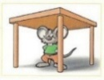**(choose the correct answer)**

a-The mouse is ( under – far from – behind )the table.

……\ 6 marks

**A -Choose the correct answer.**

1- A place to take a walk( (school- park – supermarket )

2- She was looking at her reflection in the ( motorcycle – mirror – trees)

**B- Find the odd words**

1- Health club bookstore armchair

2- washer laptop dryer

**C-Match the correct word for each picture. ( lake post office bathtub refrigerator )**

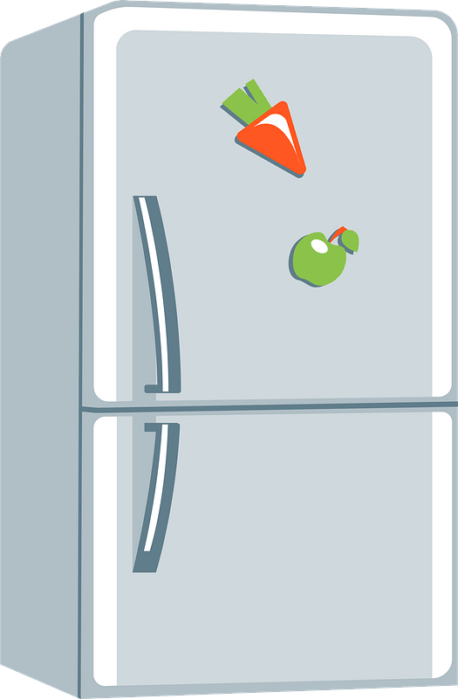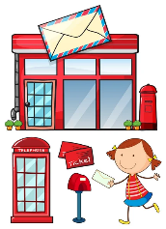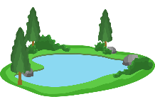



………………..

………………..

………………..

………………..

**A-choose the missing letters**

……\ 2 marks

1- He went to the museu… by taxi. ( j – h – m ).

2- He has a clo….et full of new clothes. ( s – d – j )

**B-write the missing letter**



2- Shel..….

….…ym 1-



Your teacher:



**Kingdom of Saudi Arabia**

**Ministry of Education**

**………… Education Directorate............**

**…………..……………….. Intermediate School**

|  |
| --- |
|  |
| **20** |

**Total**

**Midterm Test**

|  |
| --- |
| **First Intermediate Grade** |

**Name ………………………………… Class ………………………………**

__________________________________________________________________________________________

/ 4

**Comprehension**

**Read the following then answer the questions:**

Ali is a schoolboy. He is 13 years old. His father is a doctor. His mother is a teacher. He has 3 brothers. Ali and his family have a big house. He likes English.

**A- Put (√ ) for true or ( ᵡ ) for false :**

|  |  |
| --- | --- |
| **( )** | **1.** Ali is 14 years old. |
| **( )** | **2.** His father is a doctor. |

**B- Choose the right answer:**

|  |  |  |  |  |
| --- | --- | --- | --- | --- |
| **a doctor** | **a pilot** | **a nurse** | **a teacher** | **1-**His mother is _________. |
| **five** | **three** | **four** | **two** | **2-**He has ___ brothers. |

_________________________________________________________________

**Grammar**

/ 5

**Choose the right answer:**

|  |  |  |  |  |
| --- | --- | --- | --- | --- |
| D**.There** | C**. Is there** | B**. There are** | A**. There is** | 1. ______ a table in the kitchen. |
| D**. under** | C**. at** | B**. in** | A**. on** | 2. I live ___ Jeddah. |
| D**. after** | C**. in** | B**. on** | A**. at** | 3**.** He lives ___ the third floor. |
| D**. taller** | C**. tallest** | B**. big** | A**. tall** | 4**.** Ali is ____ than Ahmad. |
| D**. read** | C**. studies** | B**. study** | A**. studying** | 5**.** I am ______ now. |

**Vocabulary**

/ 4

**A- Choose the best answer to fill in the blank:**

|  |
| --- |
| **1.** The ______ is in the garage**.** |
| **A. tree B. shower C. motorcycle D. stove** |
| **2**. The apartment has a _____ with a beautiful view. |
| **A. balcony B. bathroom C. stove D. floor** |
| **3-** The supermarket is much _____than the convenience store. . |
| **A. far B. bigger C. big D. beautiful** |
| **4-** He is drinking a _________. |
| **A. sandwich B. pizza C. cup of tea D. fruit** |

**B- Put the right word under its picture:**

|  |  |  |  |
| --- | --- | --- | --- |
| Smartphone Mobile Phone Cartoon, PNG, 723x1109px, Smartphone, Animation,  Blue, Brand, Cartoon Download Free | Turn left Basic Rounded Lineal icon | Bedroom Graphic Black White Isolated Furniture: immagine vettoriale stock  (royalty free) 2217488523 | Shutterstock | Workout Cartoon Clipart Images | Free Download | PNG Transparent Background  - Pngtree |
|  |  |  |  |

**Bedroom - Health club - Turn right - Cell phone**

/ 4

_______________________________________________________________________________

/ 3

**Orthography**

**Choose the correct letter:**

|  |  |  |  |
| --- | --- | --- | --- |
| C**. ( b )** | B**. ( v )** | A**. ( d )** | 1. It is very nice and comforta__le. |
| C**. ( f )** | B**. ( n )** | A**. ( m )** | 2. I live in this apart__ent. |
| B**. ( t )** C**. ( z )** | | A**. ( s )** | 3**.** They are reading maga_ines. |

Good luck T.

Kingdom of Saudi Arabia Name: ……………………………

Ministry of education Class: 1st Intermediate Grade

**20 /**

Hefar Intermediate School Quiz (1) Second Term

1. **Comprehension:**

**Use the following word bank to write a paragraph about *your dream house*.**

**WORD BANK:** (have – big – room – kitchen – balcony – beautiful – view)

______________________

_____________________________________________________________________________________________________________________________________________________________________________________________________________________________________________________________________________________________________________________________________________________________________________________________________________________________________________________________________________________

1. **Grammar:**
2. **Choose:**
3. 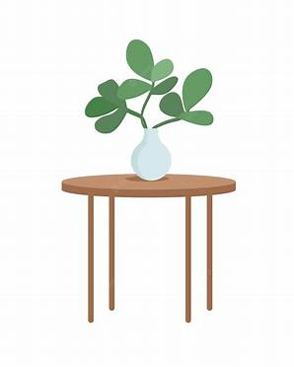There **(am – is – are)** a bike in the garage.
4. I want to go to the school **(and – but – or)** I am sick.
5. The vase is **(in – on – under)** the table.
6. The board is **(in front of – under – on)** the students.
7. **Do as shown between brackets:**
8. There are flowers in the yard.  **(Change into negative)**

…………………………………………………………

1. There is a ball under the bed.  **(Make a Yes/No question)**

…………………………………………………………

1. **Vocabulary:**
2. **Write the words under the pictures:**

**sofa – rug – closet – fridge – shower**

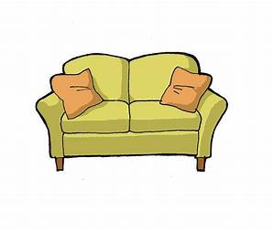



_____________ _______________ ________________ ______________

1. **Classify the words:**

**bathtub – bed – armchair – stove**

|  |  |  |  |
| --- | --- | --- | --- |
| **Living room** | **Bathroom** | **Bedroom** | **Kitchen** |
|  |  |  |  |

1. **Match the opposites:**
2. upstairs a- cold
3. hot d- unusual

. e- downstairs

1. **Fill in the blank with the correct words in the box:**

**apartment – tree – crowded**

1. His …………………... is in a really good location.
2. Taif was very ……………….. last summer.
3. **Orthography:**
4. **Fill in the missing letters:**
5. The **s__nk** was full of dirty plates.
6. She was looking at herself in the **mirr__r**.
7. There are two pens on the **de__k** .
8. The house is fully furnished, including washer and **dr__er**.

**Good Luck ☺**

**Ms. Tahani Al-Ghamdi**

Kingdom of Saudi Arabia Name: ……………………………

Ministry of education Class: 1st Intermediate Grade

**20 /**

Hefar Intermediate School Quiz (2) Second Term

1. **Grammar:**
2. **Choose:**
3. I live **(in – on – at)** Riyadh.
4. Tala is **(next to – near – between)** Reem and Lama.
5. Dr Omar is the **(good – better – best)** doctor in the city.
6. Jeddah is **(modern – more modern – most modern)** than Abha.
7. **Do as shown between brackets:**
8. Planes are **(fast)** than cars.  **(Correct the mistake)**

…………………………………………………..

1. Sahar lives ………... the tenth floor. **(Use *in* or *on*)**
2. **Vocabulary:**
3. **Write the words under the pictures:**

**gym – airport – town – sauna – pasta**

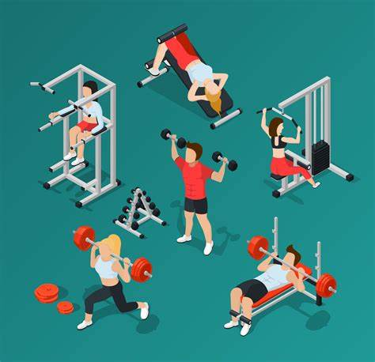

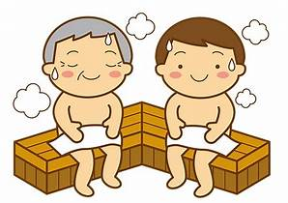

_____________ ______________ _____________ ______________

1. **Fill in the blank with the correct words in the box:**

**convenience store – trust – get off**

1. Give me a call when you ……………………. the bus.
2. I am going to the ………………………... to buy some bread.
3. **Match the opposites:**
4. left a- down
5. up. b- same

c- right

1. **Orthography:**
2. **Choose the correct missing letters:**
3. I ordered a **p__zza** for lunch.

|  |  |  |
| --- | --- | --- |
| 1. e | 1. i | 1. z |

1. Mr. Ali works in a **ba__k** .

|  |  |  |
| --- | --- | --- |
| 1. m | 1. n | 1. c |

1. I bought a **n__w** bag.

|  |  |  |
| --- | --- | --- |
| 1. e | 1. a | 1. i |

1. You can get your medicines from the **pha*__*macy** of the hospital.

|  |  |  |
| --- | --- | --- |
| 1. a | 1. c | 1. r |

1. Shahad likes to hang out at the **m__ll** with her friends.

|  |  |  |
| --- | --- | --- |
| 1. a | 1. o | 1. e |

1. Amjad went to the **super__arket** to buy some snacks.

|  |  |  |
| --- | --- | --- |
| 1. n | 1. w | 1. m |

**Good Luck ☺**

**Ms. Tahani Al-Ghamdi**