|  |  |  |  |  |  |  |  |  |  |
| --- | --- | --- | --- | --- | --- | --- | --- | --- | --- |
| **Distribution of the syllabus Super Goal 2- Second Term 1446 2nd intermediate Grade** | | | | | | | | | |
| **4th week** | | **3rd week** | | **2nd week** | | **1st week** | | **today** | |
| **What Happened?**  **Reading**  **Writing & Project**  **Form, Meaning and Function** | **7/6** | **What Happened?**  **Listen and Discuss +Pair work**  **Grammar**  **pronunciation & listening**  **About you & Conversation** | **29/5** | **What Was It Like?**  **About you & Conversation Reading**  **Writing & Project**  **Form, Meaning and Function** | **22/5** | **What Was It Like?**  **Listen and Discuss + Pair work**  **Grammar**  **pronunciation & listening** | **15/5** | **Sun** | |
| **8/6** | **1/6** | **23/5** | **16/5** | **Mon** | |
| **9/6** | **2/6** | **24/5** | **17/5** | **Tue** | |
| **إجازة مطولة** | **10/6** | **3/6** | **25/5** | **18/5** | **Wed** | |
| **11/6** | **4/6** | **26/5** | **19/5** | **Thurs** | |
| **8th week** | | **7th week** | | **6th week** | | **5th week** | | **today** | |
| **اجازة منتصف الفصل الثاني** | **/75** | **Let’s Go Out**  **Grammar**  **pronunciation & listening**  **About you & Conversation Reading, Writing & Project** | **28/6** | **What’s Wrong?**  **Reading**  **Writing & Project**  **Form, Meaning and Function**  **Let’s Go Out**  **Listen and Discuss + Pair work** | **21/6** | **What’s Wrong?**  **Listen and Discuss + Pair work**  **Grammar**  **pronunciation & listening**  **About you & Conversation** | **14/6** | **Sun** | |
| **6/7** | **29/6** | **22/6** | **15/6** | **Mon** | |
| **7/7** | **30/6** | **23/6** | **16/6** | **Tue** | |
| **8/7** | **1/7** | **24/6** | **17/6** | **Wed** | |
| **9/7** | **2/7** | **25/6** | **18/6** | **Thurs** | |
| **12th week** | | **11th week** | | **10th week** | | **9th week** | | **today** | |
| **There’s No Comparison**  **About you , Conversation**  **Reading**  **Writing & Project**  **Form, Meaning and Function** | **3/8** | **There’s No Comparison**  **Listen and Discuss +Pair work**  **Grammar**  **pronunciation & listening** | **26/7** | **It’s a Bargain!**  **About you & Conversation**  **Reading**  **Writing & Project**  **Form, Meaning and Function** | **19/7** | **Let’s Go Out**  **Form, Meaning and Function**  **It’s a Bargain!**  **Listen and Discuss +Pair work**  **Grammar**  **pronunciation & listening** | **12/7** | **Sun** | |
| **4/8** | **27/7** | **20/7** | **13/7** | **Mon** | |
| **5/8** | **28/7** | **21/7** | **14/7** | **Tue** | |
| **6/6** | **29/7** | **22/7** | **15/7** | **Wed** | |
| **7/8** | **30/7** | **23/7** | **16/7** | **Thurs** | |
|  | | **14th week** | | |  | **13th week** | **Date** | **today** | |
| شعار وزارة التعليم مع الرؤية 2030 ” نماذج مفرغه وشفافه “ | المرسال | | **Final exams** | | | **8/17** | **اختبارات المواد العملية والشفهية** | **8/10** | | **Sun** |
| **18/8** | **11/8** | | **Mon** |
| **19/8** | **12/8** | | **Tue** |
| **20/8** | **13/8** | | **Wed** |
| **21/8** | **14/8** | | **Thurs** |
| **Headmaster:** | | | **Supervisor:** | | | **Teacher:** | | | |
|  | | |  | | |  | | | |



**المملكة العربية السعودية**

**وزارة التعليم**

**الإدارة العامة للتعليم بمنطقة**

**مكتب تعليم**

**ثانوية نجد**

**المدرسة:**

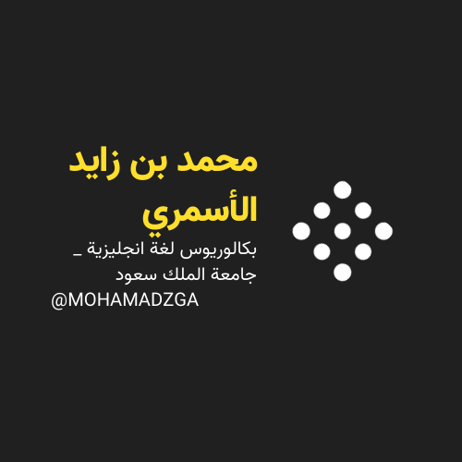

** قناتي**



**M_zaid0 MOHAMADZGA**

**لا تنسوني من صالح دعائكم**